**BABLUS**



**2021-2022**

**A PROJECT REPORT**

*Submitted by*

**VIGHNESHA N U - 191322743**

**KARTHIK V RAO - 191322718**

**NISHMITHA J SHETTY - 191322723**

In partial fulfilment for the award of the degree of

**BACHELOR OF COMPUTER APPLICATIONS**

*Under the guidance of*

**Mrs. SWARNAGOWRI S S**

Lecturer

Department of Computer Science



**GOVERNMENT FIRST GRADE COLLEGE**

**THENKANIDIYOOR, UDUPI**

**MANGALORE UNIVERSITY**



**MANGALORE UNIVERSITY**



**GOVERNMENT FIRST GRADE COLLEGE**

**THENKANIDIYOOR, UDUPI**

Department of Computer Science

Certified that the project work entitled

**Bablus**

………………………………………… is a benefited work carried out by

**VIGHNESHA N U**  **KARTHIK V RAO**  **NISHMITHA J SHETTY**

Reg No: 191322743 Reg No: 191322718 RegNo: 191322723

in partial fulfilment for the award of degree of Bachelor of Computer Applications of the Mangalore University during the year 2021-22. The project report has been approved as it satisfies the academic requirements of project work prescribed for the Bachelor of Computer Applications.

***Signature of the Signature of the HOD Signature of the***

***Project Guide Principal***

**Examiners:** 1. 2.



**MANGALORE UNIVERSITY**



**GOVERNMENT FIRST GRADE COLLEGE**

**THENKANIDIYOOR, UDUPI**

Department of Computer Science

Certified that the project work entitled

**Bablus**

…………………………………………………………………………………………… is a benefited work carried out by

**VIGHNESHA N U**

…………………………………………………………………… in partial fulfilment for the award of degree of Bachelor of Computer Applications of the Mangalore University during the year 2021-22. The project report has been approved as it satisfies the academic requirements of project work prescribed for the Bachelor of Computer Applications.

**Project Guide: Mrs. SWARNA GOWRI S S**

**VIGHNESHA N U**

**Name of the Student:**

**191322743**

**University Register Number:**

**Examiners:** 1. 2.

**DECLARATION**

I am Vighnesha N U (Reg-191322743), do hereby declare that The project entitled “Bablus” is the original work carried out by me and my teammates during the sixth semester BCA, submitted to Mangalore University, for the partial fulfillment of the requirement of Bachelor of Computer Applications

I also declare this project has not been previously submitted for any other degree or award.

Place : Thenkanidiyur, Udupi Name : Vighnesha N U

Date : 26/08/2022 Register No: 191322743

**ACKNOWLEDGEMENT**

*The magnitude of this project demanded the co-operation and assistance from a number of people and by the grace of God we have been fortunate enough to have this in the entire Process of our project work.*

*We would like to thank our principal Dr. Suresh Rai K for providing us the facilities to carry out the project work.*

*We thank Mr. Basavaraj U, Head of the Computer Science Department Govt. First Grade College, Thenkanidiyur for having permitted us to take this project.*

*We express grateful thanks to our internal guide Mrs.Swarnagowri S S, Department of Computer Science, Govt First Grade College, Udupi for her guidance throughout the work.*

*We would like to thank all the teaching and non-teaching staff member of the Computer Science Department, Govt First Grade College Thenkanidiyur for their co-operation and constant encouragement which help us in successfully completing our project.*

*Finally our heart fully gratitude to all those who helped us directly and indirectly in completing this project successfully.*

**Vighnesha N U**

**Karthik V Rao**

**Nishmitha J Shetty**

Table of Contents

**1. Introduction** 1

1.1 Introduction of the System 1

1.1.1 Project Title: 1

1.1.2 Category: 1

1.1.3 Overview 1

1.2 Background 2

1.2.1 Introduction of the Company 2

1.2.2 Brief note on Existing System 2

1.3 Objectives of the System 2

1.4. Scope of the System 2

1.5 Structure of the System 2

1.5.1 Authentication 2

1.5.2 Admin 3

1.5.3 Shop 3

1.5.4 User 3

1.6 System Architecture 4

1.7 End Users 4

1.8 Software/Hardware used for the development 5

1.8.1 Software 5

1.8.2 Hardware 5

1.9 Software/Hardware required for the implementation 5

1.9.1 Software: 5

1.9.2 Hardware 5

**2. SRS** 6

2.1 Introduction (Brief write-up about SRS) 6

2.2 Overall Description 6

2.2.1 Product perspective 6

2.2.2 Product Functions 7

2.2.3 User characteristics 7

2.2.4 General constraints 7

2.2.5 Assumptions 7

2.3 Special Requirements 8

2.4 Functional requirements 8

2.4.1 Authentication 8

2.4.2 Admin 8

2.4.2.2 Manage Shop 8

2.4.3 Shop 9

2.4.4 User 10

2.5 Design Constraints 10

2.5.1 Hardware Constraint 10

2.5.2 Software Constraint 10

2.5.3 Fault Tolerance 10

2.5.4 Security 10

2.5.5 Standard Compliance 11

2.6. System Attributes 11

2.7 Other Requirements 12

2.7.1 The safety requirements are as follows: 12

2.7.2 Security Requirements 12

**3. System Design (Functional Design)** 13

3.1. Introduction (brief write-up about System Design) 13

3.2 Assumptions and Constraints 13

3.3. Functional decomposition 14

3.4 Description of Programs 14

3.4.1 Context Flow Diagram (CFD) 14

3.4.2 Data Flow Diagrams (DFDs – Level 0, Level 1, Level 2) 14

3.5 Description of components 20

3.5.1 Registration/log in: 20

3.5.2 Admin Module: 20

3.5.3 Shop Module: 20

3.5.4 User Module: 20

**4. Database Design (or Data structure)** 21

4.1 Introduction (brief write-up about Database design) 21

4.2 Purpose and scope 22

4.3 Database Identification 23

4.4 Schema information 23

4.5 Table Definition 24

4.5.1 User table 25

4.5.2 Category table 25

4.5.3 Shop Table 26

4.5.3.7.1 Contact Schema. 26

4.5.4 Service table 27

4.5.5 Appointment table 27

4.5.6 Review table 28

4.6 Physical design 28

4.7 Data Dictionary 28

4.8. ER diagram 29

4.9 Database Administration 30

4.9.1 System information 30

4.9.2 DBMS configuration 30

4.9.3 Support software required 31

4.9.4 Storage requirements 31

4.9.5 Backup and recovery 31

**5. Detailed Design (Logic design of modules)** 34

5.1 Introduction (brief write-up about Database design) 34

5.2 Structure of the software package (structure chart) 34

5.2.1 Admin 36

5.2.2 Shop 36

5.2.2 User 37

5.3 Modular decomposition of the System 37

5.3.1 User Module 37

5.3.2 Admin Module 40

5.3.3 Shop Module 43

**6. Program code listing** 46

6.1 Database connection 46

6.2. Authorization / Authentication 47

6.2.1 Register 47

6.2.2 Verify OTP 48

6.2.3 Login 49

6.2.4 Forget Password 50

6.2.5 Set New Password 51

6.2.6 Updated Profile 51

6.2.7 Delete User 52

6.3 Data store / retrieval / update 53

6.3.1 Admin 53

6.3.2 Shop 55

6.3.2.3 Services 57

6.3.2.4 Appointments 59

6.3.3 User 61

6.4 Data validation 67

6.4.1 Login form validation 67

6.4.2 Register form validation 67

6.4.3 Shop register form validation 68

6.4.4 Service form validation 68

6.4.4 Category form validation 68

6.5 Named procedures / functions 69

6.5.1 Getting slot 69

6.5.1 Sending email 69

**7. User Interface (Screens and Reports)** 70

7.1 Register & Login 70

7.1.1 Register 70

7.1.2 Login 71

7.1.3. Forget Password 72

7.2 Main Screen / Home page 73

7.3 Menu 73

7.4 Data store / retrieval / update 74

7.4.1 User 74

7.4.2 Shop 79

7.4.3. Admin 84

7.5 Validation 86

7.5.1 User Register required fields 86

7.5.2 Invalid mail and phone 87

7.5.3 Password validation 87

7.6 On-screen reports 88

7.6.1 Shop reports 88

7.6.2 Admin reports 88

7.7 Error messages 89

7.7.1 User already exist 89

7.7.2 User not exist or invalid password while login 89

7.7.3 Shop already exist 90

**8. Testing** 91

8.1 Introduction (brief write-up about Software Testing) 91

8.2 Test Reports 91

8.2.1 Unit Testing 91

8.2.2 Integrate Testing 97

8.2.3 System Testing 99

**Conclusion** 99

**Limitations:** 100

**Scope for enhancement (future scope)** 100

**Abbreviations and Acronyms (list)** 100

**Bibliography / References (list in specified format)** 100

# **1. Introduction**

## 1.1 Introduction of the System

### 1.1.1 Project Title:

Bablus (Saloon Booking App)

## 1.1.2 Category:

Mobile Application

### 1.1.3 Overview

Bablus is an application that helps users to find the Salon and beauty parlors around by searching pin code, address, or location. The application allows users to find the best service centers in various locations based on the reviews and ratings. The primary objective of the platform includes booking a service or an appointment.

In a modern busy day-to-day life, it is always convenient to look for services that one requires through mobile phones is the best practice to save time and effort. Bablus is designed using cutting-edge technologies that help users to find solutions at their fingertips. The app is user-friendly, convenient, free of cost, and adds value to its users' needs.

## 1.2 Background

### 1.2.1 Introduction of the Company

Not applicable

### 1.2.2 Brief note on Existing System

Currently a person, who wishes to have saloon service, will go to his nearby saloon shops and ask for a seat booking and wait for some time if it’s not available. After some time when his number comes then, he can avail of the service.

## 1.3 Objectives of the System

* To help find the Salons and Beauty parlors nearby
* Easily choose the best center/shop based on information, reviews, and ratings
* Users can directly book appointments for their needs without hassling which helps save time
* It helps local businesses to increase more leads and sales that generate excellent opportunities as well as income

## 1.4. Scope of the System

* Transforming the traditional businesses to online
* Reducing the waiting time for salon services

## 1.5 Structure of the System

### 1.5.1 Authentication

**1.5.1.1 Registration**

Allows new users to register on the application

**1.5.1.2 Login**

                        Helps existing users to login into the application

**1.5.1.3 Forget Password**

Helps the user to reset the password, whenever they forgot.

### 1.5.2 Admin

**1.5.2.1 Manage Categories**

Helps Admin to create, view, update or delete different categories.

**1.5.2.2 Manage Shops**

Helps Admin to view, update or delete existing shops in the app.

**1.5.2.3 Manage Users**

Helps Admin to view, update or delete existing users in the app.

### 1.5.3 Shop

**1.5.3.1 Register/ login Shop**

Allows the user to register their shop/business with our app

**1.5.3.2 Manage Shop/Business**

Helps Shop to view, update or delete shop details.

**1.5.3.3 Manage Services**

Helps Shop to add, view, update or delete different services in the shop.

**1.5.3.4 Manage Appointments**

Helps Shop to view, accept or reject appointment requests.

### 1.5.4 User

**1.5.4.1 Profile Management**

Helps users to view and update their profile information.

**1.5.4.2 View Shops**

Helps users to view all shops based on relativity and ratings

**1.5.4.3 Shop Details**

Helps the users to view the shop details, contact, services, ratings, and reviews.

**1.5.2.4 Appointment**

Helps users to book appointments, and view and manage appointments.

**1.5.2.5 Review**

Allows the users to share reviews on a shop.

## 1.6 System Architecture

**User**

**GUI**

Menu

Tools

Textbox

Buttons

**Saloons Booking System**

Authentication/Login

Shop Registration

Shop overview, services and contact

Appointment booking

Reviews and ratings

Shop listing

**Database**

**Operating System**

**Processing Hardware**

System Level

**Secondary Storage Devices**

User Level

Application Level

**Fig.No: 1.1 - System Architecture**

## 1.7 End Users

* Admin who is managing the whole system
* Shop owner and members running saloon services
* User who is booking appointments

## 1.8 Software/Hardware used for the development

### 1.8.1 Software

1.8.1.1 Programming languages: **Dart, JavaScript.**

1.8.1.2 Libraries and frameworks: **Flutter, Nodejs, Express.js, etc**.

1.8.1.3 Applications: **Visual Studio Code, Android Studio, Chrome, Postman.**

1.8.1.4 Database: **MongoDB**

1.8.1.5 Version: **MongoDB**

### 1.8.2 Hardware

* Laptop with processor i3 or higher, any operating system, with at least 4GB of RAM, and minimal storage of Hard Disk Drive or Solid-State Drive.
* Mobile Device

## 1.9 Software/Hardware required for the implementation

### 1.9.1 Software:

* Visual Studio Code
* GitHub
* Azure Cloud Services
* Google Play console
* MongoDB Atlas

### 1.9.2 Hardware

* Virtual Private Cloud with processor i3 or higher, any operating system, with at least 4GB of RAM, and minimal storage of Hard Disk Drive or Solid-State Drive
* Mobile Device

# **2. SRS**

## 2.1 Introduction (Brief write-up about SRS)

The Software Requirements Specification (SRS) outlines what the software should do and how it should be expected to perform. The specification also outlines the functionality required by the product to meet all the needs of its users.

## 2.2 Overall Description

This section describes general factors that affect the product, but the specific requirements are not discussed, but the general overview is presented to aid in understanding the specific requirements.

### 2.2.1 Product perspective

This project provides an effective way to handle all the beauty & well-being needs of the customer. Helps the customer to easily find out the required services, in less time.

The project is intended to reduce the time required to avail of beauty services. It helps customers to easily book the service on time as per their requirements early and helps the shop owners effectively manage their customers. Enabling holding of the customer and providing ease of service to the customer. This website relay on the shop owners to get the data and there is no external data required.

### 2.2.2 Product Functions

A general abstract description of a function to be performed by a product is given in the product function. This system contains modules like User Registration & login. User verification, password recovery, and user profile for handing the User. Shop registration, adding services, and managing their shop information in the shop module. The appointment module handles appointments by the users and to the shops. Users can review the shop and services. Admin has access to everything.

### 2.2.3 User characteristics

The user needs to have the basic computer knowledge to operate the system. The types of users and their characteristics are

* **Admin**

The admin has a high level of authority compared to other users. He has the authority to change the passwords and to create a new admin. Oversee all the data flow in the system. Perform necessary action to the data if any kind of malfunction happens in the system.

* **Shop Owners**

The shop owner should have basic knowledge of working with mobile devices. And should respond to the client’s requests on time.

* **Users**

Users can find a service and book an appointment and provide feedback/reviews.

### 2.2.4 General constraints

* GUI is only in English.
* Requires all users’ registration.
* Requires all mandatory fields to be filled with valid information.
* Minimum capacity to run the application.

### 2.2.5 Assumptions

* + Users should be familiar with using mobile applications.
  + The information provided by the shop is assumed to be genuine and trustworthy.
  + The user has an active internet connection.

## 2.3 Special Requirements

Not applicable for now

## 2.4 Functional requirements

### 2.4.1 Authentication

**2.4.1.1 Registration**

2.4.1.1.1 Email - String

2.4.1.1.2 Name  - String

2.4.1.1.3 Phone  - Number

2.4.1.1.4 Password  - String

**2.4.1.2 Login**

2.4.1.2.1 Email - String

2.4.1.2.2 Password - String

**2.4.1.3 Forget Password**

2.4.1.3.1 Email - String

2.4.1.3.2 OTP - String

2.4.1.3.3 New Password - String

2.4.1.3.4 Confirm Password - String

### 2.4.2 Admin

#### **2.4.2.1 Manage Categories**

#### **2.4.2.1.1 Create or Update Categories**

2.4.2.1.1.1 Categories Name - String

2.4.2.1.1.2 Photo - File

2.4.2.1.1.3 Description - String

### 2.4.2.2 Manage Shop

**2.4.2.2.1 Update Shop Info**

2.4.2.2.1.1 Shop Name - String

2.4.2.2.1.2 Categories - List

2.4.2.2.1.3 Shop Id - String

2.4.2.2.1.4 Type - String

2.4.2.2.1.5 About Shop - String

**2.4.2.2.2 Update Shop Contact**

2.4.2.2.2.1 Email address - String

2.4.2.2.2.2 Phone - Number

2.4.2.2.2.3 Address - String

2.4.2.2.2.4 Pin Code - Number

2.4.2.2.2.5 Whatsapp - Number

2.4.2.2.2.6 Website - String

2.4.2.2.2.7 Facebook - String

2.4.2.2.2.8 Instagram - String

2.4.2.2.2.9 Twitter - String

### 2.4.3 Shop

**2.4.3.1 Register Shop**.

2.4.3.1.1 Shop Id - String

2.4.3.1.2 Email - String

2.4.3.1.3 Phone - Number

2.4.3.1.4 Pin Code - Number

2.4.3.1.5 Address - String

**2.4.3.2 Update Shop Info**

2.4.3.2.1 Shop Name - String

2.4.3.2.2 Categories - List

2.4.3.2.3 Shop Id - String

2.4.3.2.4 Type - String

2.4.3.2.5 About Shop - String

**2.4.3.3 Update Shop Contact**

2.4.3.31 Email address - String

2.4.3.3.2 Phone - Number

2.4.3.3.3 Address - String

2.4.3.3.4 Pin Code -Number

2.4.3.3.5 Whatsapp - Number

2.4.3.3.6 Website - String

2.4.3.3.7 Facebook - String

2.4.3.3.8 Instagram - String

2.4.3.3.9 Twitter - String

**2.4.3.4 Add or Update Service**

2.4.3.4.1 Service Name - Name

2.4.3.4.2 Price - Number

2.4.3.4.3 Time - Number

2.4.3.4.4 Category - List

2.4.3.4.5 Description - String

2.4.3.4.6 Photo - File

### 2.4.4 User

**2.4.4.1 Edit or Update Profile**.

2.4.4.1.1 Name - String

2.4.4.1.2 Photo - File

2.4.4.1.3 Phone - Number

2.4.4.1.4 City - String

2.4.4.1.5 Pin Code - Number

2.4.4.1.6 Date of Birth - Date

2.4.4.1.7 Gender - String

## 2.5 Design Constraints

### 2.5.1 Hardware Constraint

* RAM- 4GB
* CPU- i3 or more, or any modern processing unit
* Storage- minimum of 1GB or more. Hard disk drive or Solid-state drive
* Mobile Device

### 2.5.2 Software Constraint

* OS- any operating system
* Visual studio code
* Flutter
* Node JS.
* MongoDB Compass

### 2.5.3 Fault Tolerance

* Fault tolerance requirements can place a major constraint on how the system is to be designed.
* Fault tolerance requirements often make the system more complex and expensive, so they should be minimized
* To make the system fault tolerant exception handling, validation, and verification features are implemented.

### 2.5.4 Security

* Currently security requirements have become essential and major for all types of systems.
* To make this system more secure at the level of sign-up authentication techniques are used by sending verification links to valid email IDs and at the time of sign-in passwords and email id are used as login credentials, these techniques avoid the unusual authentication to access data.

### 2.5.5 Standard Compliance

* To maintain the system standard, this product follows all the specific requirements.
* All types of standard reports, navigations, and naming conventions for all types of components and containers are included in this system.

## 2.6. System Attributes

* Availability:
* Availability refers to the percentage of time that the infrastructure, system, or solution remains operational under normal circumstances to serve its intended purpose.
* According to its definition, this application is ready to perform its function when it is needed by the user.
* Portability:
* The portability of a computer program refers to its ability to run under another operating system without requiring major alterations.
* The application is able to run on a variety of operating systems.
* Reliability:
* Software Reliability means Operational reliability. It is described as the ability of a system or component to perform its required functions under static conditions for a specific period.
* Output of this product is accurate with a desired time of duration, and can also handle different types of users.
* Maintainability:
* This application source code is easy to read, understand, and easy for other developers to maintain and for further changes in the future.
* Scalability:
* Scalability is the measure of a system's ability to increase or decrease in performance.
* an Increased number of users can be easily handled.

## 2.7 Other Requirements

### 2.7.1 The safety requirements are as follows:

* The password should not be visible while typing
* The system should use a secure connection to connect API services

### 2.7.2 Security Requirements

* The user (customer or owner and admin) requires a username and password to login the system
* Password should be stored in an encrypted format.
* Any keys used for the API should be stored securely.

# **3. System Design (Functional Design)**

## 3.1. Introduction (brief write-up about System Design)

• System design is the process of defining the architecture, module interfaces, and data for a system to satisfy specified requirements.

• The purpose of the design phase is to plan the solution to the problem specified by the required documents.

• This is the first step that moves from the problem domain to the solution domain.

• The design of the system is essentially a blueprint or a plan for a solution for the system.

## 3.2 Assumptions and Constraints

An assumption is a condition you think to be true, and a constraint is a fixed limitation of project development.

* All the functional requirements collected from the client are sufficient for the project life cycle.
* All the non-functional and specific requirements specified in SRS are well enough for the development of the system.
* Time constraint.

## 3.3. Functional decomposition

This is the process of taking a complex process and breaking it down into smaller, simpler parts. Using functional decomposition large or complex functionalities are more easily understood. It is mainly used during the project analysis phase, so each phase can be viewed as software. So, this has modular with some sub-modules.

## 3.4 Description of Programs

### 3.4.1 Context Flow Diagram (CFD)

**In CFD entire system is considered as single process. It shows input and outputs of the system. It shows all the external entities that interact with the system and how the data flows between these external entities and system.**

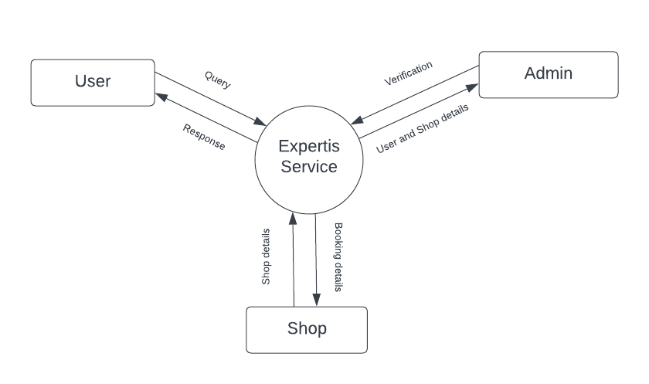

**Fig.No: 3.1 - System Architecture**

### 3.4.2 Data Flow Diagrams (DFDs – Level 0, Level 1, Level 2)

**Data flow diagram shows the flow of data through system. Data flow diagrams also called the data flow graphs. It views a system as a function that transforms the inputs into desired outputs. It aims to capture the transformation that taken place within a system to the input data so that eventually the out data is produced.**

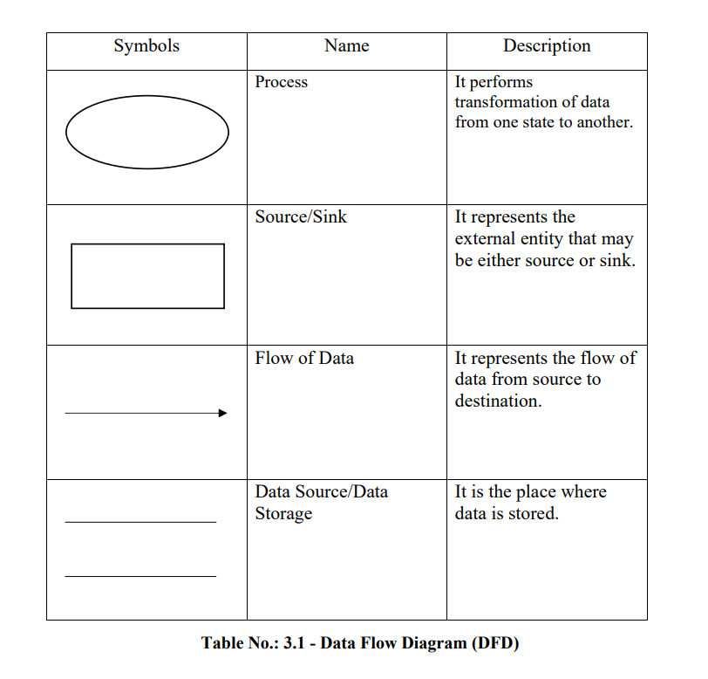

**Fig.No: 3.2 – Data flow Diagram**

#### **3.4.2.1 Level 1 (Admin)**

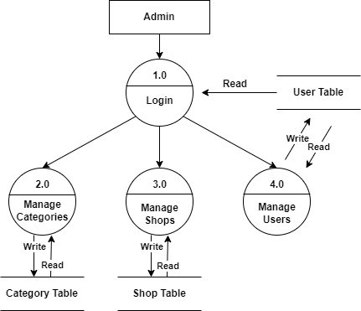

**Fig.No: 3.3 – Admin DFD - level 1**

#### **3.4.2.1.1 Level 2 (Admin)**

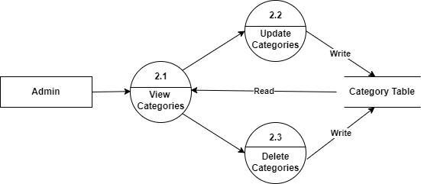

**Fig.No: 3.4 – Admin manage category DFD**

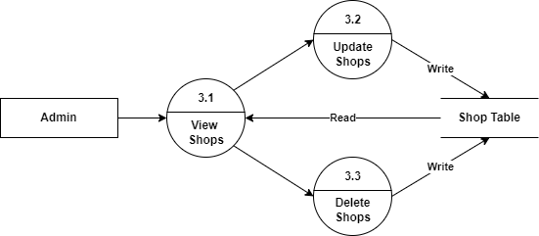

**Fig.No: 3.5 – Admin manage shop DFD**

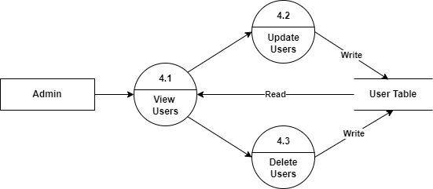

**Fig.No: 3.6 – Admin manage users category DFD**

#### **3.4.2.2 Level 1 (Shop)**

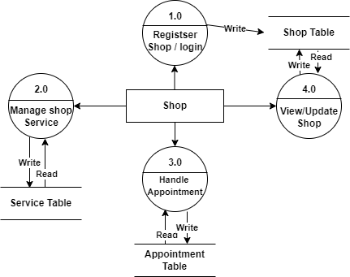

**Fig.No: 3.7 – Shop DFD Level 1**

#### **3.4.2.2.1 Level 2 (Shop)**

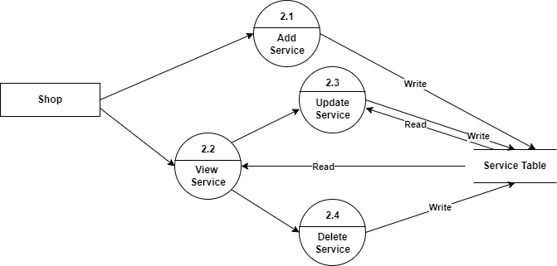

**Fig.No: 3.8 – Shop Manage service DFD**

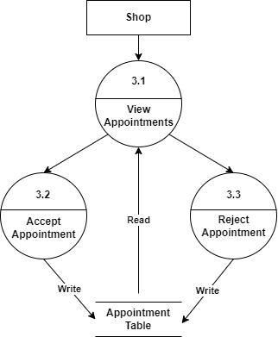

**Fig.No: 3.9 – Shop Manage appointments DFD**

#### **3.4.2.3 Level 1 (User)**

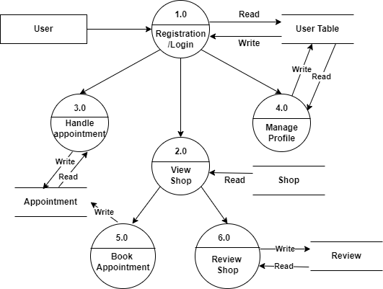

**Fig.No: 3.10 – User DFD Level 1**

#### **3.4.2.3.1 Level 2 (User)**

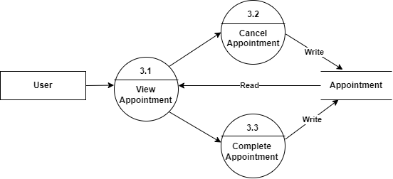

**Fig.No: 3.10 – User handle appointment DFD**

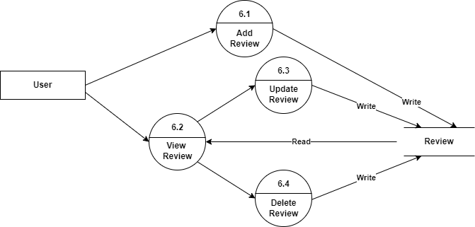

**Fig.No: 3.11 – User give review DFD**

## 3.5 Description of components

### 3.5.1 Registration/log in:

This module allows the user who is new to register to the software. & login who allow already registered and also can reset their password if they forget

### 3.5.2 Admin Module:

This is the master who can add categories. He has complete control over this application and can edit or can delete the details of the user and the shop.

### 3.5.3 Shop Module:

Shop owners can register here and add their services with the price and time so that they can get the appointment request from the customers who were registered here as a user.

### 3.5.4 User Module:

The user module is the main component of the application. In which users can see all the top-rated and nearby shops and also they can book an appointment and make a review

# **4. Database Design (or Data structure)**

## 4.1 Introduction (brief write-up about Database design)

**Introduction**

Database is a collection of related data. Relational database stores data in a table or relations. The data stored in a relation are arranged in records. Each record consists of a set of attributes. Fields can be referred to as characteristics of records. This document describes the table that is used to design software, its attributes, data type, constraints, and relationship among those tables.

Through MongoDB Compass, this application uses MongoDB as a database design platform. Database System based on NoSQL.

**Definition for NoSQL(Not only SQL):**

NoSQL databases (Not only SQL) are non-tabular databases and store data differently than relational tables. NoSQL databases come in a variety of types based on their data model. The main types are document, key-value, wide-column, and graph. They provide flexible schemas and scale easily with large amounts of data and high user loads.

**Definition for MongoDB:**

MongoDB is a document database with the scalability and flexibility you want with the querying and indexing you need.

**Definition for MongoDB Compass:**

MongoDB Compass is a powerful GUI for querying, aggregating, and analyzing your MongoDB data in a visual environment.

**The design process consists of the following steps in MongoDB:**

* + Design your schema according to user requirements.
  + Combine objects into one document if you will use them together. Otherwise, separate them (but make sure there should not be a need for joins).
  + Duplicate the data (but limited) because disk space is cheap as compared to compute time.
  + Do joins while writing, not on reading.
  + Optimize your schema for the most frequent use cases.
  + Do complex aggregation in the schema.

## 4.2 Purpose and scope

**4.2.1 Purpose**

* **Avoid Redundantly**

The table in the database should be constructed following standards and with utmost dedication. It should have different fields and minimize redundant data. The table should always have a unique id.

* **Faultless Information**

The database should follow the standards and conventions and provide meaningful information useful to the organization.

* **Data Integrity**

Integrity assists in guaranteeing that the values are valid and faultless. Data Integrity is set to tables, relationships, etc.

* **Modify**

The database developed should be worked upon with the conventions and standards so that it can be easily modified whenever the need arises.

**4.2.2 Scope**

* Normalization of Database.
* Establishing the Relation between the tables.
* Accessing the data from multiple tables.

## 4.3 Database Identification

The identification of a database by a unique name given to the various database objects. The identifier is the name of the database object. The following are the various database objects.

· Tables

· Columns

· Views

· Sequences

· Indexes

· Stored Procedures

## 4.4 Schema information

Schema design for NoSQL usually involves designing Keys, Indexes & Denormalization of attributes, all of which are inter-dependent on the application queries & workflows. The query requirements elicitation should include the following specifications at a minimum: Business Data Entities.

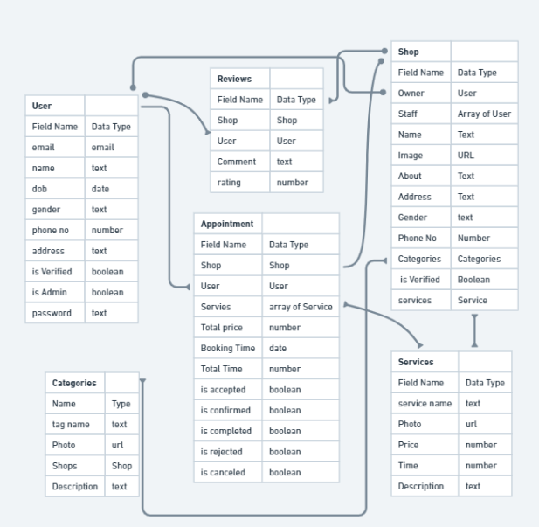

**Fig.No: 4.1 – Database Schema**

## 4.5 Table Definition

Instead of tables, a MongoDB database stores its data in collections. A collection holds one or more BSON documents. Documents are analogous to records or rows in a relational database table. Each document has one or more fields; fields are similar to the columns in a relational database table

### 4.5.1 User table

|  |  |  |  |  |
| --- | --- | --- | --- | --- |
| **NO** | **Column Name** | **Data Type** | **Description** | **Required** |
| 4.5.1.1 | Email | String | Email id of the user as primary key | True |
| 4.5.1.2 | Name | String | Name of the user | True |
| 4.5.1.3 | Phone | Number | Phone number of the user | True |
| 4.5.1.4 | DOB | Date | Date of Birth of user | False |
| 4.5.1.5 | Gender | String | Gender of the user | False |
| 4.5.1.6 | Roles | Role Schema | Roles of the user | True |
| 4.5.1.7 | PinCode | Number | Pin code of the user address | False |
| 4.5.1.8 | UserPic | String | Location path of the user pic | False |
| 4.5.1.9 | Password | String | Encrypted password | True |
| 4.5.1.10 | Verified | Boolean | To check is user email verified by default false | False |
| 4.5.1.11 | FavoriteShop | List | It contains the list of favorite shop id | False |
| 4.5.1.12 | Shop | List | It contains the shop id of the user | False |
| 4.5.1.13 | Appointment | List | It contains the appointment id of the user | False |

#### **4.5.1.6.1 Roles Schema**

|  |  |  |  |  |
| --- | --- | --- | --- | --- |
| **NO** | **Column Name** | **Data Type** | **Description** | **Required** |
| 4.5.1.6.1.1 | IsAdmin | Boolean | To check he is admin by default false | False |
| 4.5.1.6.1.2 | IsUser | Boolean | To check he is a user by default true | False |
| 4.5.1.6.1.3 | IsShopOwner | Boolean | To check he is shop owner by default false | False |
| 4.5.1.6.1.4 | IsShopMember | Boolean | To check he is shop member by default false | False |

### 4.5.2 Category table

|  |  |  |  |  |
| --- | --- | --- | --- | --- |
| **No** | **Column Name** | **Data Type** | **Description** | **Required** |
| 4.5.2.1 | CategoryName | String | Name of the category | True |
| 4.5.2.2 | CategoryPic | String | Picture location path of the category | False |
| 4.5.2.3 | Description | String | Description of the category | True |
| 4.5.2.4 | Shops | List | Shop id who were added this category to their shops | False |
| 4.5.2.5 | Services | List | Service id who were added this category to their services | False |

### 4.5.3 Shop Table

|  |  |  |  |  |
| --- | --- | --- | --- | --- |
| **No** | **Column Name** | **Data Type** | **Description** | **Required** |
| 4.5.3.1 | Owner | String | User id of the shop owner | True |
| 4.5.3.2 | ShopId | String | It should be a unique as a primary key | True |
| 4.5.3.3 | ShopName | String | Name of the shop | True |
| 4.5.3.4 | ShopLogo | String | Picture location path of the shop logo | False |
| 4.5.3.5 | About | String | It is the description about the shop | False |
| 4.5.3.6 | Gender | String | Type of service provided to the gender | True |
| 4.5.3.7 | Contact | Contact Schema | It is table contains shop contacts | True |
| 4.5.3.8 | Likes | List | It contains user id who were added this shop to favorite list | False |
| 4.5.3.9 | Category | List | It contains the category id | False |
| 4.5.3.10 | Members | List | It contains the user id of the shop members | False |
| 4.5.3.11 | Services | List | It contains the services id of the shop | False |
| 4.5.3.12 | Appointments | List | It contains the appointment id of the shop | False |
| 4.5.3.13 | Rating | Double | Average rating of the shop | False |
| 4.5.3.14 | Reviews | List | It contains the review id of the shop | False |
| 4.5.3.15 | IsActive | Boolean | Is the shop active from long time | True |
| 4.5.3.16 | IsOpen | Boolean | Is shop open or not | True |

### 4.5.3.7.1 Contact Schema.

|  |  |  |  |  |
| --- | --- | --- | --- | --- |
| **No** | **Column Name** | **Data Type** | **Description** | **Required** |
| 4.5.3.7.1.1 | Email | String | Email id of the shop owner | True |
| 4.5.3.7.1.2 | Website | String | URL of the shop website | False |
| 4.5.3.7.1.3 | Phone | Number | Phone number of the shop | True |
| 4.5.3.7.1.4 | Address | String | Address of the shop | True |
| 4.5.3.7.1.5 | PinCode | Number | Pin code of the shop address | True |
| 4.5.3.7.1.6 | Whatsapp | String | Whatsapp number of the shop | False |
| 4.5.3.7.1.7 | Instagram | String | Instagram profile URL of the shop | False |
| 4.5.3.7.1.8 | Twitter | String | Twitter profile link of the shop | False |

### 4.5.4 Service table

|  |  |  |  |  |
| --- | --- | --- | --- | --- |
| **No** | **Column Name** | **Data Type** | **Description** | **Required** |
| 4.5.4.1 | ServiceName | String | Name of the service | True |
| 4.5.4.2 | Price | Number | Price of the service | False |
| 4.5.4.3 | Photo | String | Picture location path of the service | False |
| 4.5.4.4 | Time | String | Time duration require for the service | True |
| 4.5.4..5 | Description | String | Description about the service | True |
| 4.5.4.6 | Category | List | It contains the category id of the service | True |

### 4.5.5 Appointment table

|  |  |  |  |  |
| --- | --- | --- | --- | --- |
| **No** | **Column Name** | **Data Type** | **Description** | **Required** |
| 4.5.5.1 | ShopId | String | Object id of the shop | True |
| 4.5.5.2 | MemberId | String | Id of the shop member | True |
| 4.5.5.3 | UserId | String | Id of the user | True |
| 4.5.5.4 | TotalPrice | Number | Total price of the services | True |
| 4.5.5.5 | TotalTime | Number | Total time required to complete the service | True |
| 4.5.5.6 | Services | List | Id of the services which is required | True |
| 4.5.5.7 | StartTime | Date | Start time of the service | True |
| 4.5.5.8 | EndTime | Date | End time of the service | True |
| 4.5.5.9 | AppointmentStatus | String | A status of the appointment by default pending | true |

### 4.5.6 Review table

|  |  |  |  |  |
| --- | --- | --- | --- | --- |
| **No** | **Column Name** | **Data Type** | **Description** | **Required** |
| 4.5.6.1 | From | String | Id of the user who reviewed | True |
| 4.5.6.2 | To | String | Id of the shop | True |
| 4.5.6.3 | Model_Type | String | It contains type of review (shop or Service) | True |
| 4.5.6.4 | Photo | String | Location path of the photo | True |
| 4.5.6.5 | Comment | String | Comment about the review | False |
| 4.5.6.6 | Title | String | Title about the review | True |
| 4.5.6.7 | Rating | String | Rating about the service or shop | False |

## 4.6 Physical design

The physical design is where you translate schemas into actual database structures

* Entity to collections
* Objects to fields
* ObjectID (Unique)

## 4.7 Data Dictionary

A data dictionary is a file or a set of files that includes a database’s metadata. The data dictionary holds records about other objects in the database, such as data ownership, data relationship to other objects, and other data.

The data dictionary, in general, includes information about the following:

· Name of the data item

· Aliases

· Description/Purpose

· Related data items

· Range of values

· Data structure definition

## 4.8. ER diagram

ER- modelling is a data modelling method used in software engineering to produce a conceptual data model of an information system. Diagrams created using this ER-modelling method are called Entity-Relationship Diagrams or ER-diagrams or ERDs.

|  |  |
| --- | --- |
| Symbols | Conversion |
|  | Entity |
|  | Weak entity |
|  | Relation |
|  | Identity Relation |
|  | Attribute |
|  | Derived Attribute |
| R  E  E  1  N    R | Cardinality ratio 1: N from E1:E2 in R. |

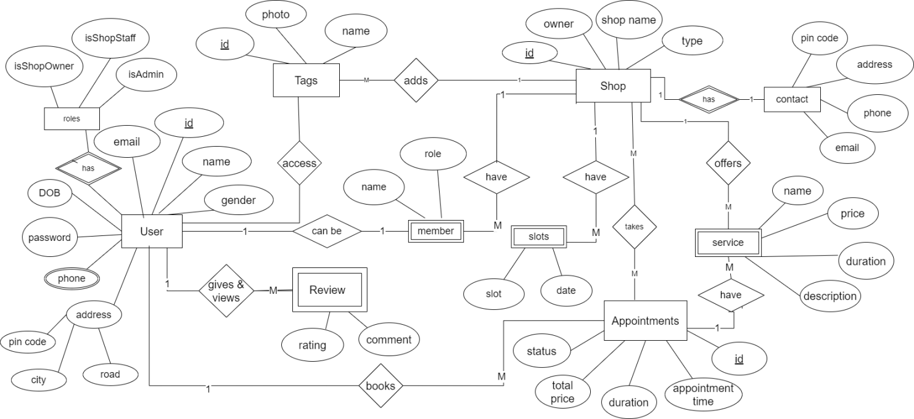

## 4.9 Database Administration

### 4.9.1 System information

A database is an organized collection of structured information, or data typically stored electronically in a computer system. A database is usually controlled by a database management system (DBMS).

In our case “MongoDB” is DBMS.

### 4.9.2 DBMS configuration

To configure DBMS through MongoDB compass is:

* Install Node JS
* Install the MongoDB Node JS Drive
* Create a MongoDB Atlas cluster and load the sample data.
* Next, you'll need a MongoDB database.
* Get your cluster's connection info.
* Import MongoClient.
* Create main function.
* List the databases in cluster.
* Save Your File.

### 4.9.3 Support software required

**“**MongoDB compass”

**Software Requirements:**

The following operating system are officially supported:

* Windows 7 (64-bit, Professional level or higher)
* Mac OS X 10.6.1+
* Ubuntu 9.10 (64bit)
* Ubuntu 8.04 (32bit/64bit)

### 4.9.4 Storage requirements

The minimum hardware requirements are:

* Hard Disk:1 GB Required 500GB(Recommended)
* CPU: Intel Core or Xeon 3GHz (or Dual Core 2GHz) or equal AMD CPU
* Cores: Single (Dual/Quad Core is recommended)
* RAM: 4 GB (6 GB recommended)
* Graphic Accelerators: NVidia or ATI with support of OpenGL 1.5 or higher
* Display Resolution: 1280×1024 is recommended, 1024×768 is minimum.

### 4.9.5 Backup and recovery

**To back up our database**

Step 1: Create Direct Backups Using Mongodump

You can run the **Mongodump**command using the below syntax from the system command line as follows:

Code:

mongodump <options> <connection-string>

Step 2: Backup a Remote MongoDB Instance

As mentioned in Step 1, you can customize a host and a port number with the **–uri** connection string using the following syntax:

Code:

mongodump --uri="mongodb://<host URL/IP>:<Port>" [additional options]

Step 3: Backup a Secure MongoDB Instance

MongoDB’s Mongodump command allows you to implement access control mechanisms for your data backups. This will require you to provide a Username, Password, and specific Authentication options in the following syntax:

Code:

mongodump --authenticationDatabase=<Database> -u=<Username> -p=<Password> [additional options]

Step 4: Select Databases & Collections

In Step 3 you learned how to back up a remote database using Mongodump. This step involves the**–db**and **–collection** options which indicate a database and a collection that requires backing up. You can run the –db option in a standalone manner, but to execute a collection, you have to specify a database. Moreover, you can remove a collection from the backup process, by using the **–excludeCollection** option.

To select a particular database, use the following command:

Code:

mongodump --db=<Backup Target - Database> [additional options]

Step 5: Change the Backup Directory

You can leverage the**–out** option to specify the backup folder’s location in the following way:

Code:

mongodump --out=<Directory Location> [additional options]

Step 6: Create an Archive File

The Mongodump utility provides you with a method to create an archive file. You can use the **–archive**option can for specifying the file to be archived. In case no specification is given, the output will be in the standard form (stdout).

Keep in mind that you can’t use the **–archive**option along with the **–out**option.

Code:

mongodump --archive=<file> [additional options]

Step 7: Compress the MongoDB Backup

Now, since you know how to backup data using Mongodump, it’s time to understand the process of compressing these files. You can use the **–gzip** option to compress the JSON and BSON files individually using the following command:

Code:

mongodump --gzip [additional options]

Step 8: Restore Database

Apart from excellent backups, MongoDB also provides you the facility to restore your data. The **Mongorestore** command will seamlessly load data from the Mongodumb backups and restore your Mongo database. The mongorestore command, however, cannot overwrite documents present in the database if the id for the document already exists. Otherwise, Mongorestore will generate a new database or will add data to the existing one.

The Mongorestore command requires you to mention the path to your dump directory and the syntax is follows:

Code:

mongorestore dump/

**To restore database**

In order to restore data into a remote MongoDB instance, you need to establish the connection. The connection to a database can be specified using either:

* The URI connection string
* The host option
* The host and port option

1. Connecting using the URI option:

Code:

mongorestore [additional options] --uri="mongodb://<host URL/IP>:<Port>" [restore directory/file]

1. Connecting using the host option:

Code:

mongorestore [additional options] --host="<host URL/IP>:<Port>"  [restore directory/file]

1. Connecting using host and port options:

Code:

mongorestore [additional options] --host="<host URL/IP>" --port=<Port>  [restore directory/file]

# **5. Detailed Design (Logic design of modules)**

## 5.1 Introduction (brief write-up about Database design)

During detailed design, the internal logic of each module specified in system design is decided. During this phase, further details of the modules are decided. The design of each of the modules is usually specified in a high-level description language which is independent of the language in which software eventually be implemented.

## 5.2 Structure of the software package (structure chart)

**Structure chart:**

A structure chart is a top-down modular design, consisting of squares representing different models in a system and lines. The structure chart shows how the program has been partitioned into manageable modules hierarchy and organization of those modules and communicational interface.

|  |  |  |
| --- | --- | --- |
| **Symbol** | **Name** | **Process** |
|  | Data flow | Show the direction flow of data. |
|  | Control flow | Shows the direction of flow control. |
|  | Processing | Shows manipulation calculation and processing. |
|  | Module Invocation | It represents a subordinate module being invoked by a superior ordinate module. |
| A  B  C  Main | Condition invocation | It indicates the invocation of subordinates.  Modules depend on the evaluation of a condition. |
| Main  A  B | Iteration | It represents the iteration |

**Fig No: 5.1 – Structure chart**

### 5.2.1 Admin

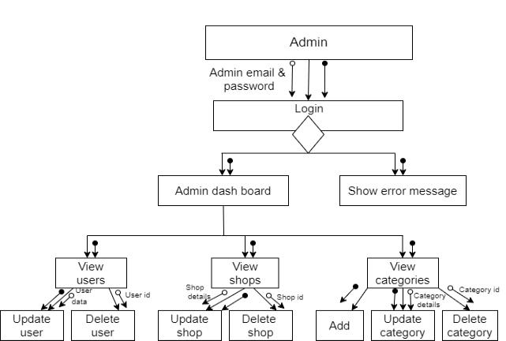

**Fig No: 5.2 – Admin structure chart**

### 5.2.2 Shop

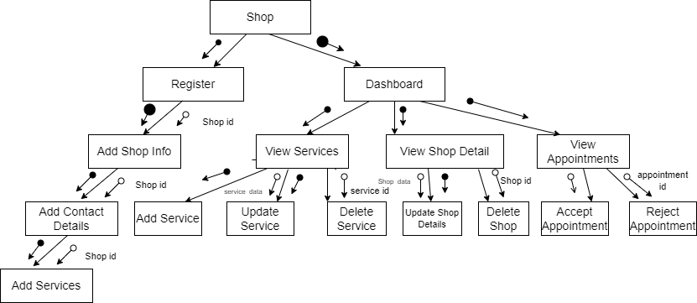

**Fig No: 5.3 – Shop structure chart**

### 5.2.2 User

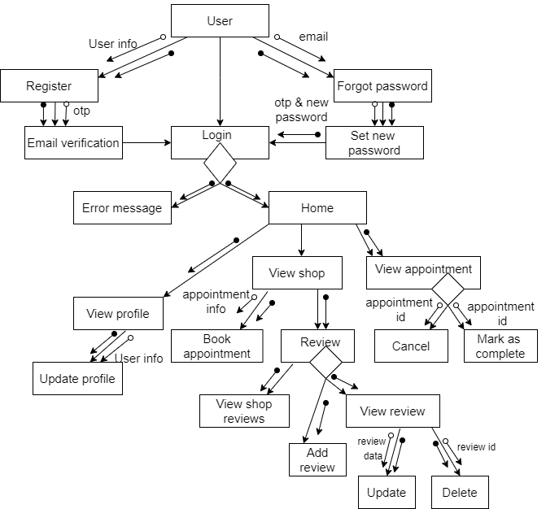

**Fig No: 5.2 – User structure chart**

## 5.3 Modular decomposition of the System

### 5.3.1 User Module

#### **5.3.1.1 Signup/Register**

#### **5.3.1.1.1 Inputs**

Email, Name, Phone, Password

#### **5.3.1.1.2 Procedural details**

Validate the input data and user information is saved in database.

#### **5.3.1.1.3 File I/O interfaces**

Saving the data in User table

#### **5.3.1.1.4. Outputs**

Message displayed. User registered successfully on valid data otherwise error messages.

#### **5.3.1.1.5. Implementation aspects**

from the frontend data is taken and request sent to API backend. Returned response will be showed.

#### **5.3.1.2 Login**

#### **5.3.1.2.1 Inputs**

Email, Password

#### **5.3.1.2.2 Procedural details**

* Check is user exist or not
* if exist check the password
* and then login the user
* send the response

#### **5.3.1.2.3 File I/O interfaces**

Not applicable

#### **5.3.1.2.4. Outputs**

Message displayed. User Registered successfully on valid data otherwise error messages

#### **5.3.1.2.5. Implementation aspects**

from the frontend data is taken and request sent to API backend. returned response will be showed.

#### **5.3.1.3 Forget Password**

#### **5.3.1.3.1 Inputs**

Email, OTP, new password

#### **5.3.1.3.2 Procedural details**

* send OTP to the email sent by the user
* verify OTP entered by the user
* set the new password for the user

#### **5.3.1.3.3 File I/O interfaces**

Saving the data in User table

#### **5.3.1.3.4 Outputs**

Message displayed. User Password reset successfully on valid data otherwise error messages

#### **5.3.1.4 View Shops**

#### **5.3.1.4.1 Inputs**

pin code (optional) , address (optional), gender (optional).

#### **5.3.1.4.2 Procedural details**

retrieve the shops based on rating and or any parameters given.

#### **5.3.1.4.3 File I/O interfaces**

Retrieve the data from Shops Table

#### **5.3.1.4.4. Outputs**

All the shops are listed so user can select any shops

#### **5.3.1.4.4. Implementation aspects**

not applicable

#### **5.3.1.5 Book Appointment**

#### **5.3.1.5.1 Inputs**

User, services, shop, member, date

#### **5.3.1.5.2 Procedural details**

Book the appointment to the user based on the given user

#### **5.3.1.5.3 File I/O interfaces**

Store the necessary data in User, Shop and Appointments table.

#### **5.3.1.5.4 Outputs**

Appointment booked successfully on booked otherwise error messages

#### **5.3.1.5.5 Implementation aspects**

Show the only available slots to book

#### **5.3.1.6 Give reviews**

#### **5.3.1.6.1 Inputs**

User, shop, rating, comment

#### **5.3.1.6.2 Procedural details**

If the user has not already given review then save the review other allow them to update the review.

#### **5.3.1.6.3 File I/O interfaces**

Store the necessary data in the Review table.

#### **5.3.1.6.4 Outputs**

Review saved successfully on success otherwise error messages.

#### **5.3.1.6.5 Implementation aspects**

Not applicable

### 5.3.2 Admin Module

#### **5.3.2.1 View Categories**

#### **5.3.2.1.1 Inputs**

not required

#### **5.3.2.1.2 Procedural details**

List all the categories in the app

#### **5.3.2.1.3 File I/O interfaces**

Retrieving the data in Category table

#### **5.3.2.1.4 Outputs**

List of categories

#### **5.3.2.1.5 Implementation aspects**

not applicable

#### **5.3.2.2 Add or Update Categories**

#### **5.3.2.2.1 Inputs**

Category name, category image, description

#### **5.3.2.2.2 Procedural details**

Add a new category or update the existing one

#### **5.3.2.2.3 File I/O interfaces**

Add or update the data in Category table

#### **5.3.2.2.4 Outputs**

Message displayed. category added or updated successfully on valid data otherwise error messages

#### **5.3.2.3 View all shops**

#### **5.3.2.3.1 Inputs**

Not required

#### **5.3.2.3.2 Procedural details**

List all the shops in the app

#### **5.3.2.3.3 File I/O interfaces**

Retrieving the data in Shop table

#### **5.3.2.3.4 Outputs**

List of shops

#### **5.3.2.3.5 Implementation aspects**

not applicable

#### **5.3.2.4 Add or update shop information**

#### **5.3.2.4.1 Inputs**

shop name, description, shop photo, adding categories

#### **5.3.2.4.2 Procedural details**

save shop information in corresponding shop

#### **5.3.2.4.3 File I/O interfaces**

Update User table

#### **5.3.2.4.4 Outputs**

Message displayed. Shop information Update successfully on valid data otherwise error messages

#### **5.3.2.4.5 Implementation aspects**

from the frontend data is taken and request sent to API backend. returned response will be showed.

#### **5.3.2.5 Add or Update Shop Contact details**

#### **5.3.2.5.1 Inputs**

Phone, address, pin code, social media links, and website

#### **5.3.2.5.2 Procedural details**

Find the shop an update the contact details

#### **5.3.2.5.3 File I/O interfaces**

Updating the data in Shop table

#### **5.3.2.5.4 Outputs**

Message displayed. shop updated successfully on valid data otherwise error messages

#### **5.3.2.6 View Users**

#### **5.3.2.6.1 Inputs**

not required

#### **5.3.2.6.2 Procedural details**

List all the users in the app

#### **5.3.2.6.3 File I/O interfaces**

Retrieving the data in User table

#### **5.3.2.6.4 Outputs**

List of users

#### **5.3.2.6.5 Implementation aspects**

Not applicable

#### **5.3.2.7 Add or Update Categories**

#### **5.3.2.7.1 Inputs**

user name, address, dob, profile pic, isAdmin, isShopOwner, isVerified, isShopMember

#### **5.3.2.7.2 Procedural details**

Update the existing user

#### **5.3.2.7.3 File I/O interfaces**

Add or update the data in User table

#### **5.3.2.7.4 Outputs**

Message displayed. user  updated successfully on valid data otherwise error messages

### 5.3.3 Shop Module

#### **5.3.3.1 Register**

##### **5.3.3.1.1 Inputs**

Email, shop Name, Phone

#### **5.3.3.1.2 Procedural details**

Check if the shop with the same name and phone already exists. otherwise register the shop

#### **5.3.3.1.3 File I/O interfaces**

Saving the data in Shop table

#### **5.3.3.1.4 Outputs**

Message displayed. Shop registered successfully on valid data otherwise error messages

#### **5.3.3.1.5 Implementation aspects**

from the frontend data is taken and request sent to API backend. returned response will be showed.

#### **5.3.3.2 Add or update shop information**

#### **5.3.3.2.1 Inputs**

shop name, description, shop photo, adding categories

#### **5.3.3.2**.2 Procedural details

save shop information in corresponding shop

#### **5.3.3.2.3 File I/O interfaces**

Update User table

#### **5.3.3.2.4 Outputs**

Message displayed. Shop information Update successfully on valid data otherwise error messages

#### **5.3.3.2.5 Implementation aspects**

from the frontend data is taken and request sent to API backend. returned response will be showed.

#### **5.3.3.3 Add or Update Shop Contact details**

#### **5.3.3.3.1 Inputs**

Phone, address, pin code, social media links and website

#### **5.3.3.3.2 Procedural details**

Find the shop an update the contact details

#### **5.3.3.3.3 File I/O interfaces**

Updating the data in Shop table

#### **5.3.3.3.4 Outputs**

Message displayed. Shop updated successfully on valid data otherwise error messages

#### **5.3.3.4 Add or Update Shop Services**

#### **5.3.3.4.1 Inputs**

service name, Price, Duration, service image, tags

#### **5.3.3.4.2 Procedural details**

Find the shop and add or update the services

#### **5.3.3.4.3 File I/O interfaces**

Updating the data in Shop table

#### **5.3.3.4.4 Outputs**

Message displayed. Service added or updated successfully on valid data otherwise error messages

#### **5.3.3.4 Accept or Reject Appointment**

#### **5.3.3.4.1 Inputs**

Appointment id

#### **5.3.3.4.2 Procedural details**

update appointment status

#### **5.3.3.4.3 File I/O interfaces**

Update the data from Appointment Table

#### **5.3.3.4.4 Outputs**

Success message is shown on completion

#### **5.3.3.4.5 Implementation aspects**

Not applicable

# **6. Program code listing**

## 6.1 Database connection

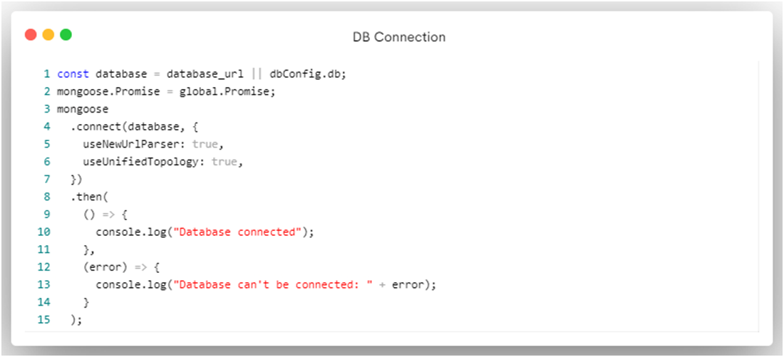

## 6.2. Authorization / Authentication

### 6.2.1 Register

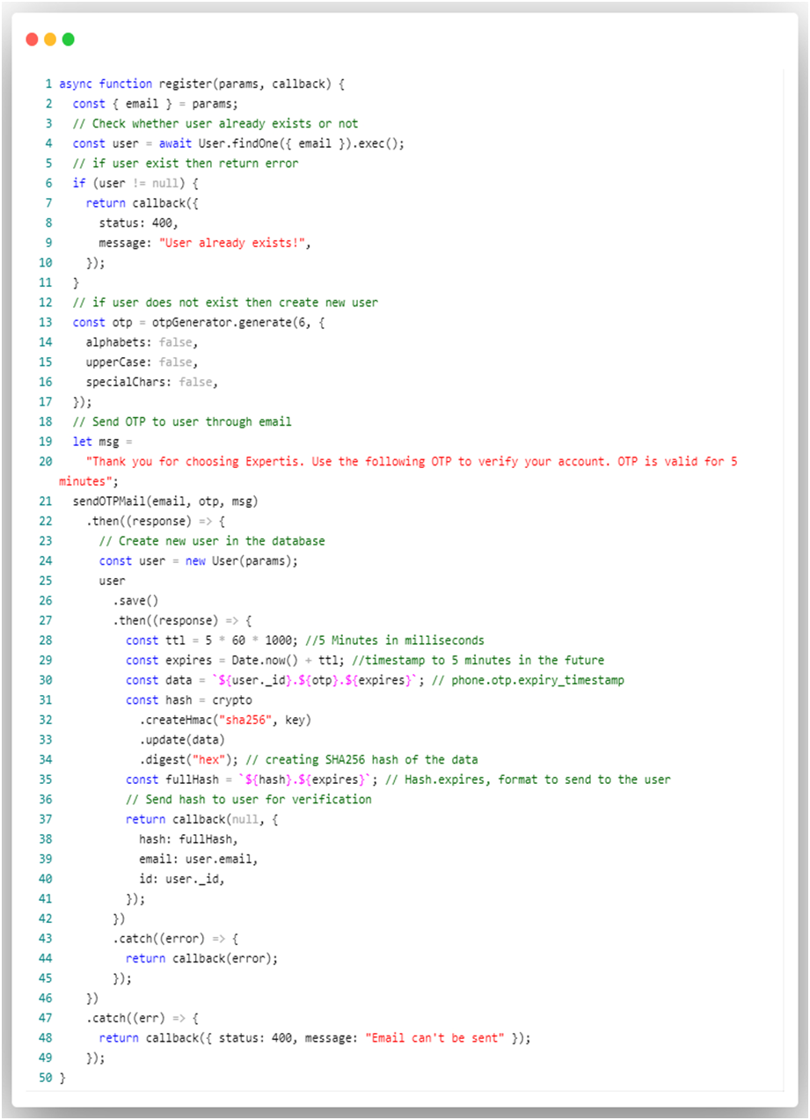

### 6.2.2 Verify OTP

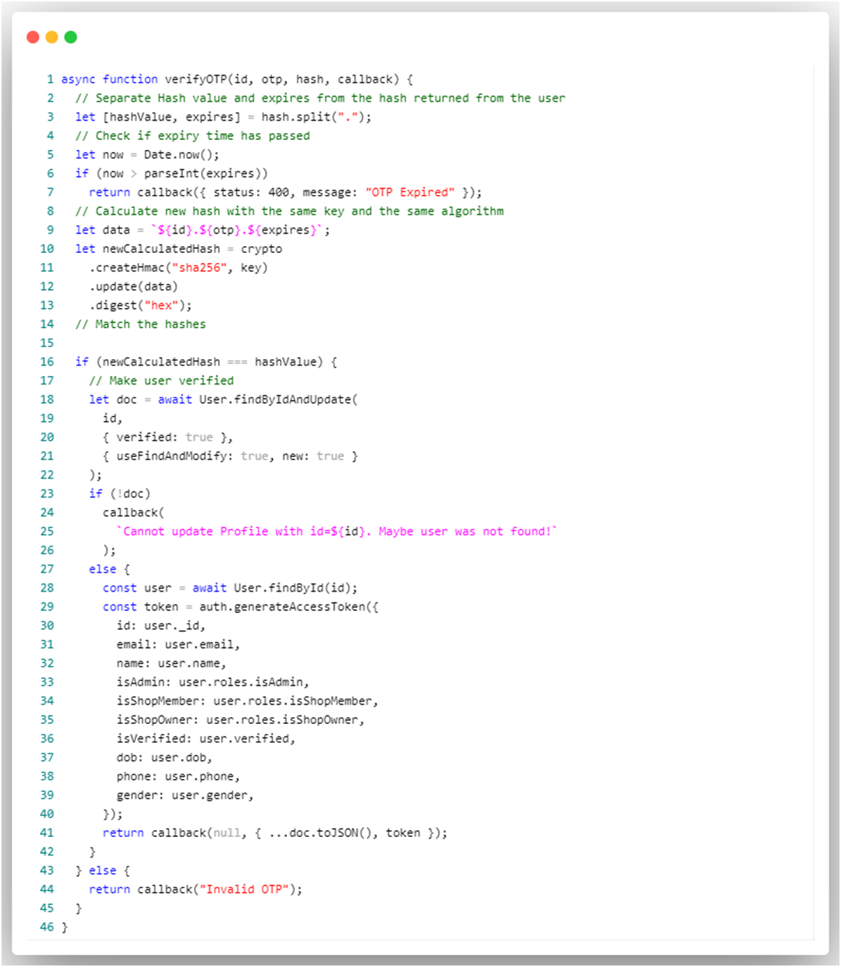

### 6.2.3 Login

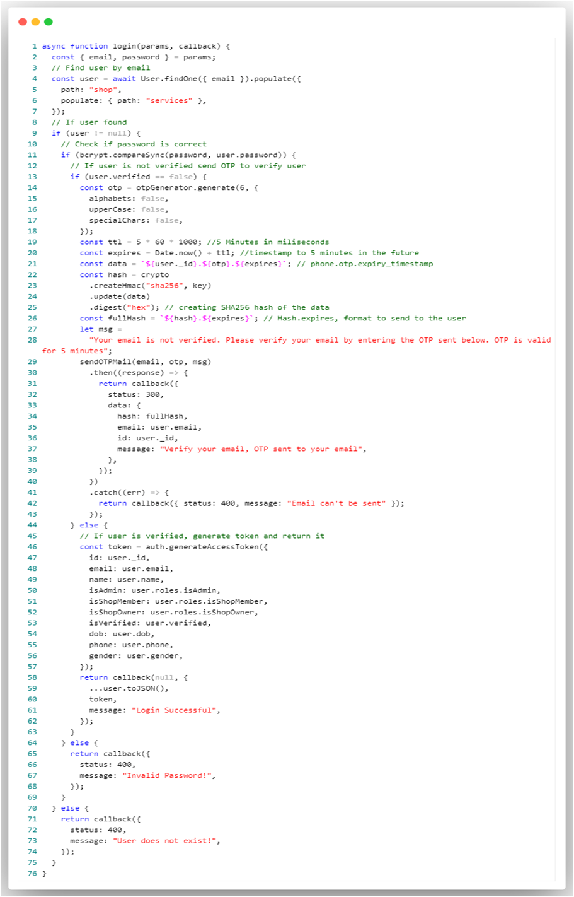

### 6.2.4 Forget Password

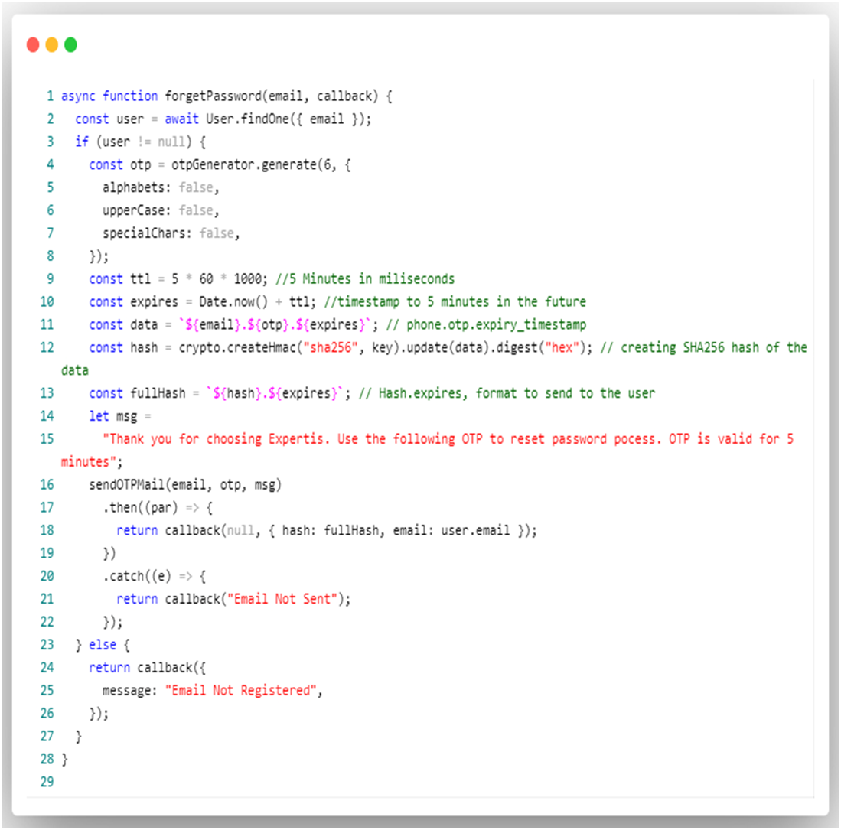

### 6.2.5 Set New Password

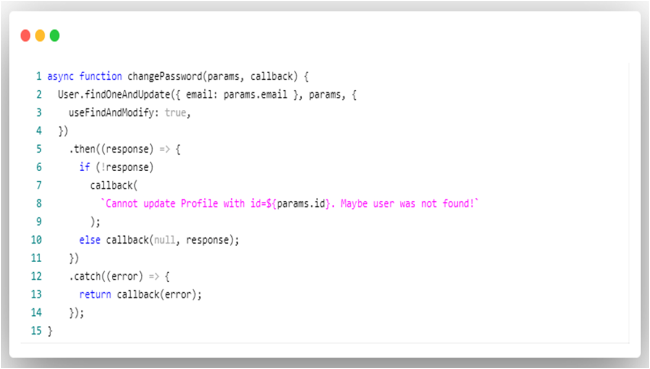

### 6.2.6 Updated Profile

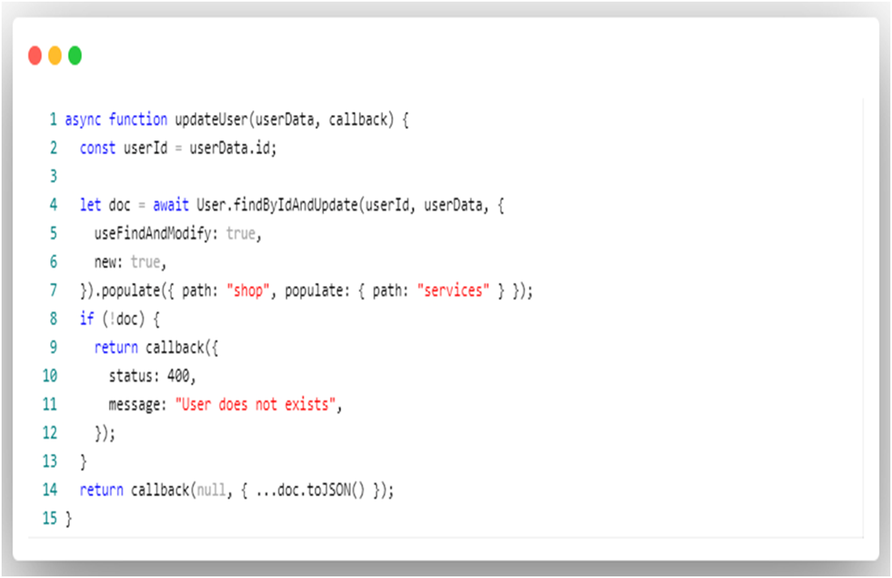

### 6.2.7 Delete User

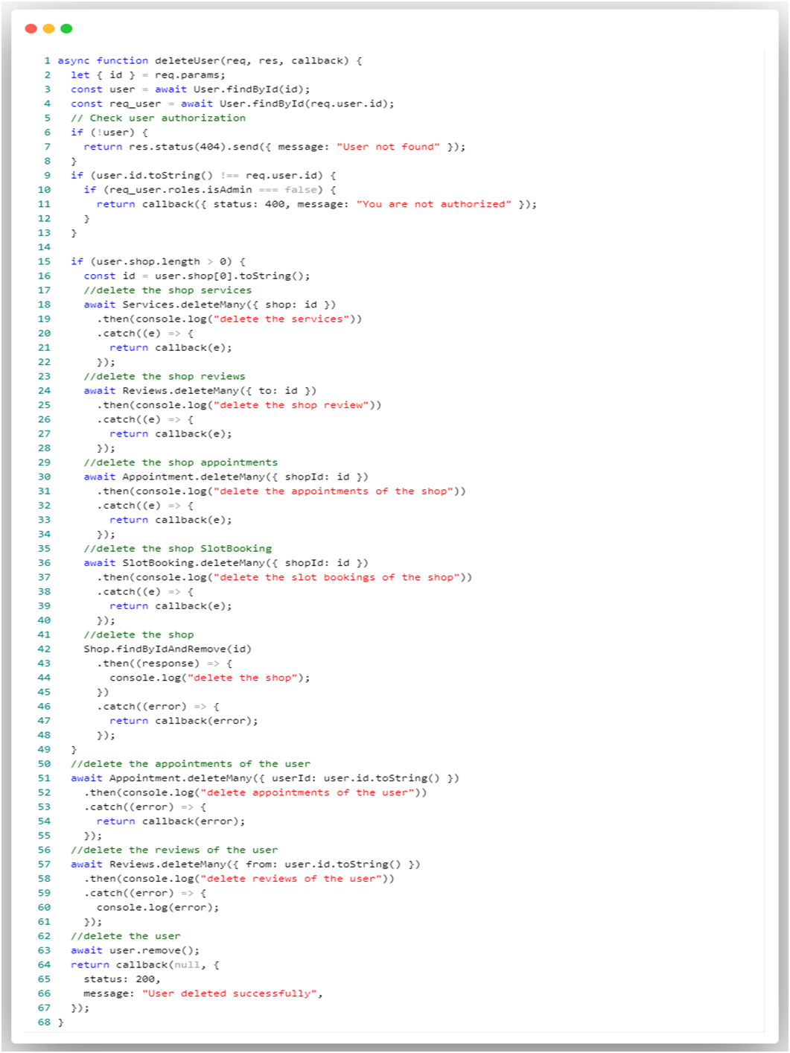

## 6.3 Data store / retrieval / update

### 6.3.1 Admin

#### **6.3.1.1 Categories**

**6.3.1.1.1 Create New Category**

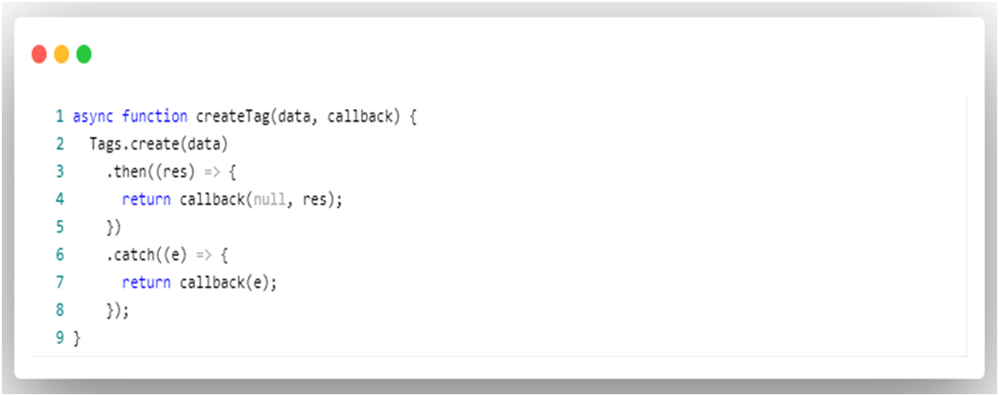

##### **6.3.1.1.2 Update Category**

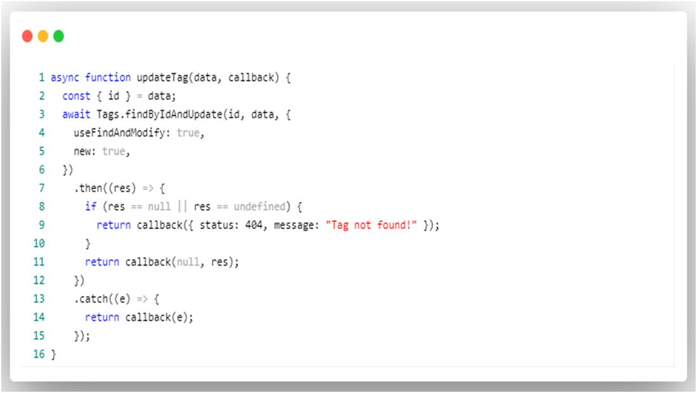

###### **6.3.1.1.3 Get All Categories**

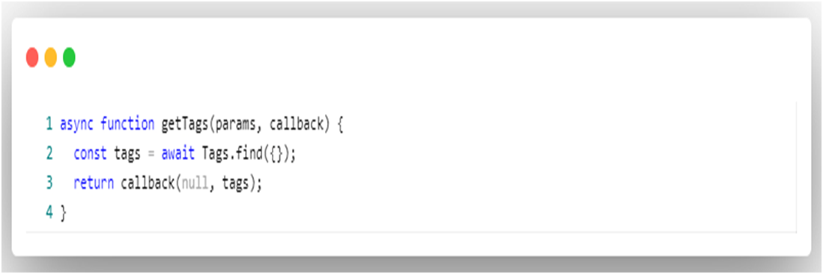

**6.3.1.1.3 Delete Category**

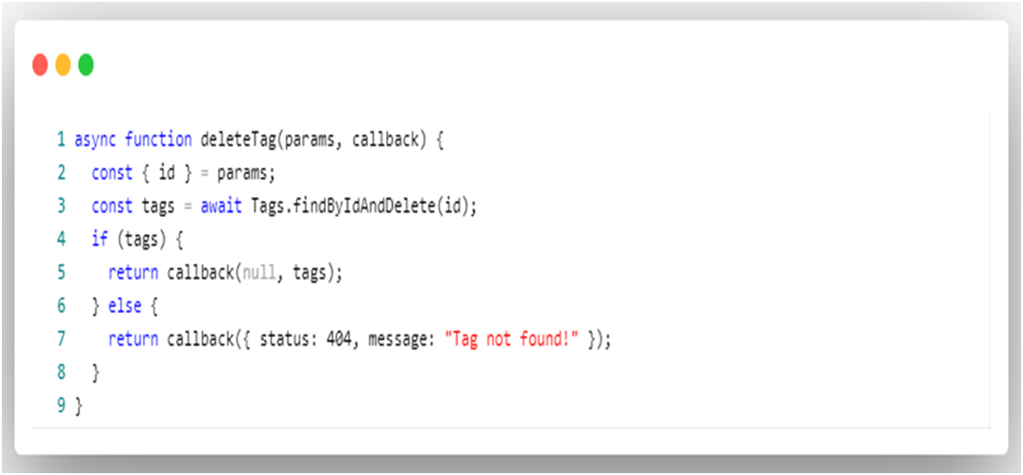

#### **6.3.1.2 Users**

**6.3.1.2.1 View all users**

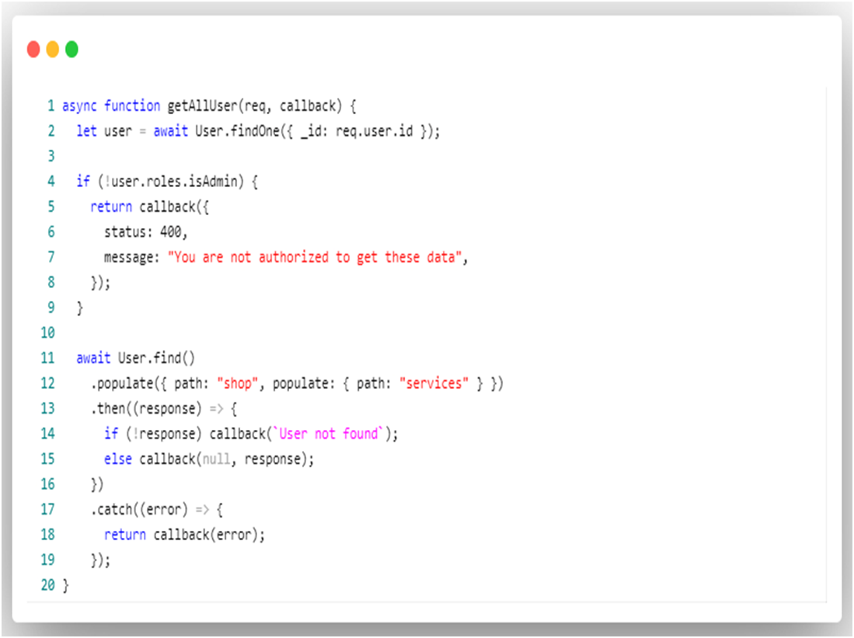

**Note**: Admin have all the below functionalities of shop and user

### 6.3.2 Shop

#### **6.3.2.1 Create Shop**

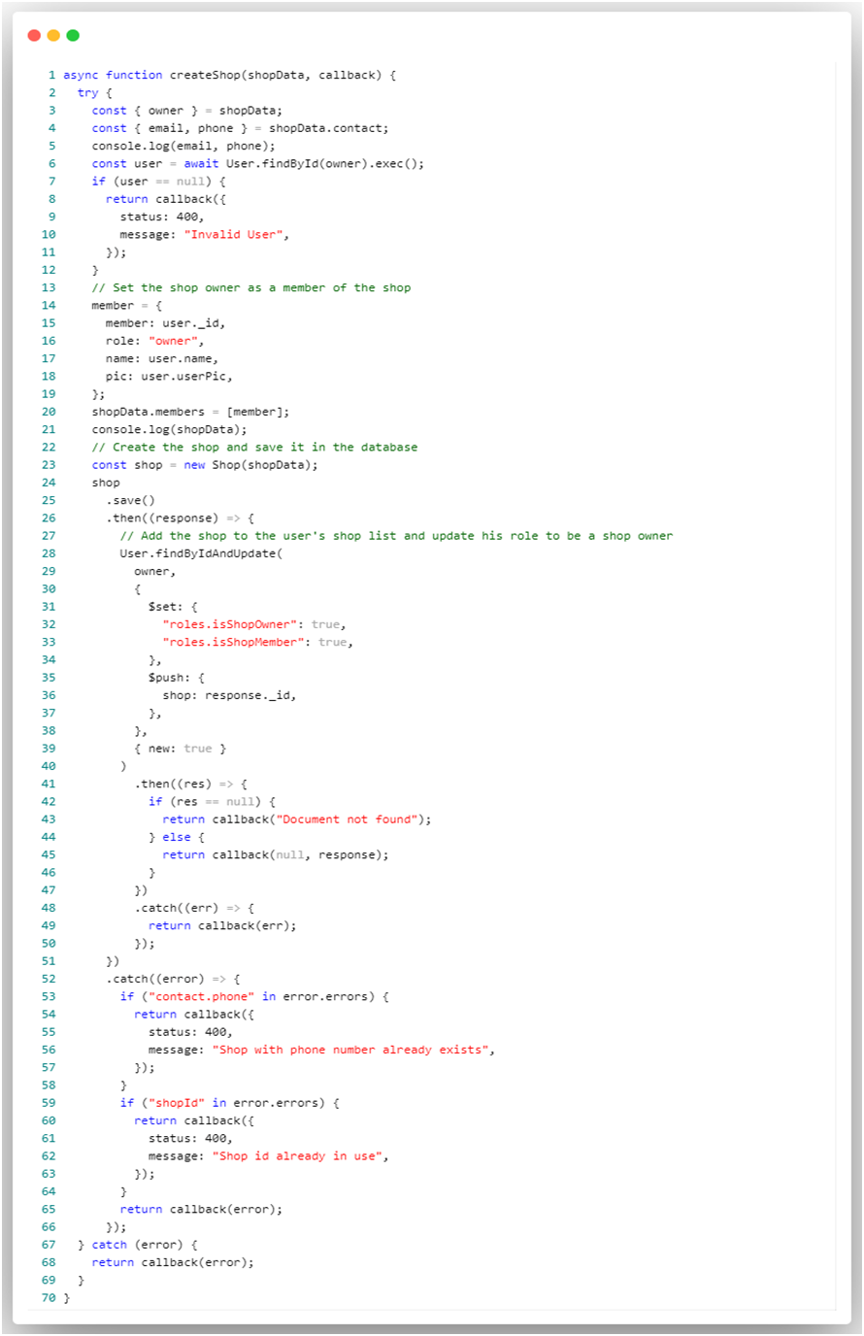

#### **6.3.2.2 Update Shop**

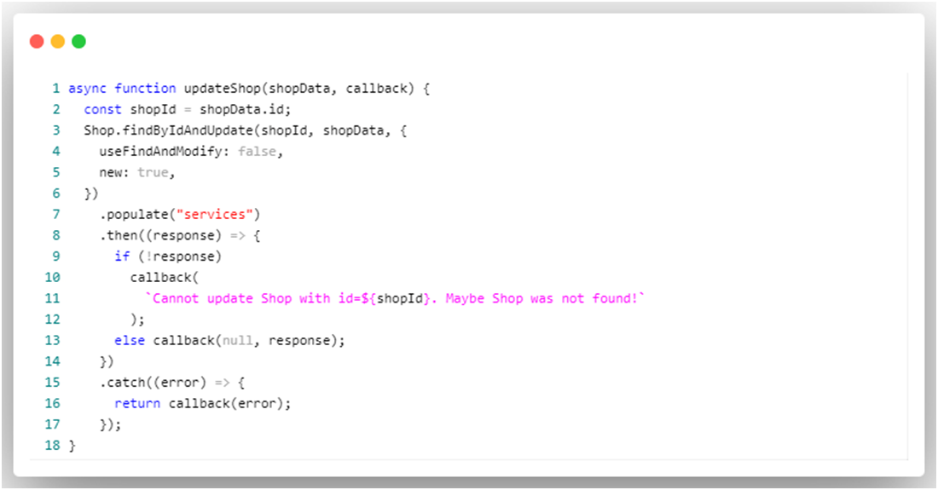

### 6.3.2.3 Services

#### **6.3.2.3.1 Add Service**

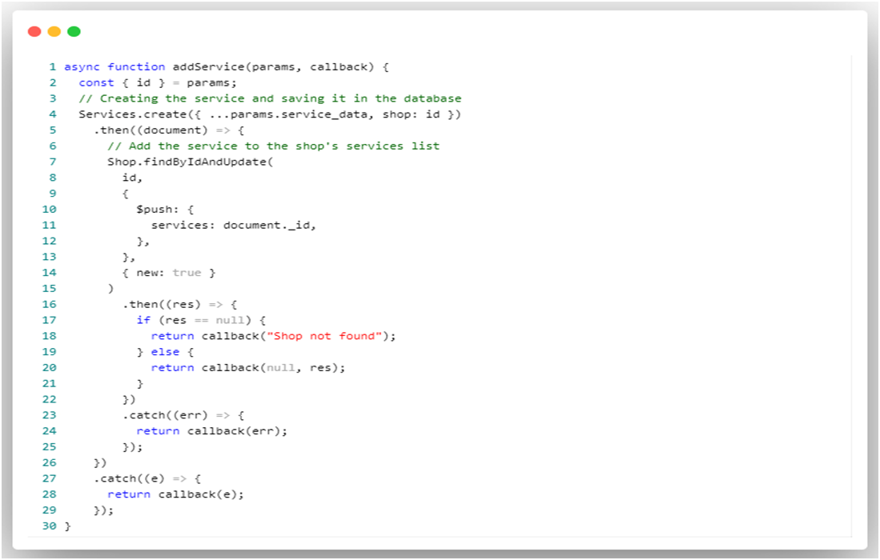

**6.3.2.3.2 Update Service**

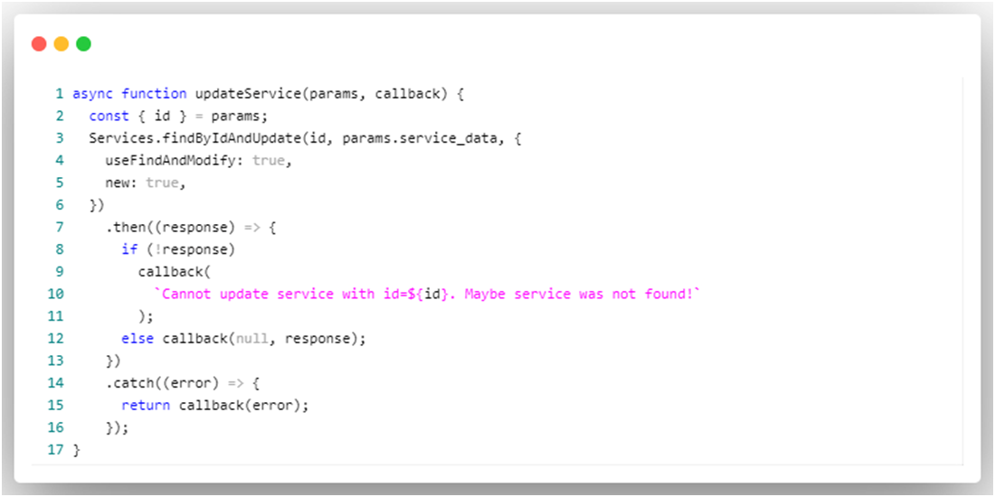

**6.3.2.3.3 Delete Service**

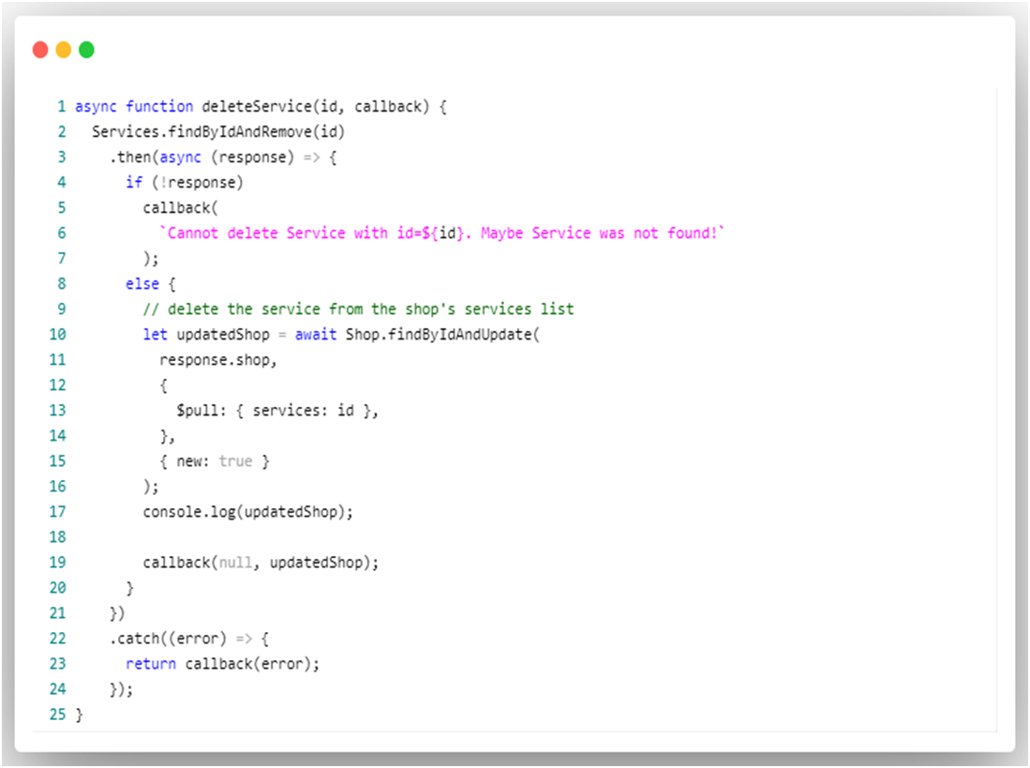

### 6.3.2.4 Appointments

**6.3.2.4.1 View Shop Appointments**

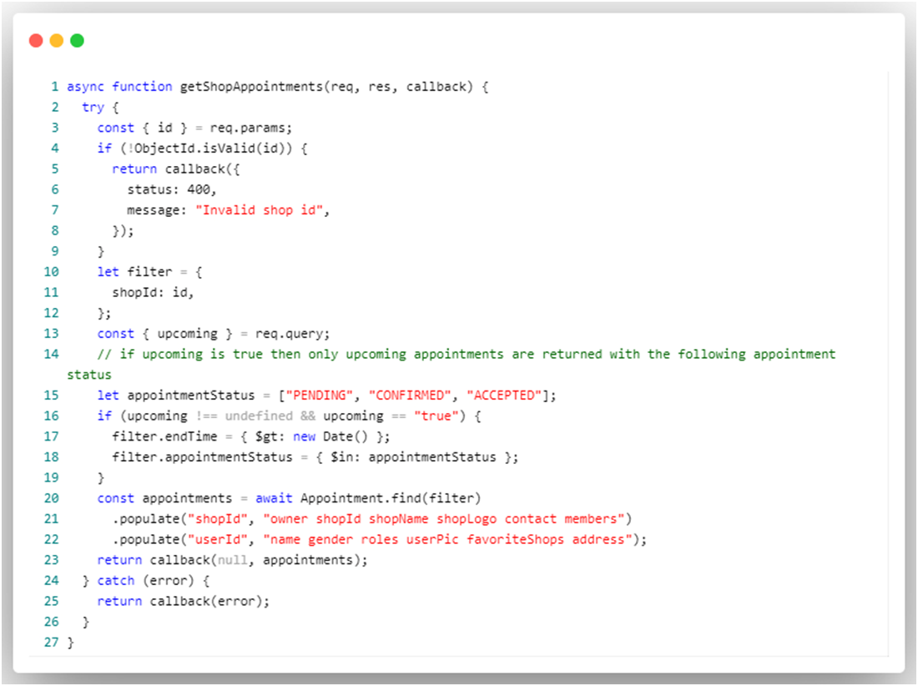

**6.3.2.4.2 Accept Appointment**

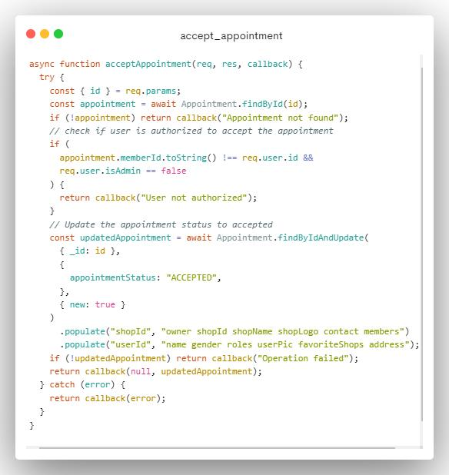

**6.3.2.4.3 Reject Appointment**

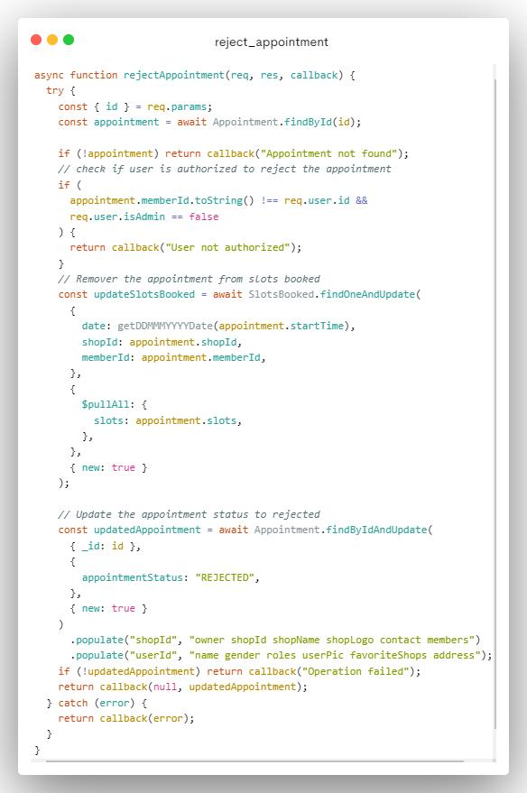

**6.3.2.5 Delete Shop**

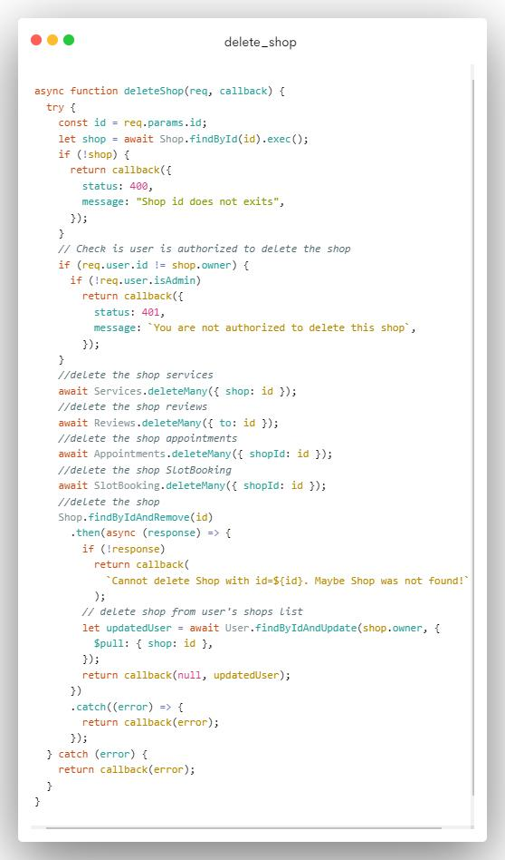

### 6.3.3 User

**6.3.3.1 Shops**

**6.3.3.1.1 View Shops Based on personal info and ratings**

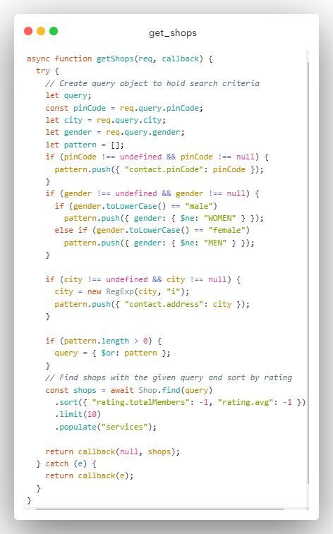

**6.3.3.1.2 View Shop**

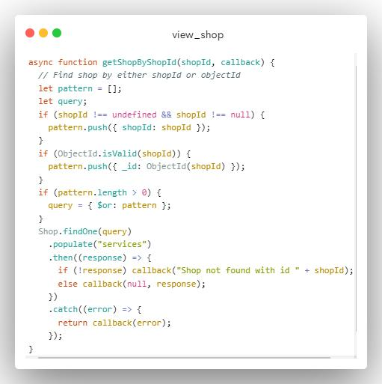

**6.3.3.1.3 View shop rating and reviews**

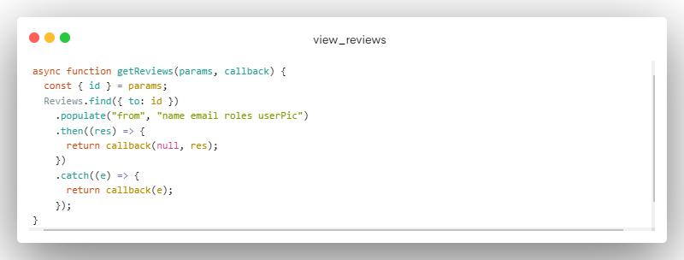

**6.3.3.2 Appointments**

**6.3.3.2.1 Book Appointments**

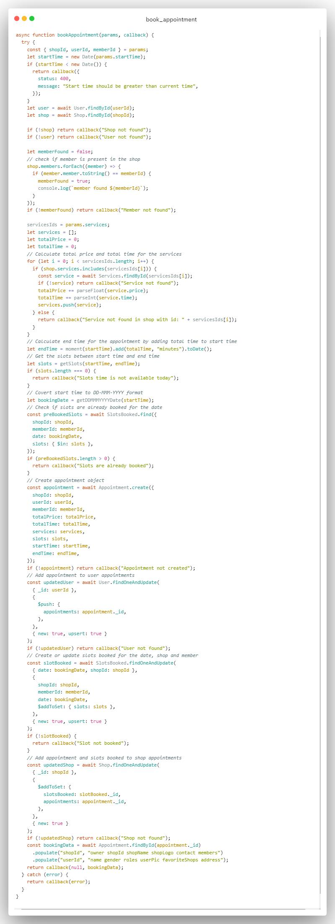

**6.3.3.2.2 Get user appointments**

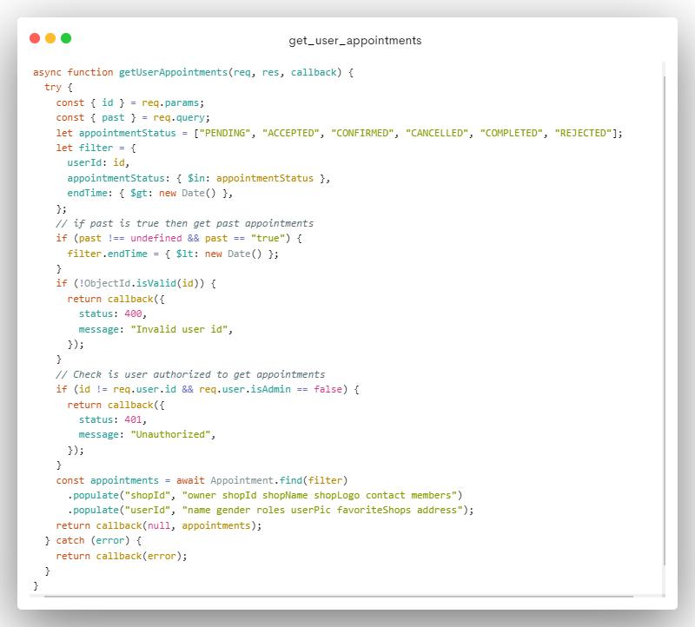

**6.3.3.2.3 View appointments**

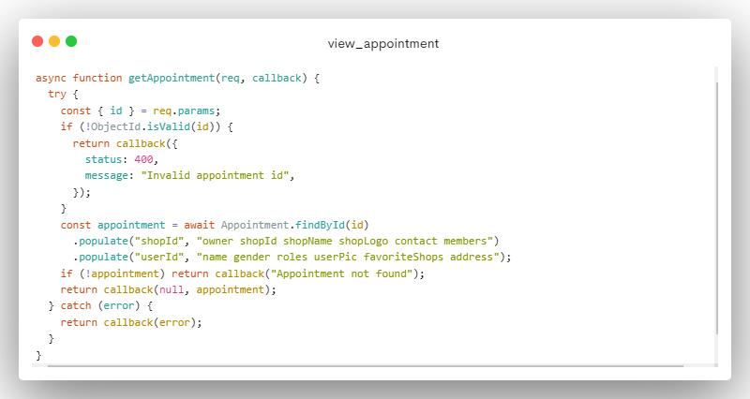

**6.3.3.2.4 Cancel appointments**

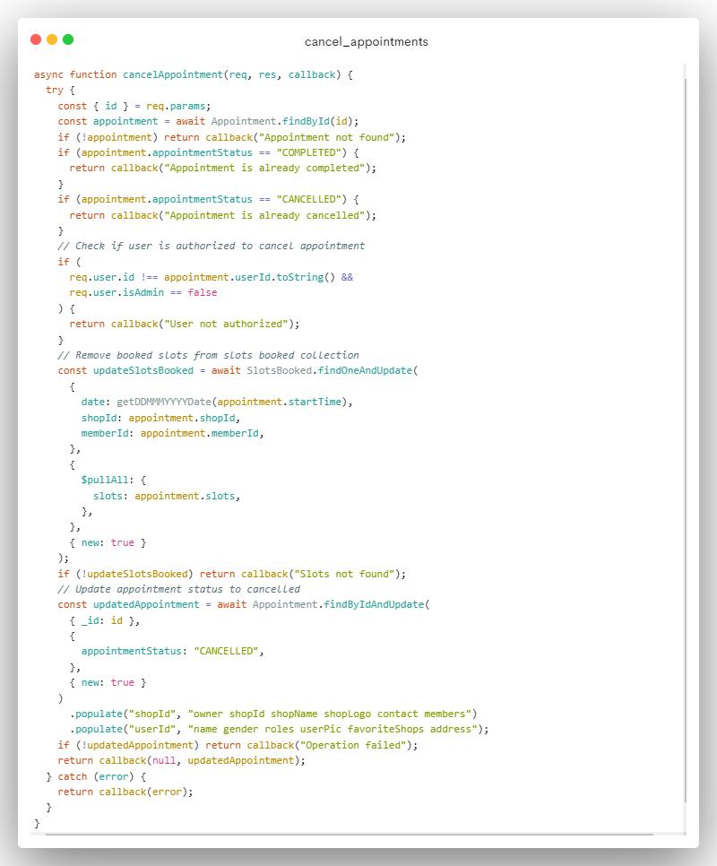

**6.3.3.2.5 Complete appointments**

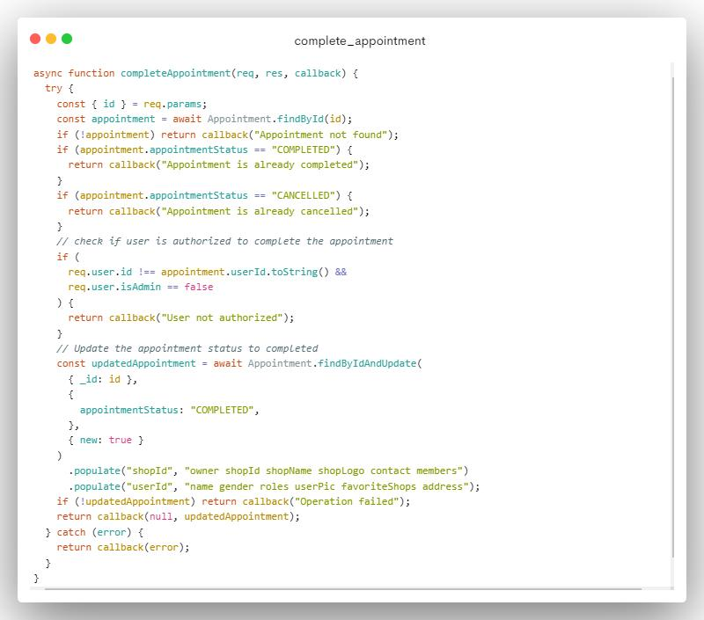

**6.3.3.3 Reviews**

**6.3.3.3.1 Give review**

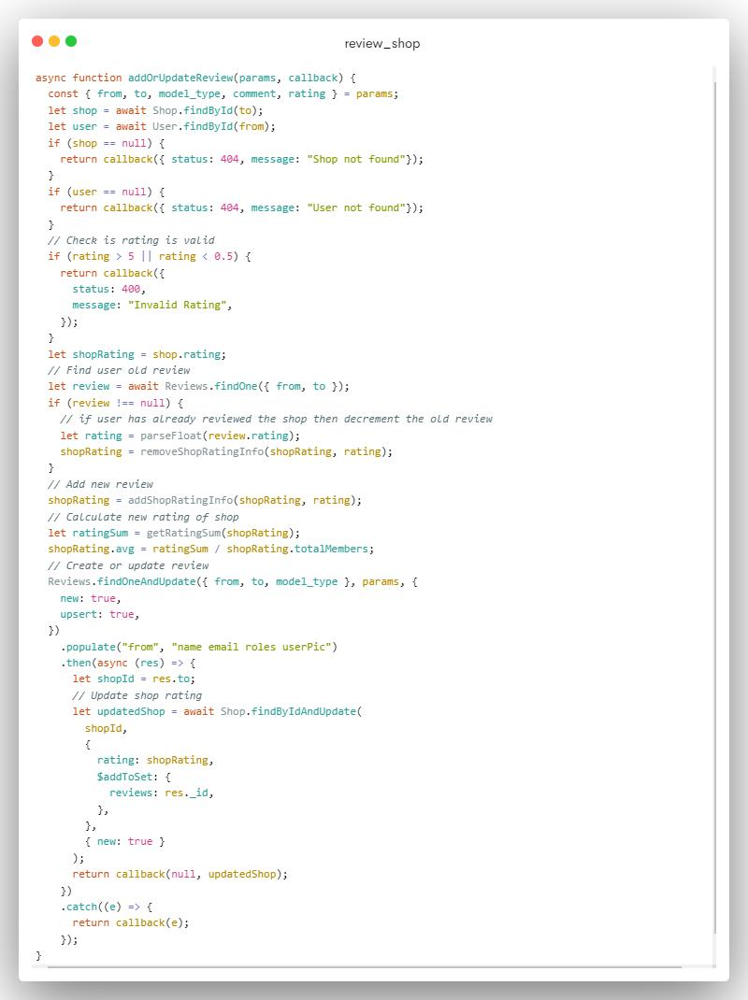

**6.3.3.3.2 Delete review**

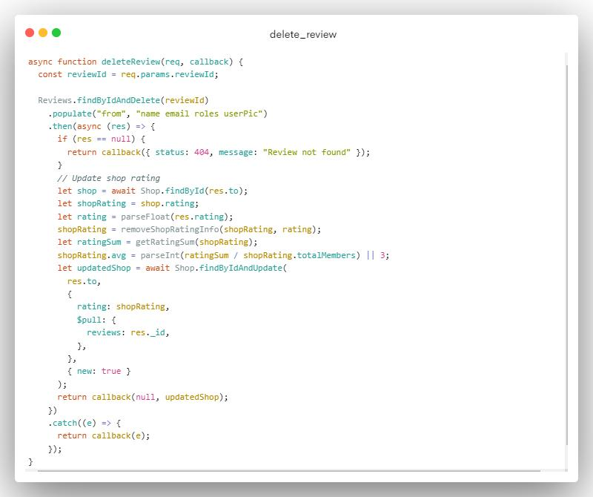

## 6.4 Data validation

### 6.4.1 Login form validation

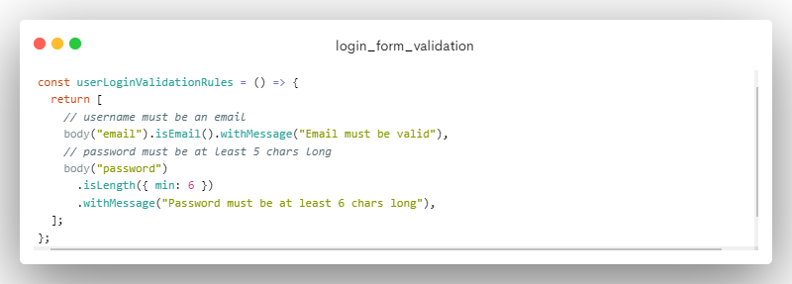

### 6.4.2 Register form validation

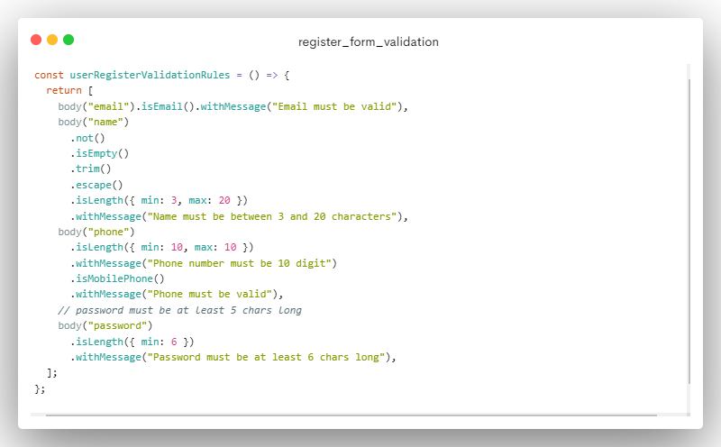

### 6.4.3 Shop register form validation

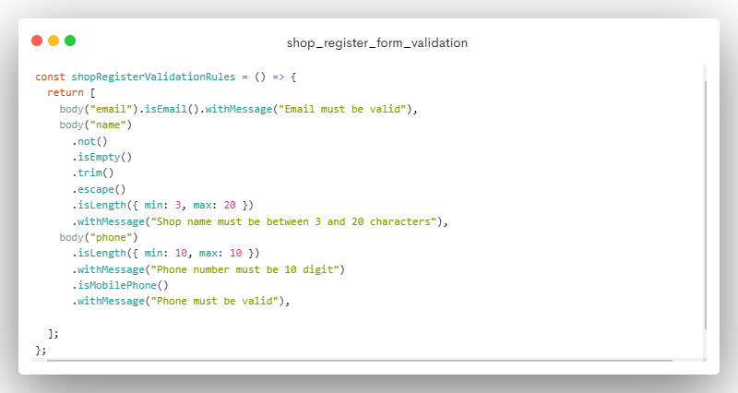

### 6.4.4 Service form validation

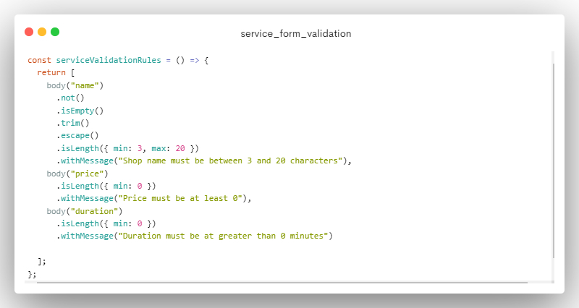

### 6.4.4 Category form validation

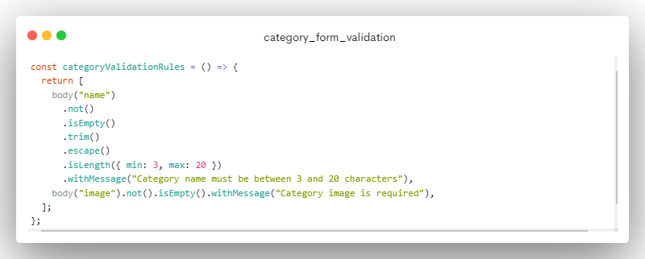

## 6.5 Named procedures / functions

### 6.5.1 Getting slot

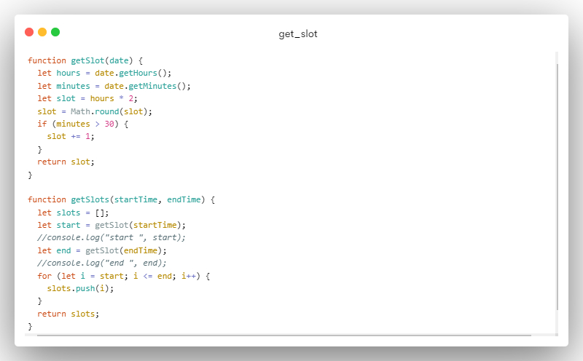

### 6.5.1 Sending email

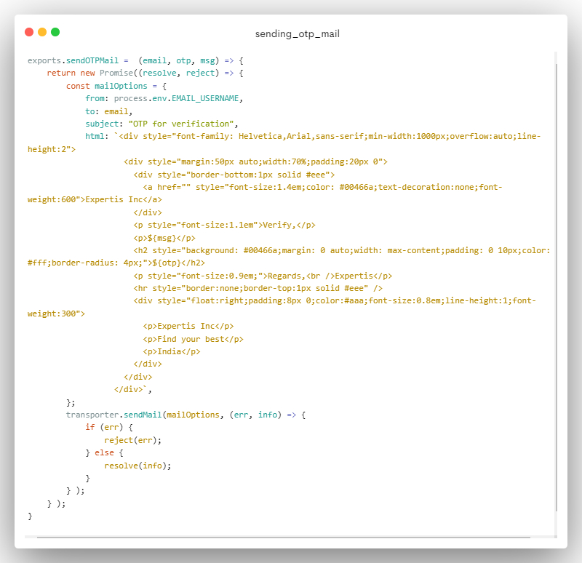

# **7. User Interface (Screens and Reports)**

## 7.1 Register & Login

### 7.1.1 Register

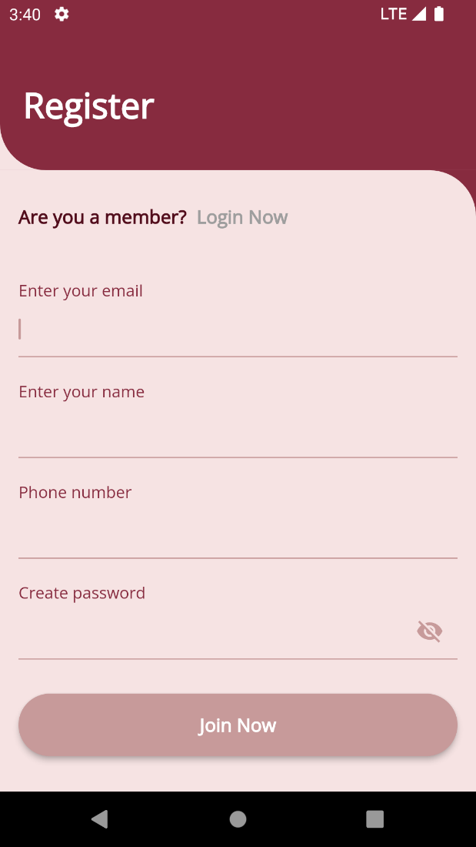 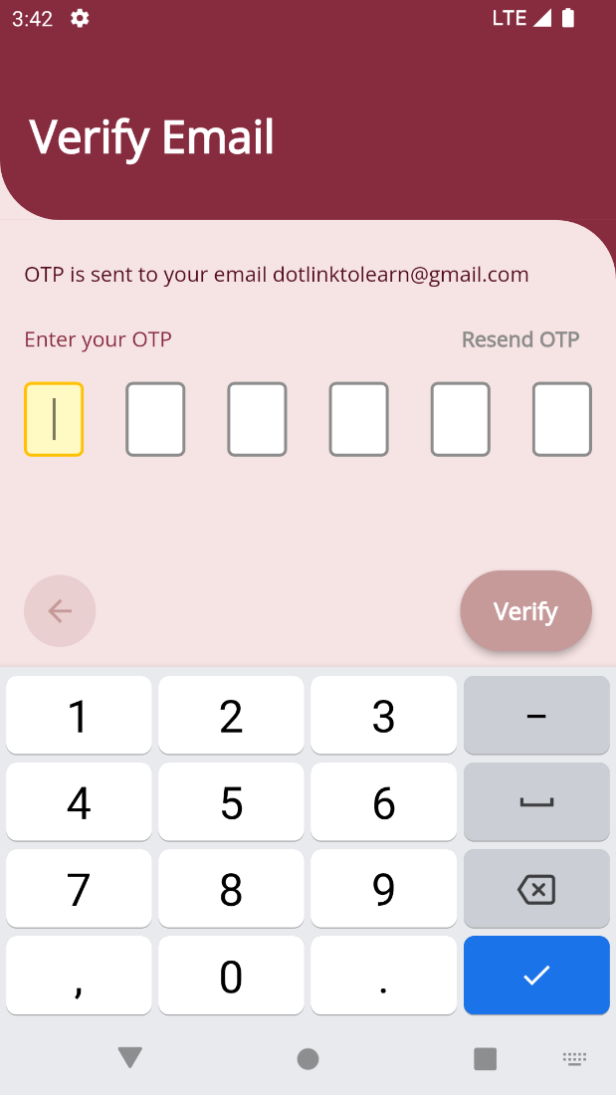

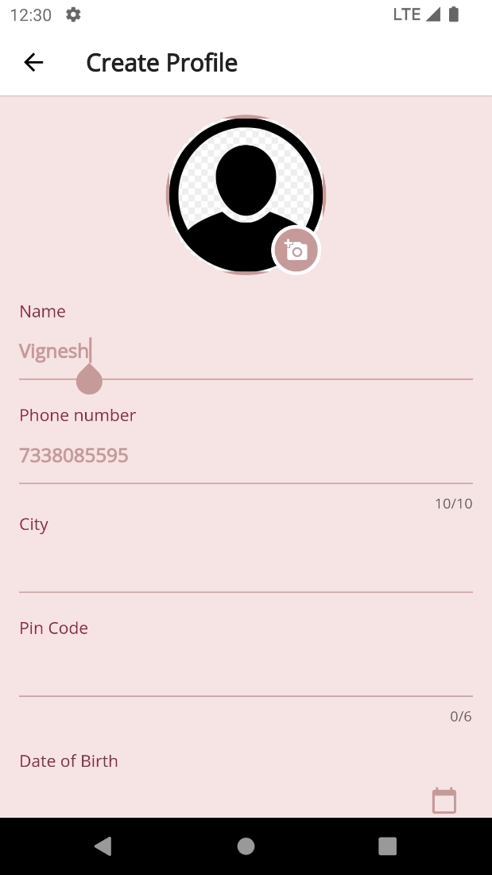 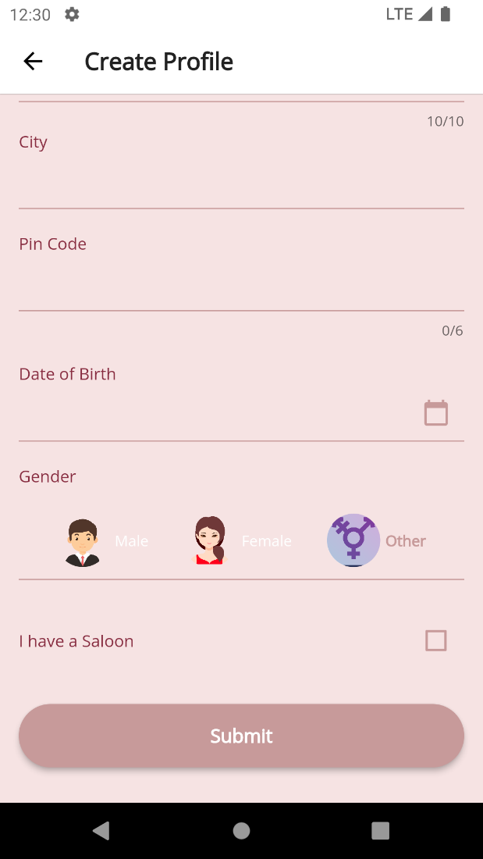

### 7.1.2 Login

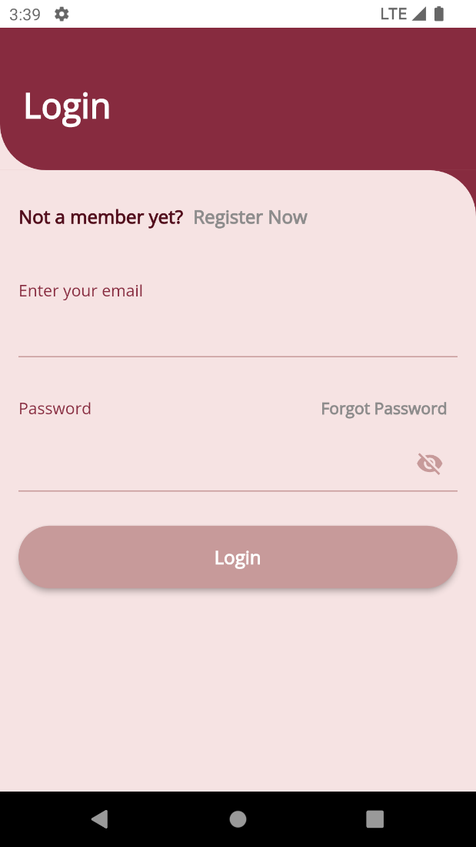

### 7.1.3. Forget Password

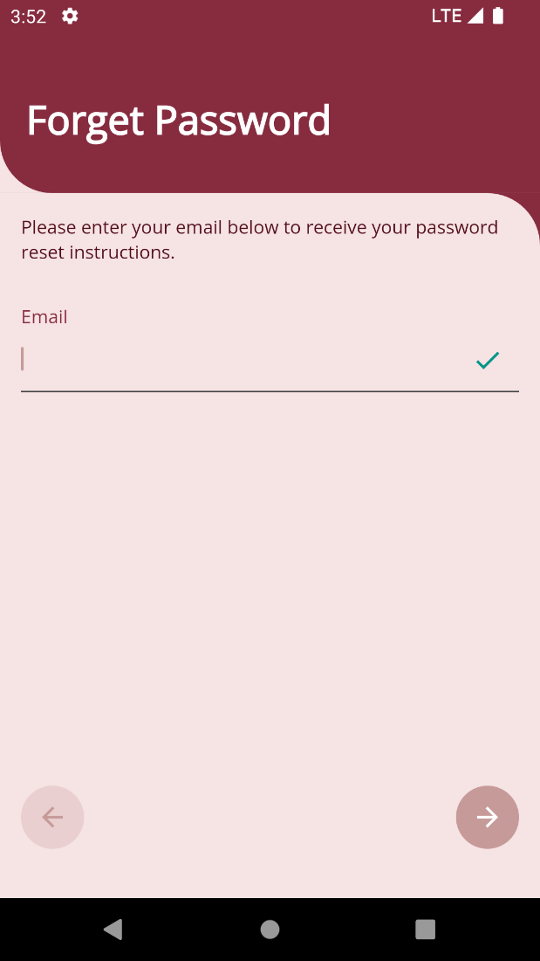 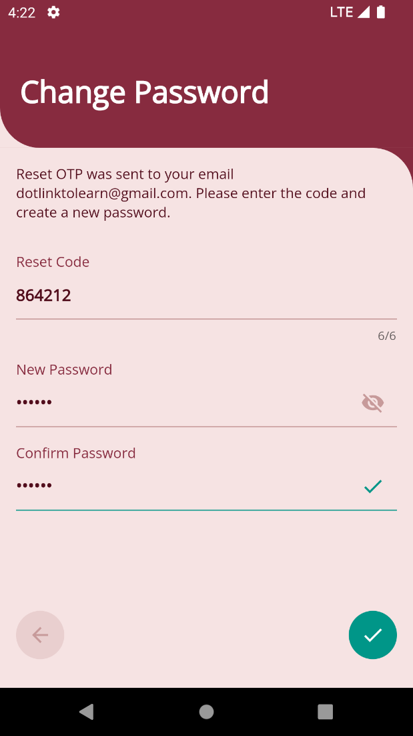

## 7.2 Main Screen / Home page

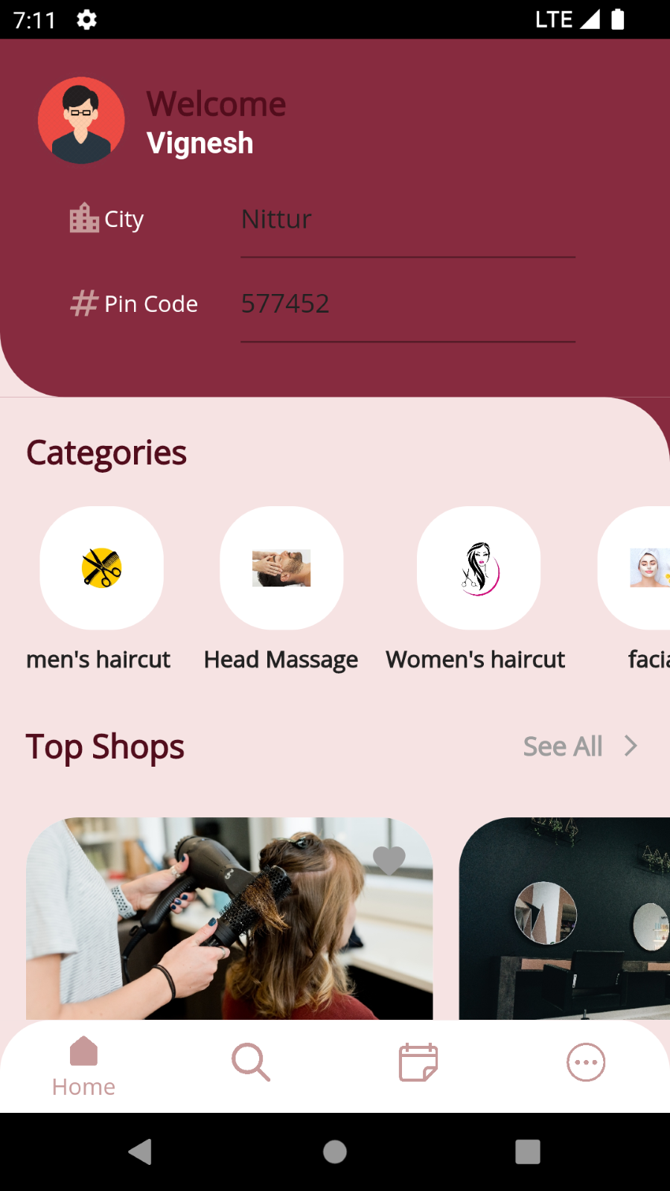 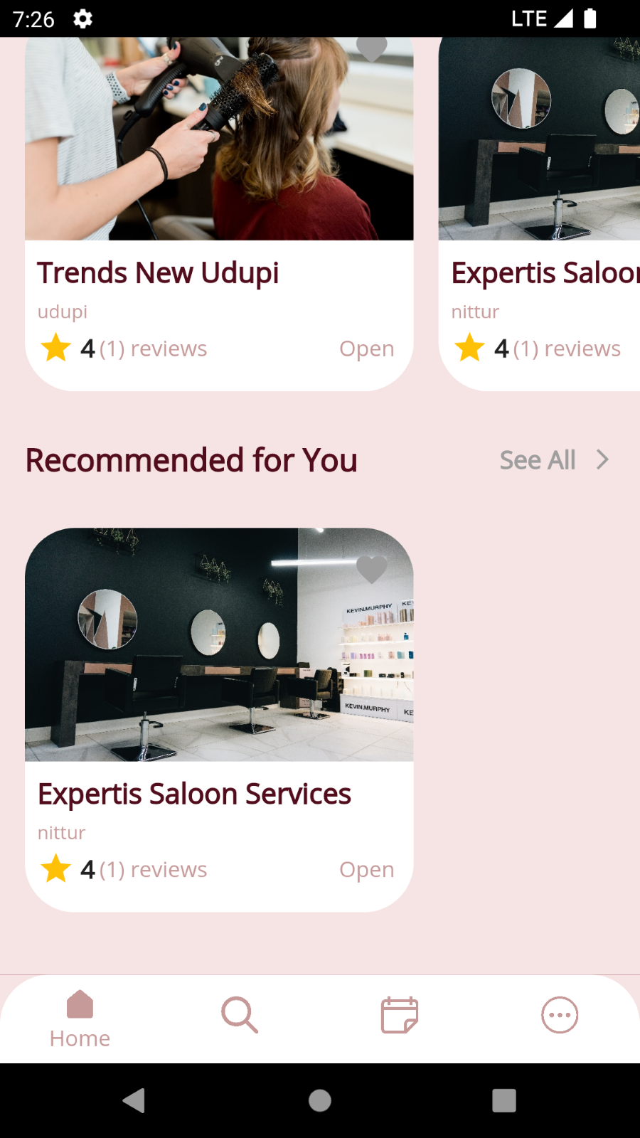

## 7.3 Menu

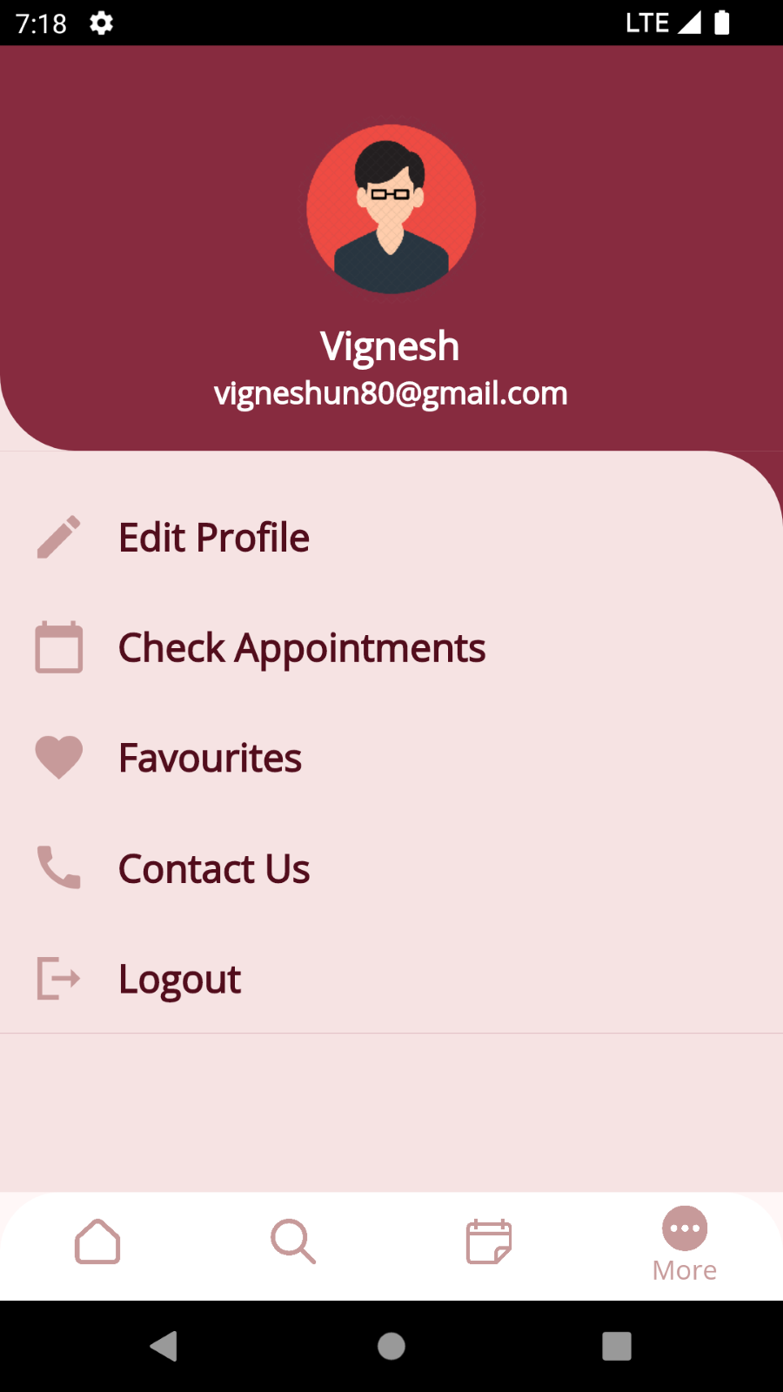

## 7.4 Data store / retrieval / update

### 7.4.1 User

#### **7.4.1.1 View Shop**

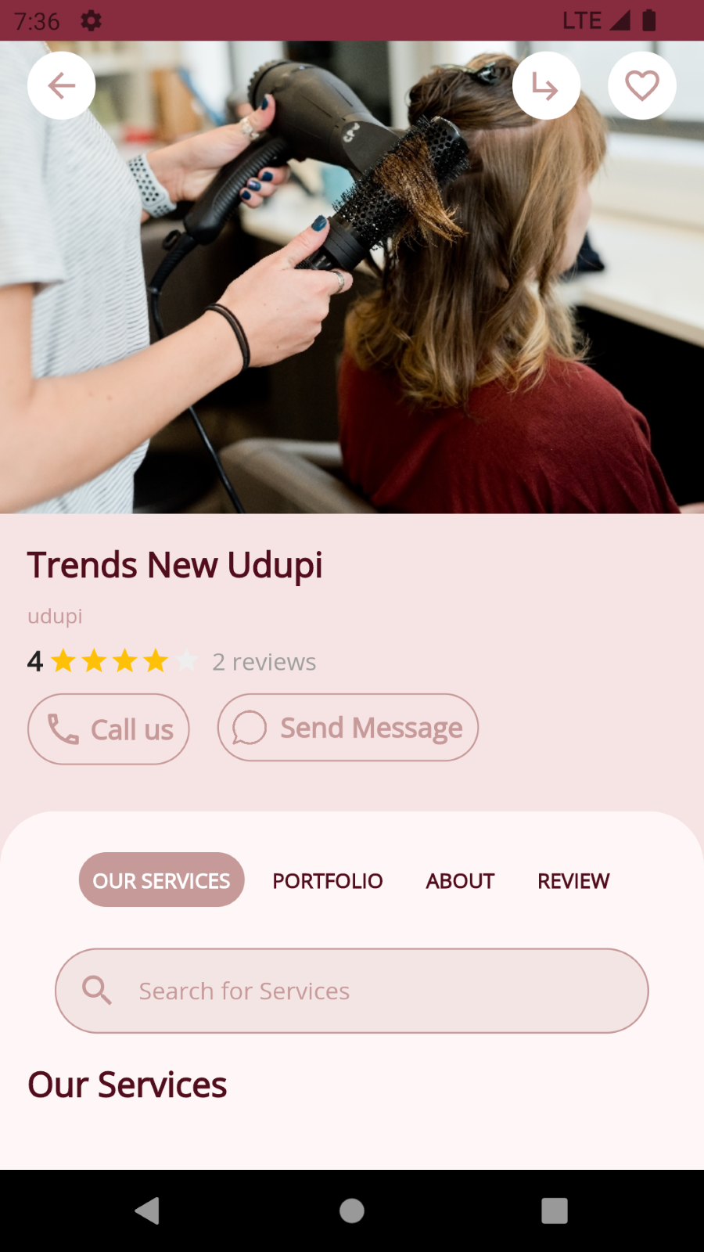 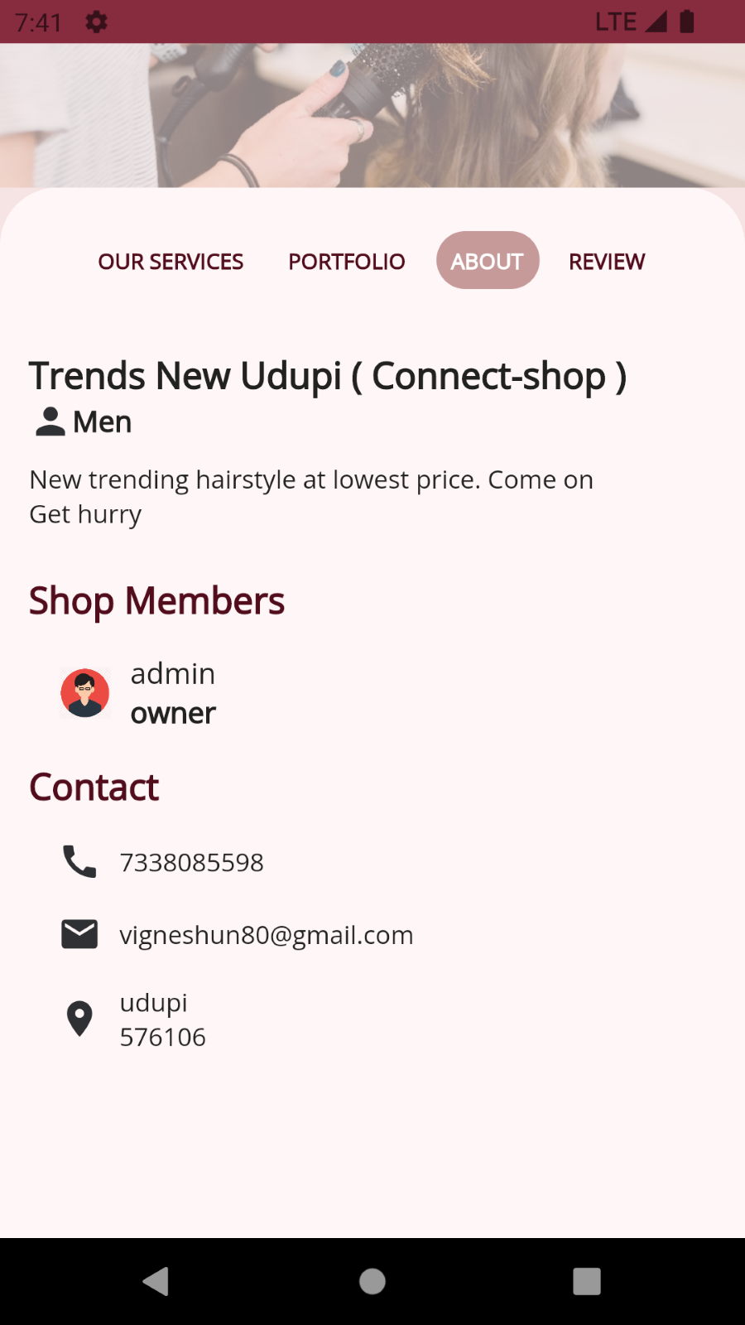



#### **7.4.1.2 Write review**

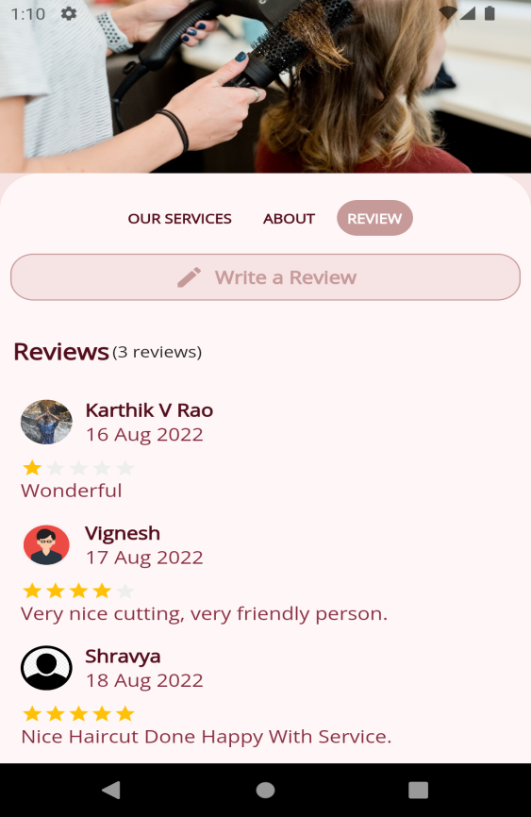 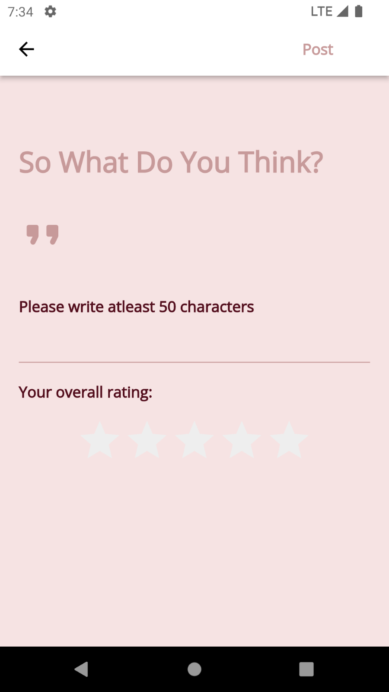

#### **7.4.1.3 Write review**

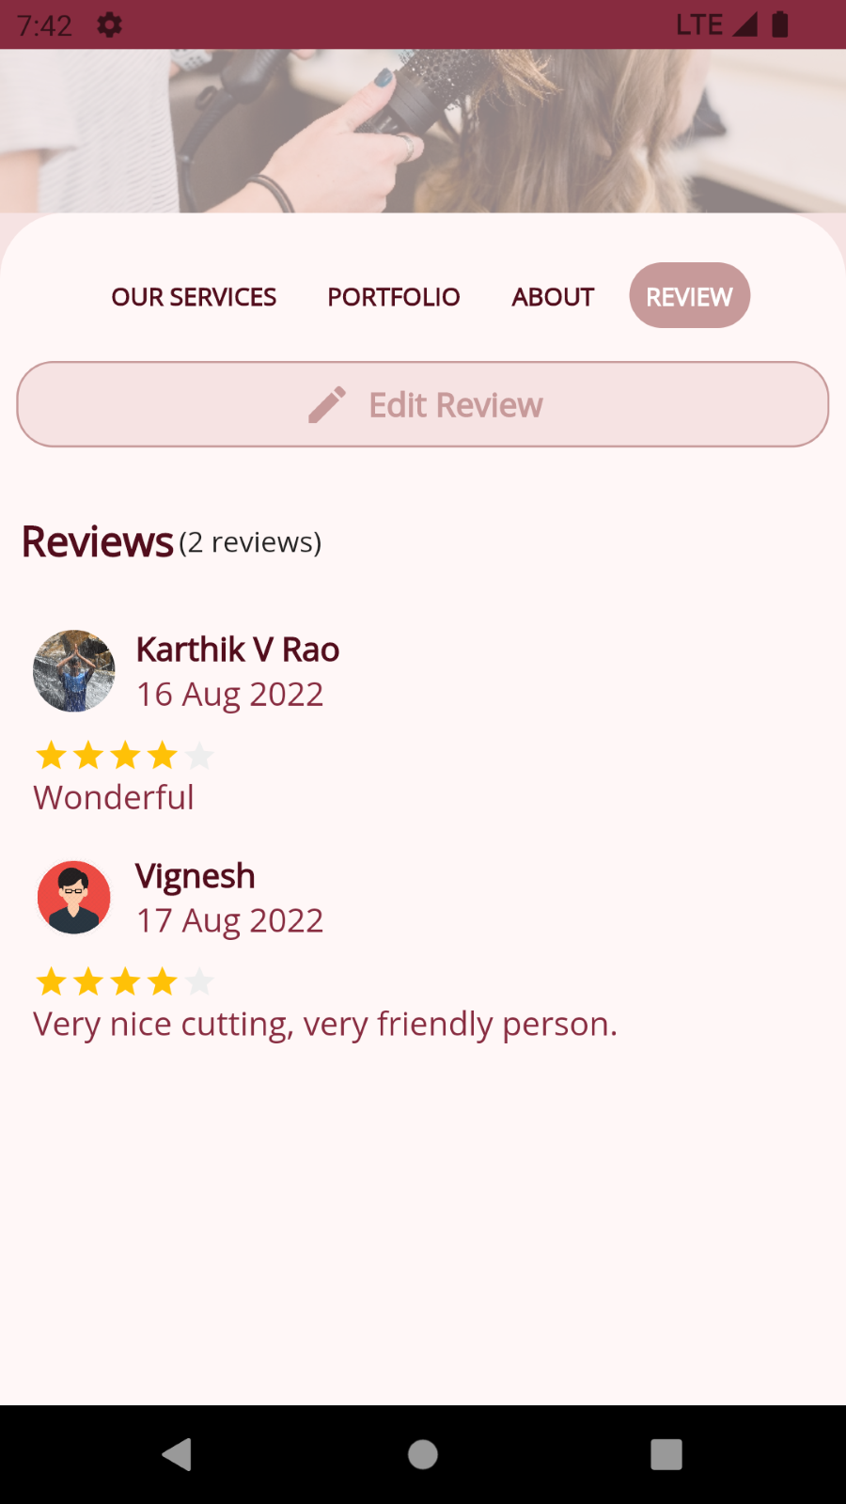 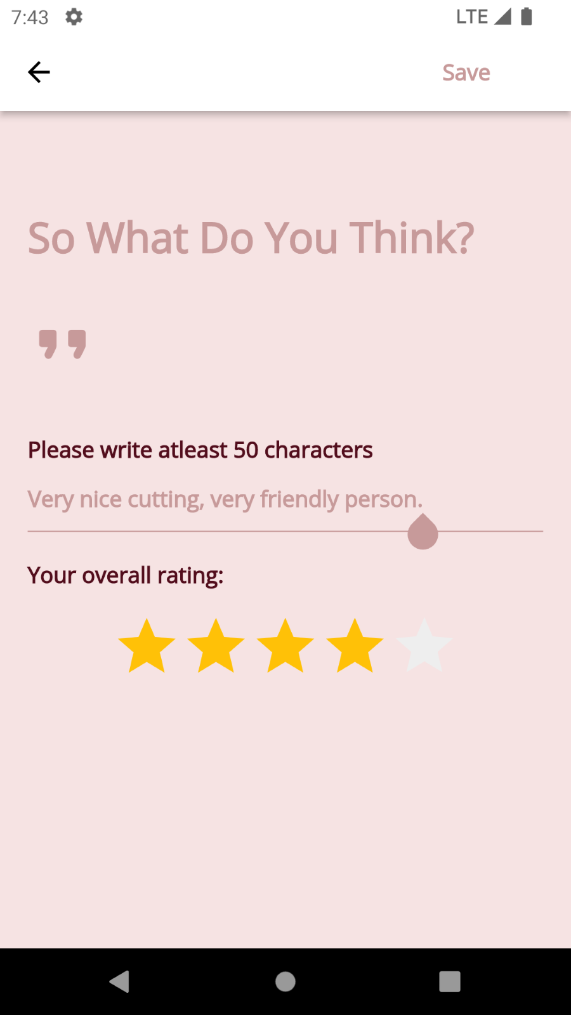

#### **7.4.1.4 Book Appointment**

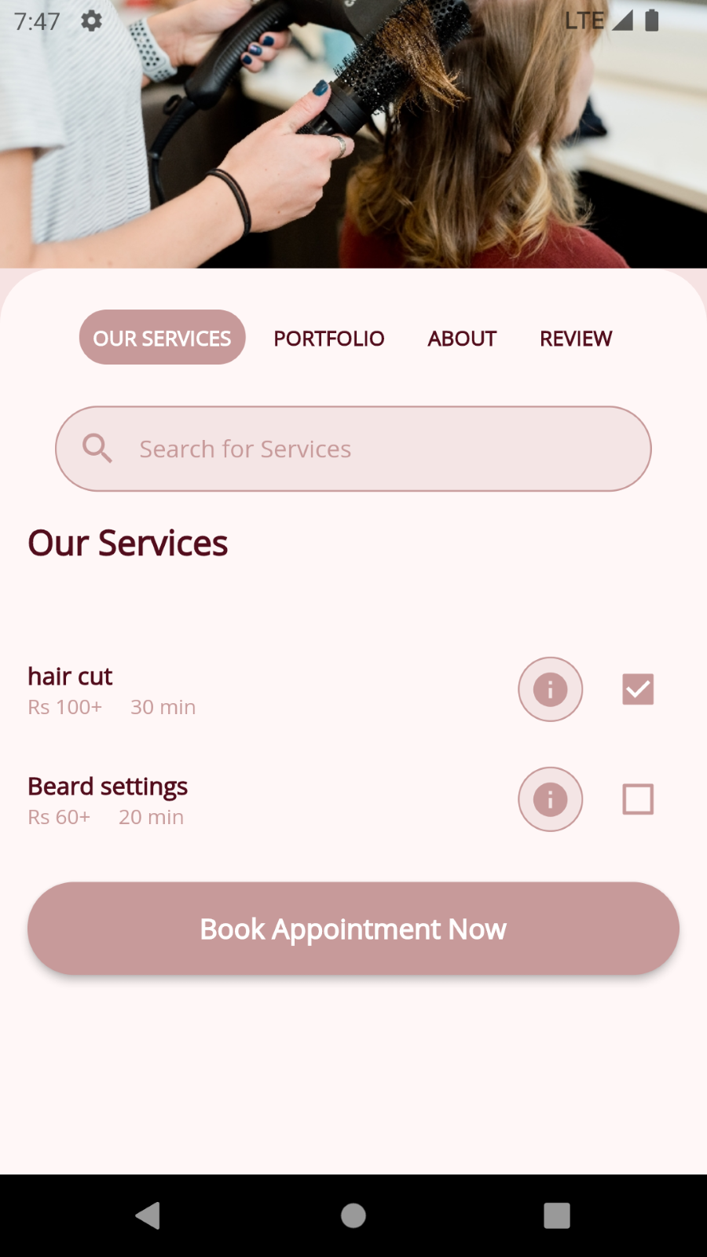 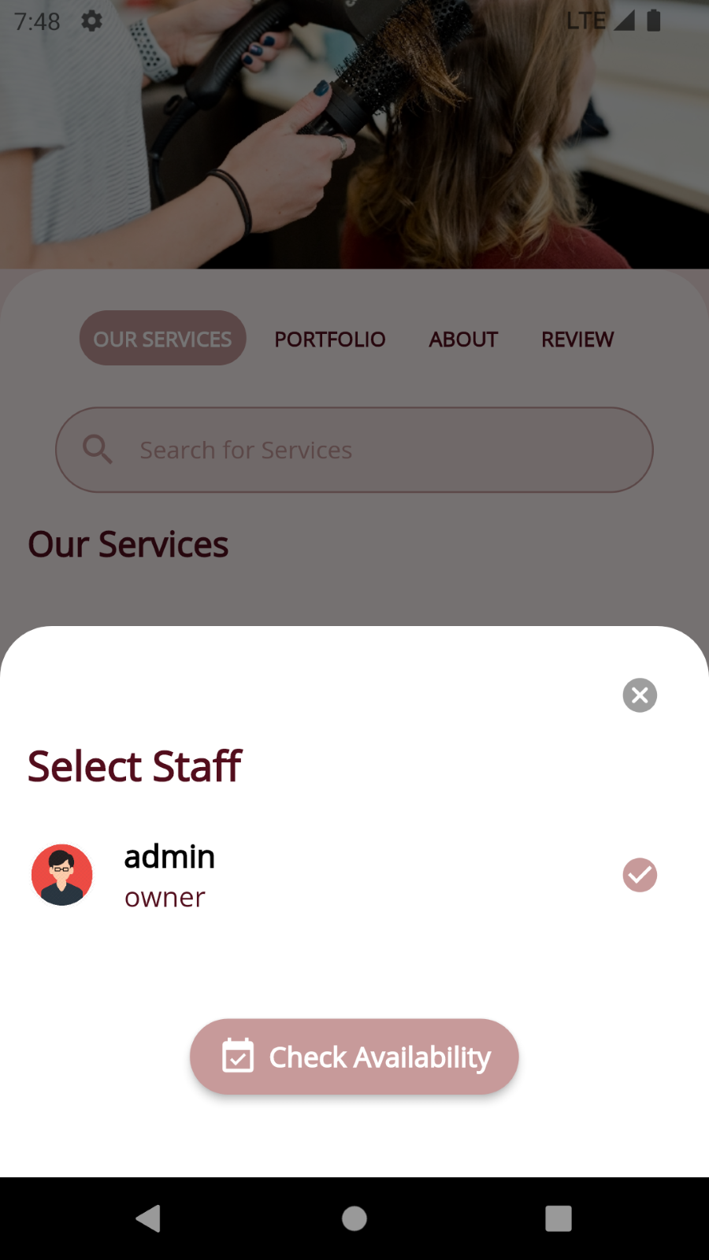

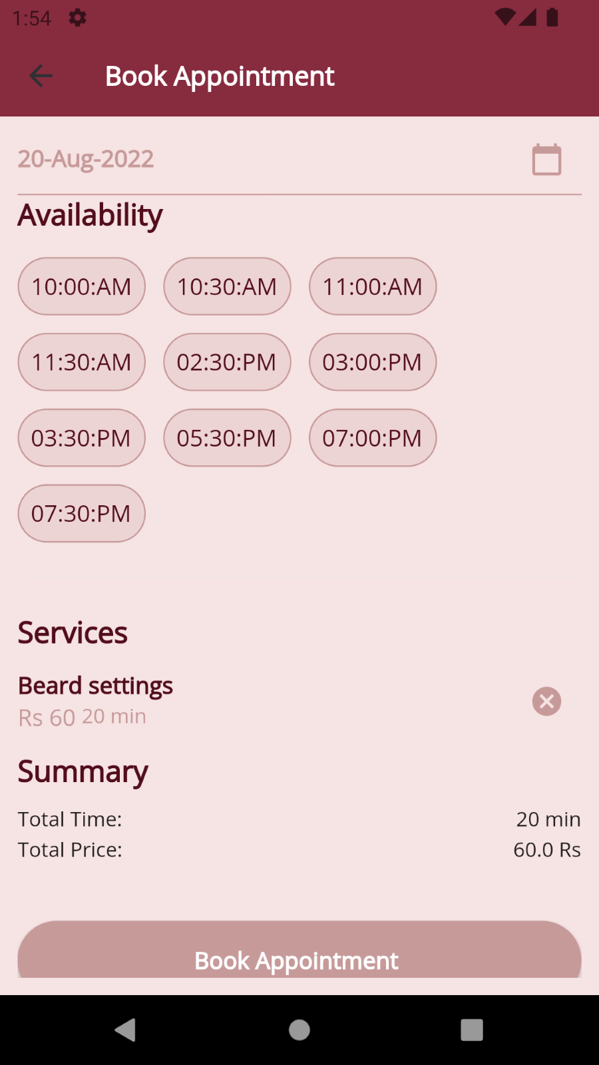

#### **7.4.1.5 Manage profile**

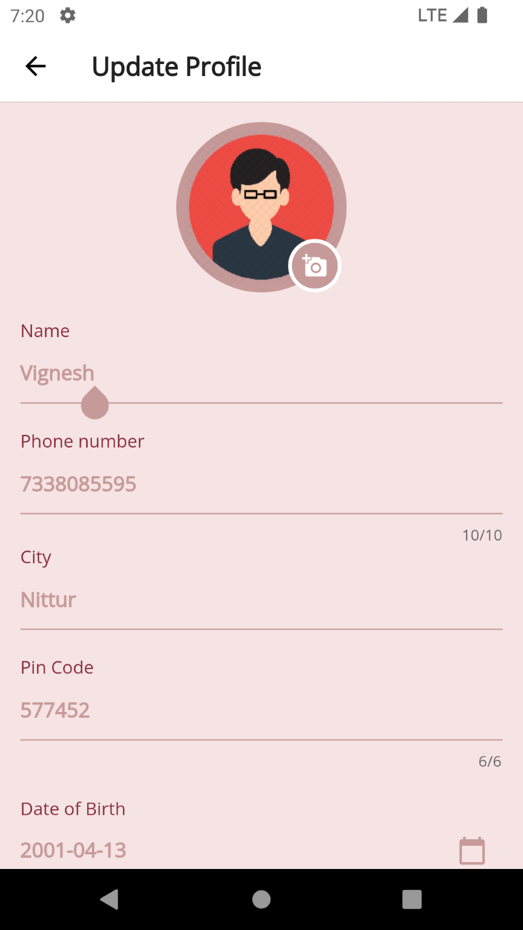 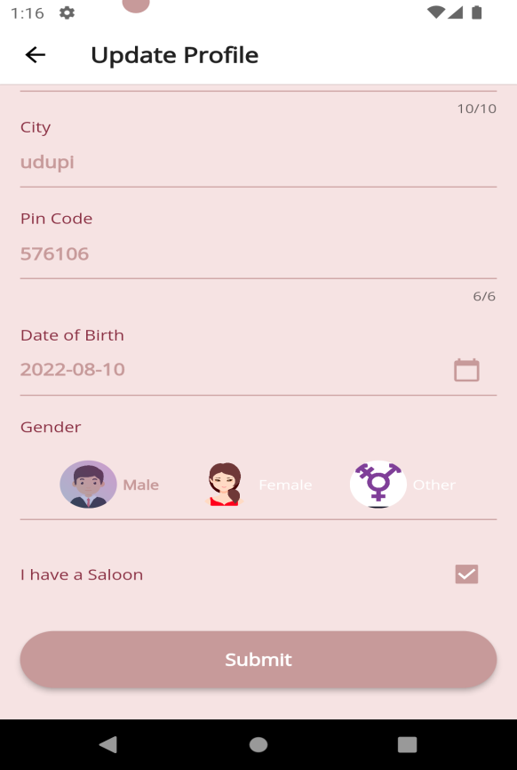

#### **7.4.1.5 View appointments**

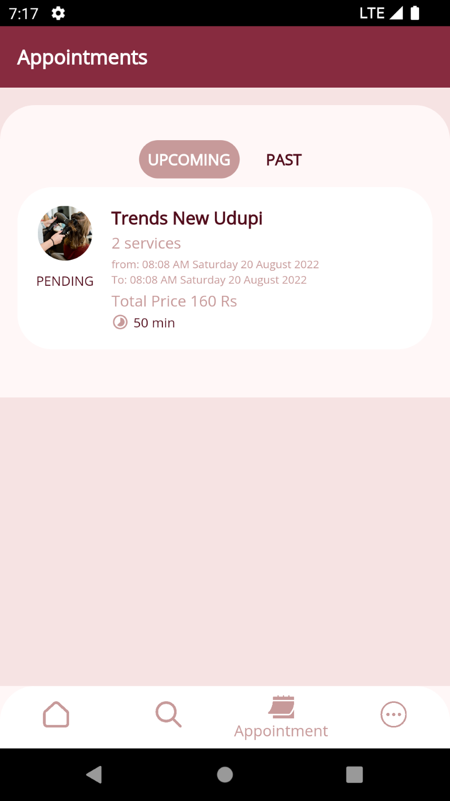 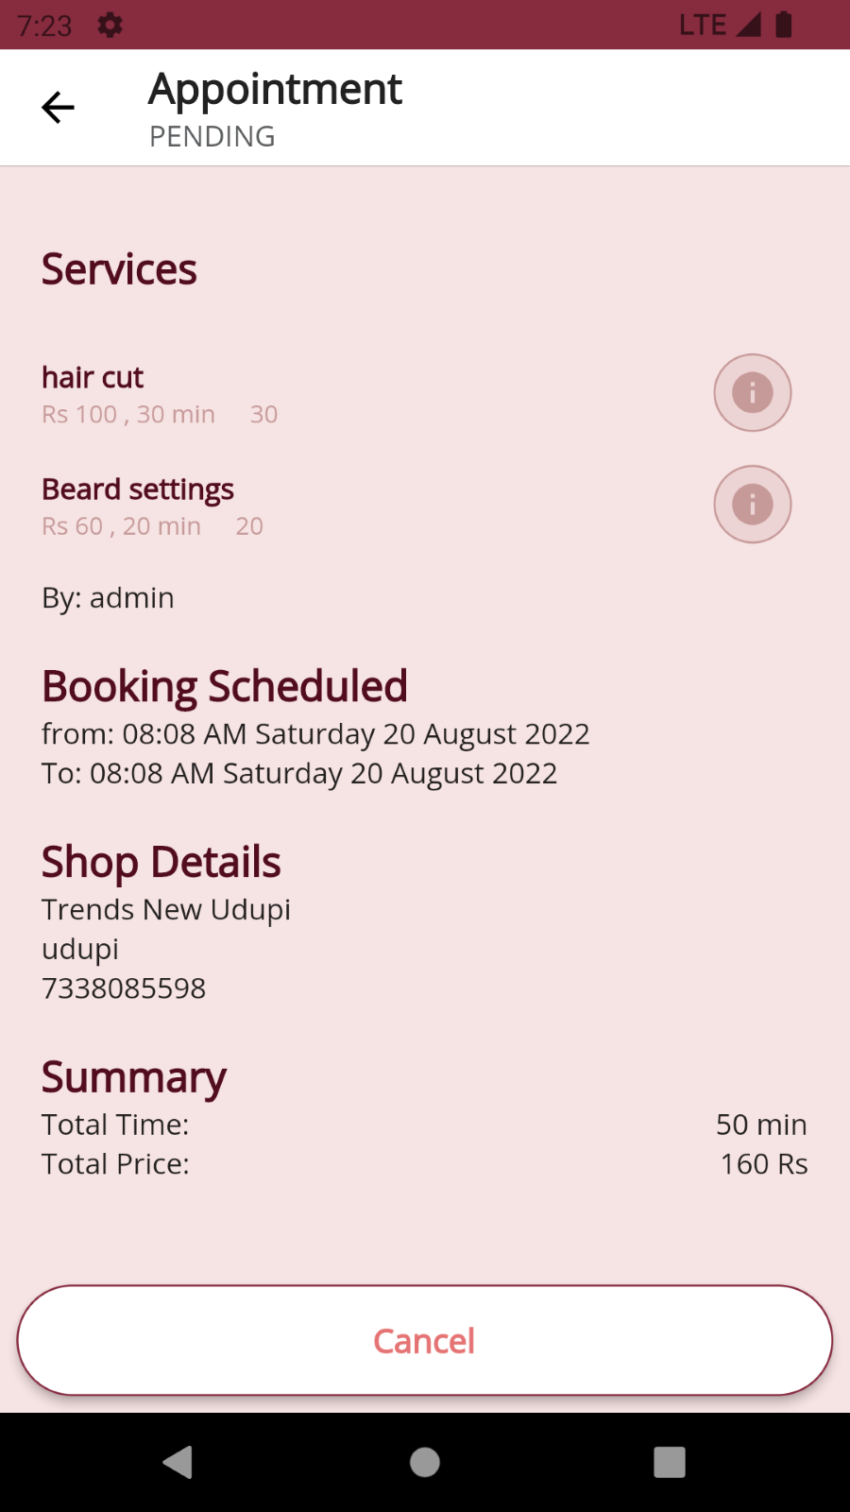

#### **7.4.1.6.1 Cancel Appointment**

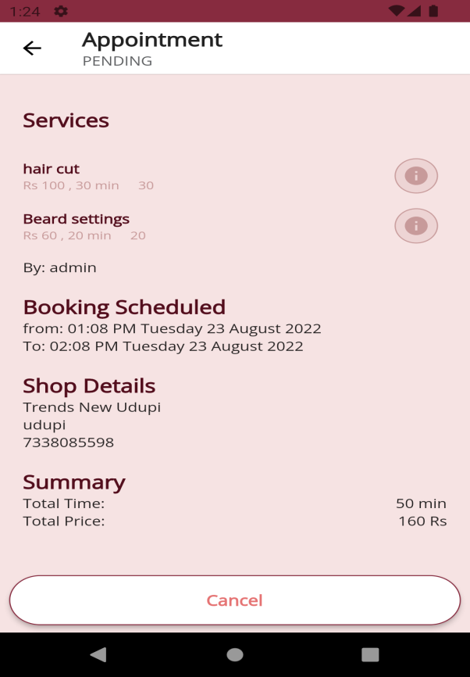 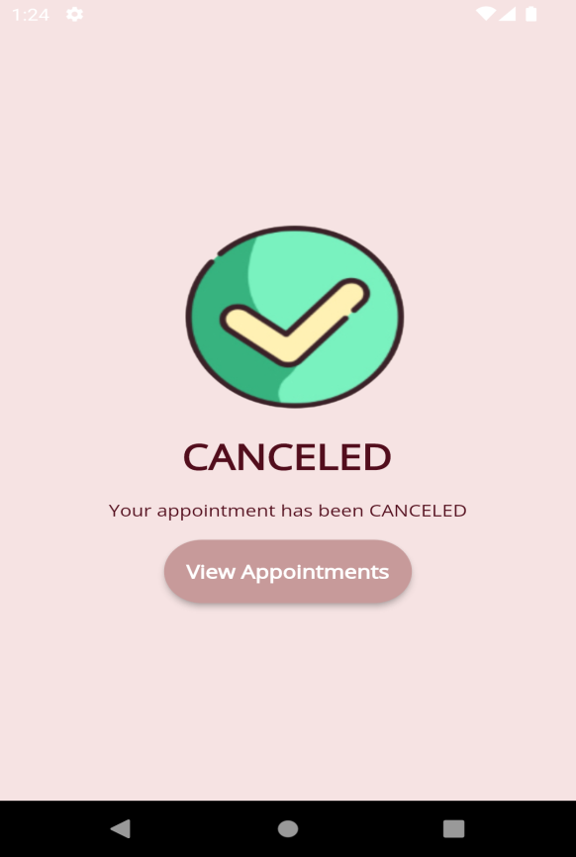

#### **7.4.1.6.1 Complete Appointment**

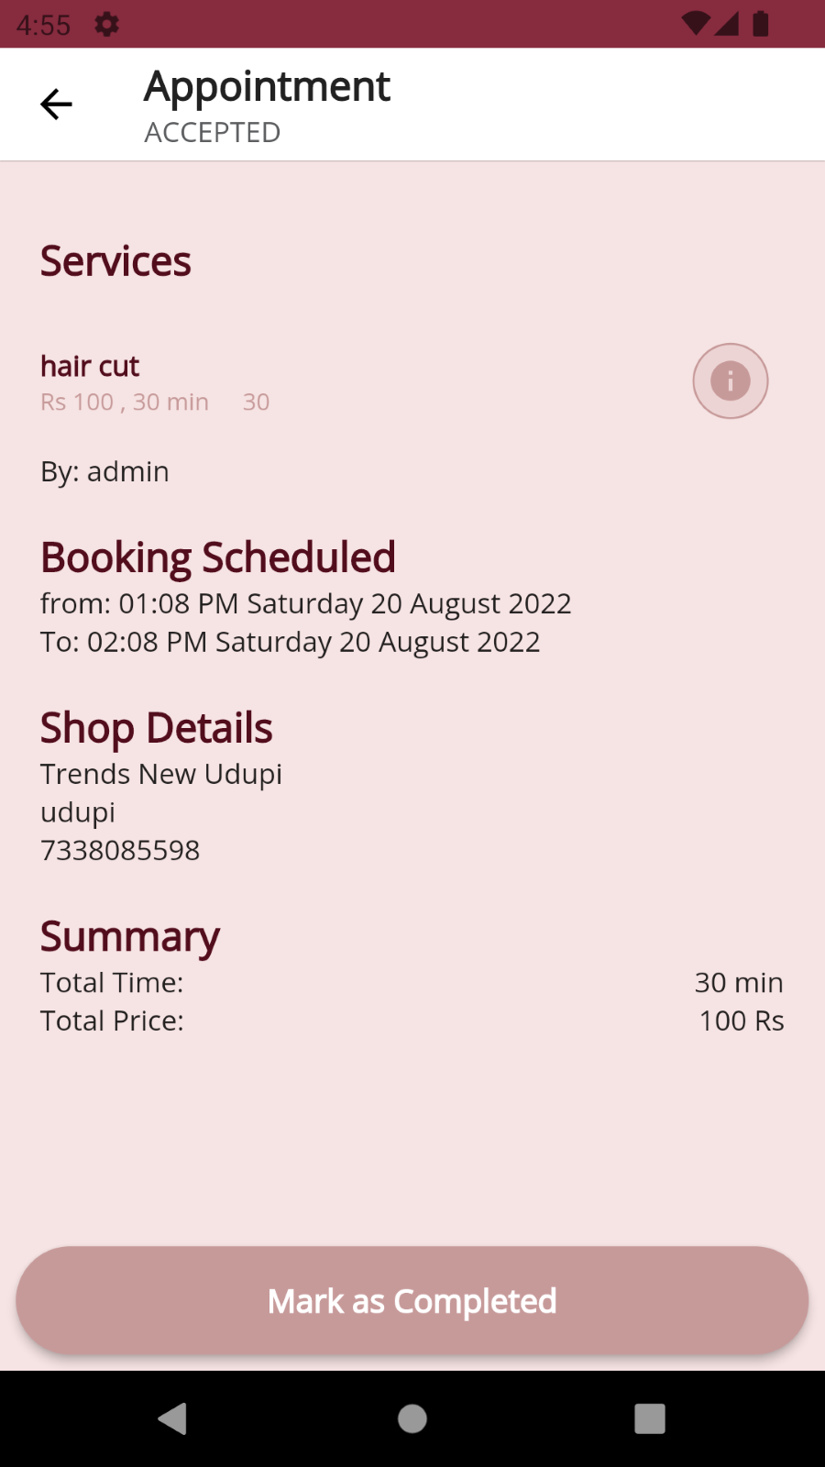 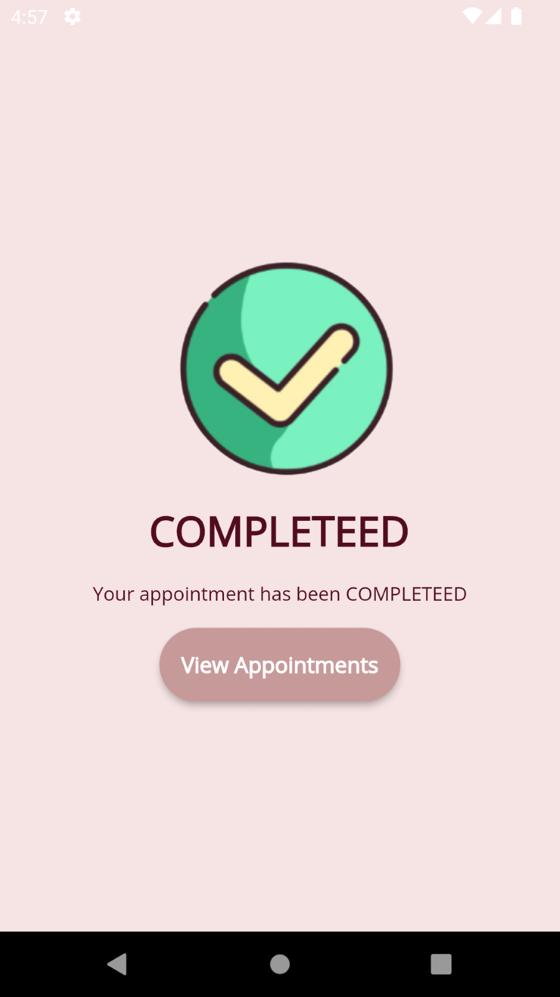

### 7.4.2 Shop

#### **7.4.2.1 Create shop**

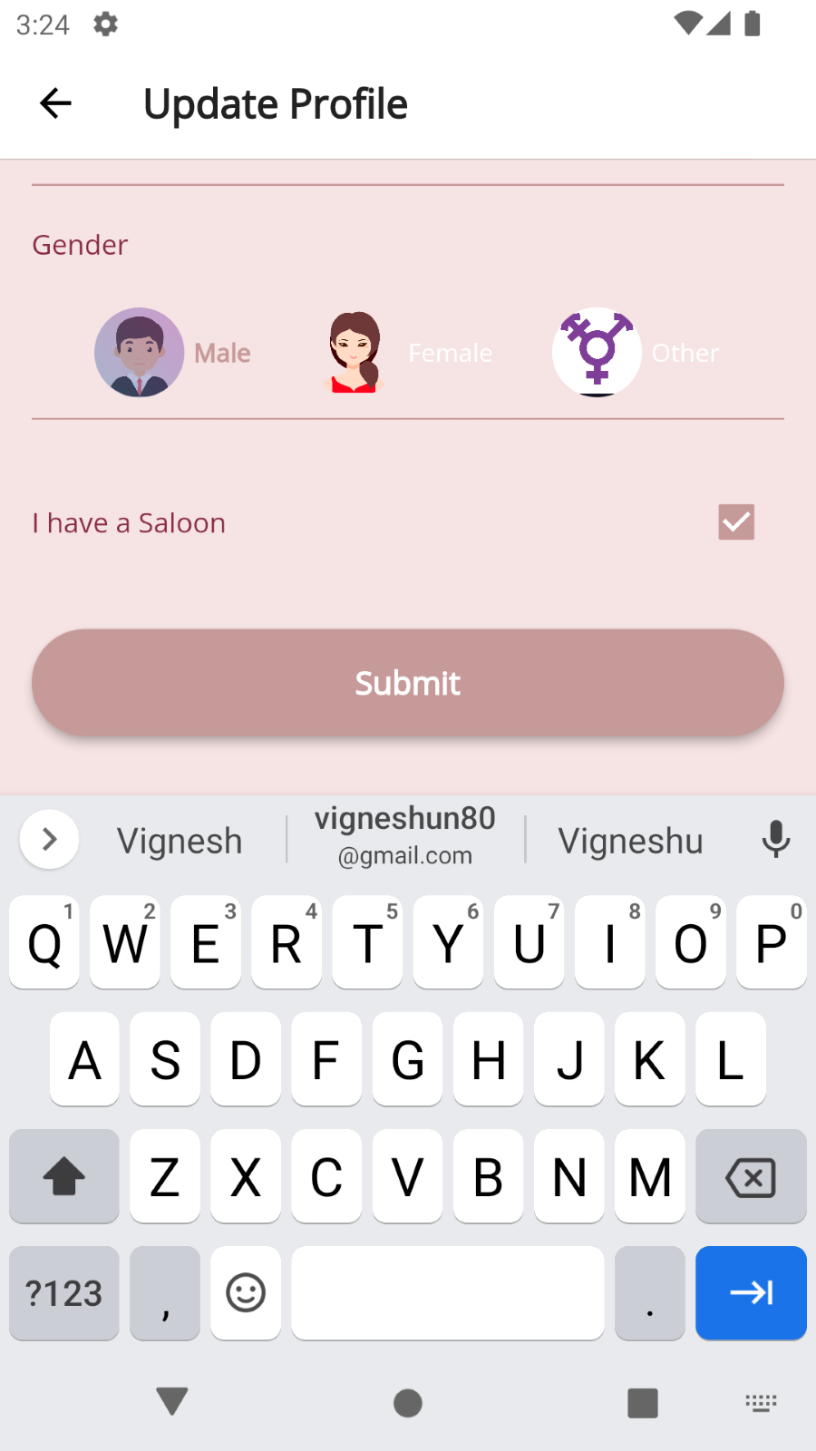 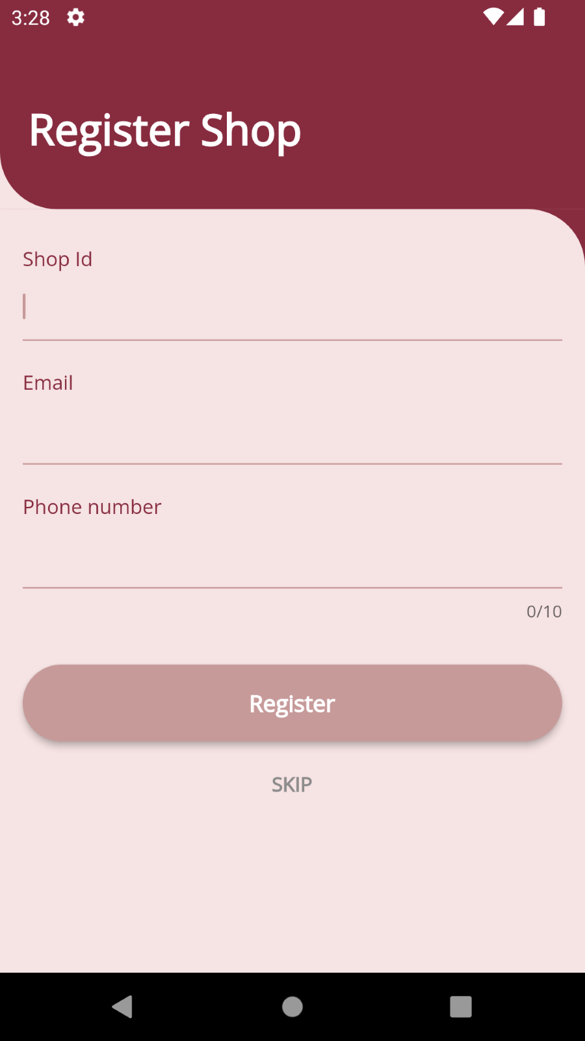

#### **7.4.2.1 Add or update shop information**

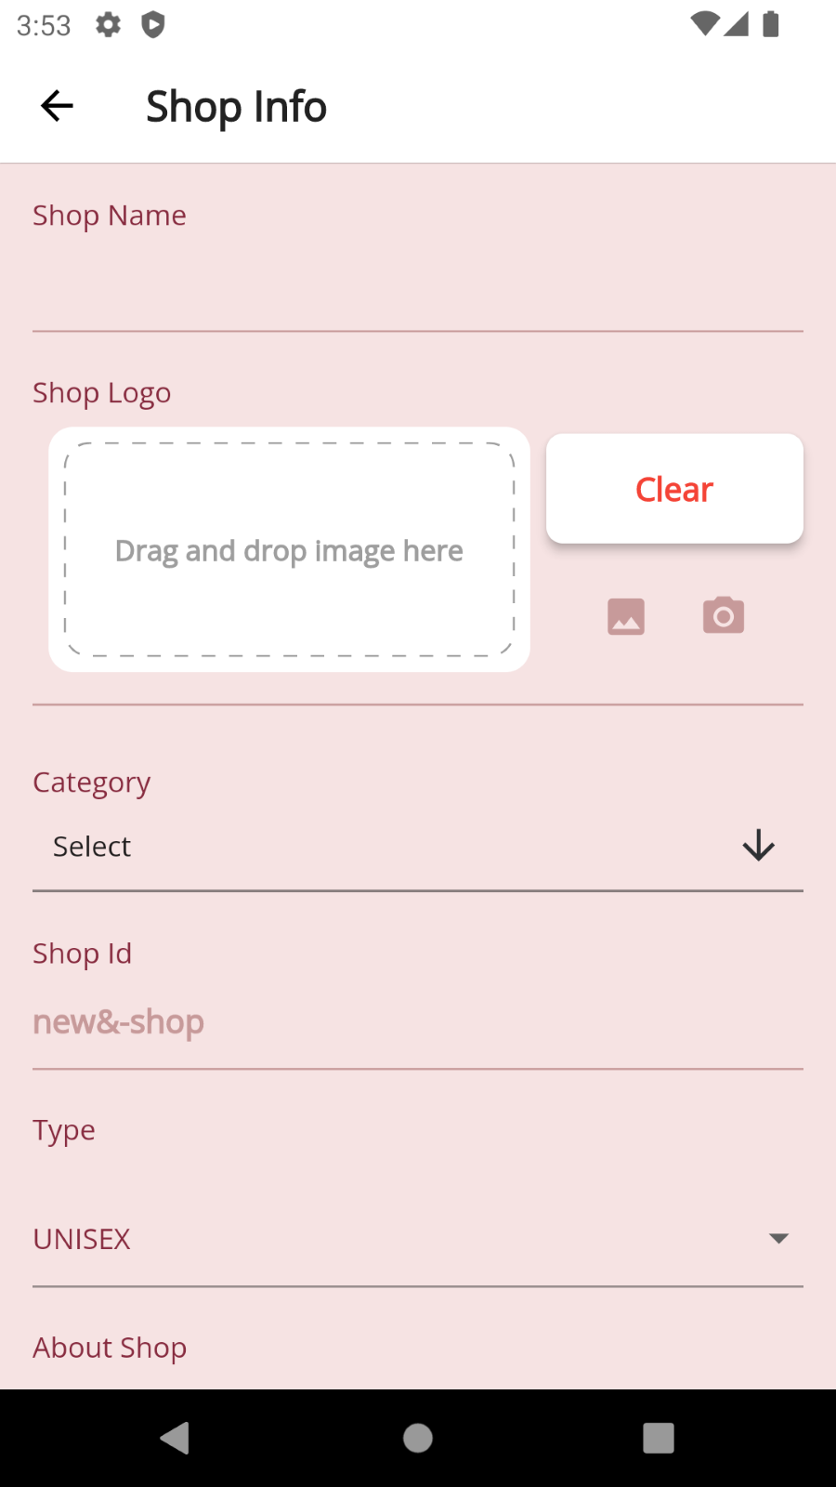 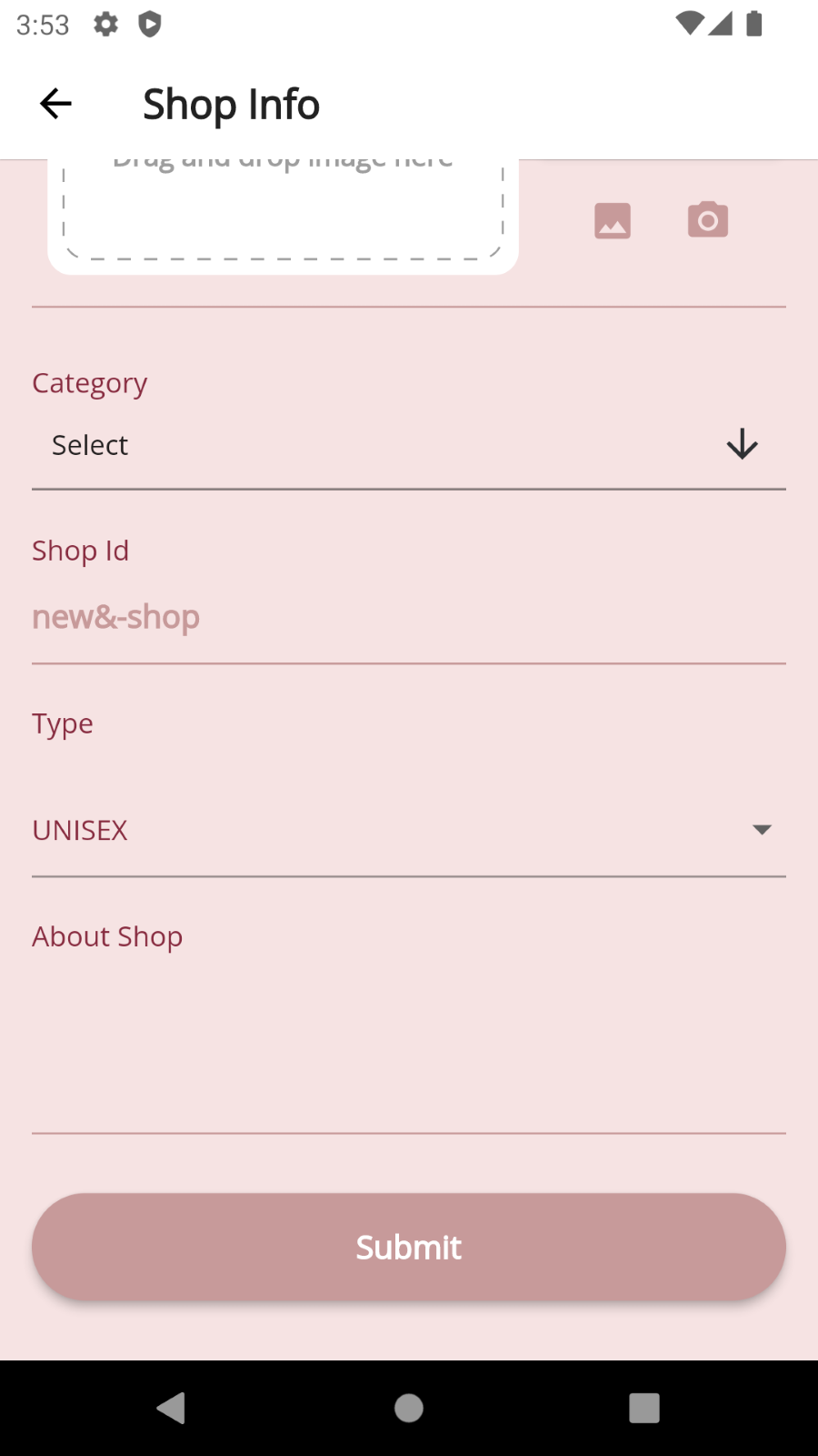

#### **7.4.2.1 Add or update shop contact detail**

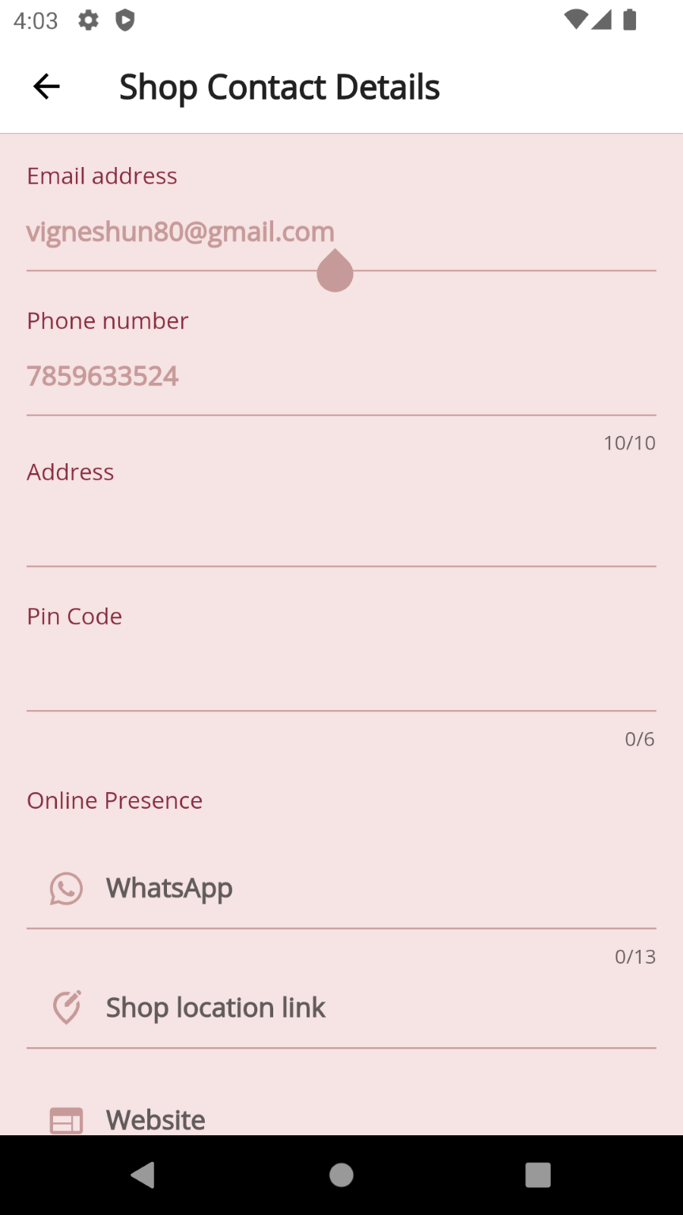 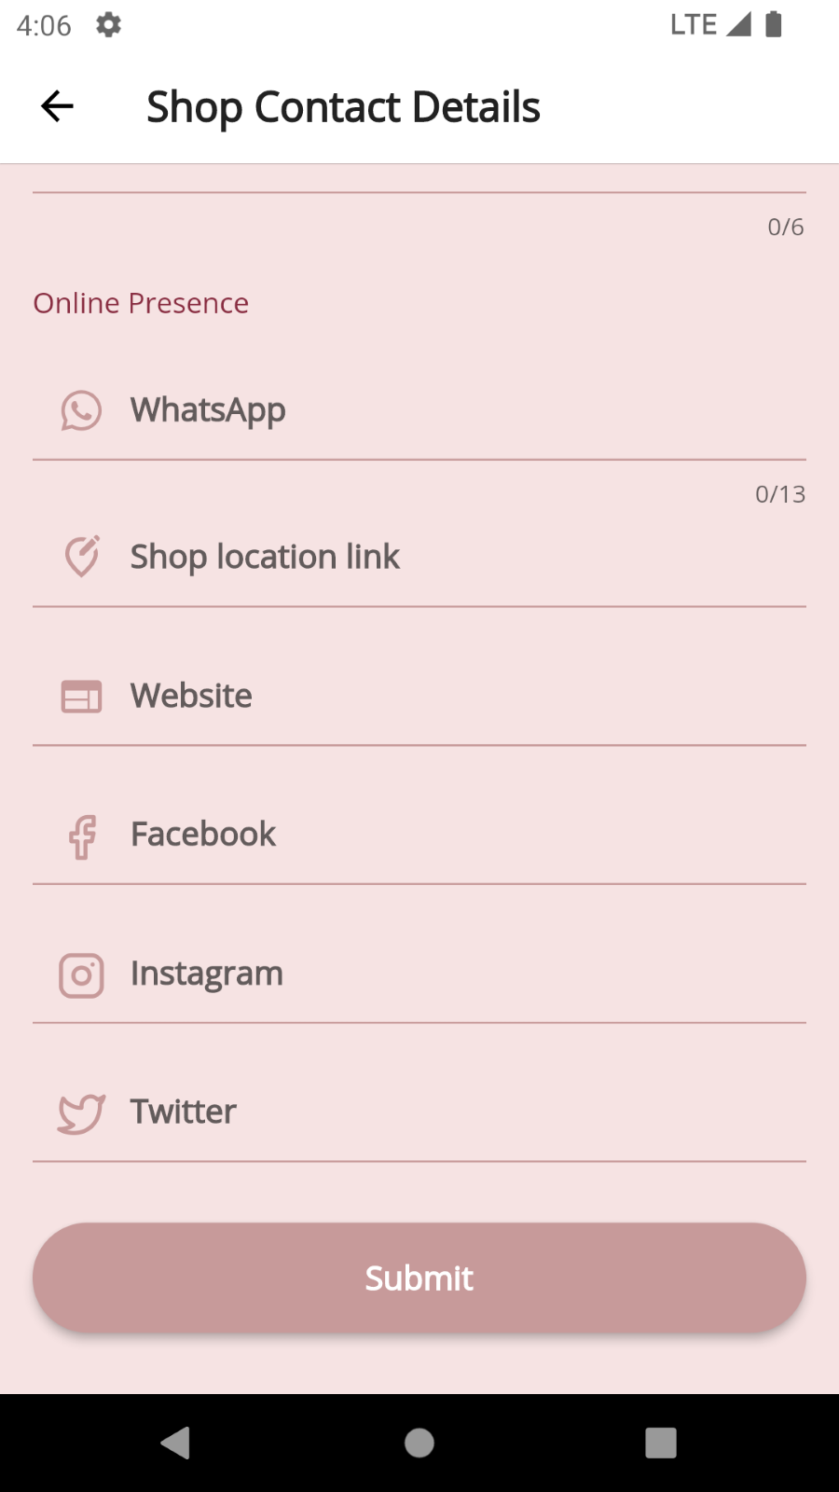

#### **7.4.2.2 Shop Services handling**

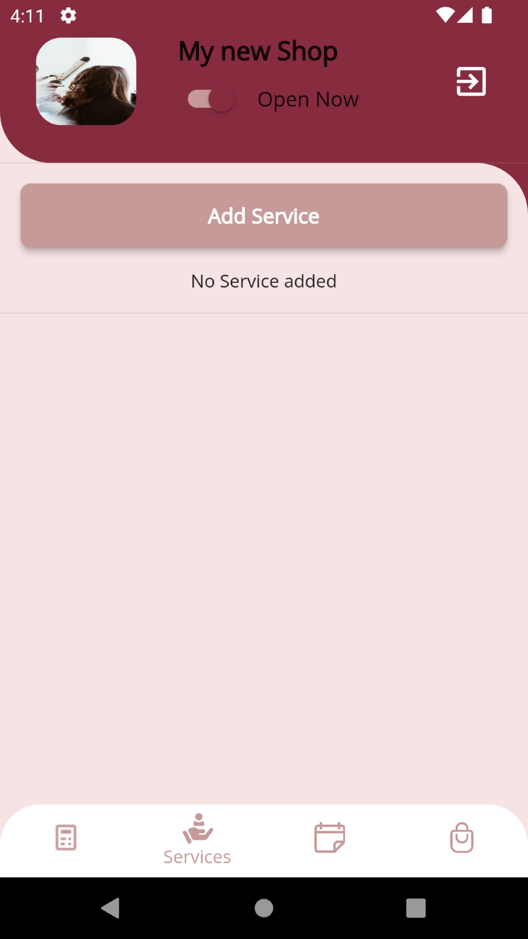 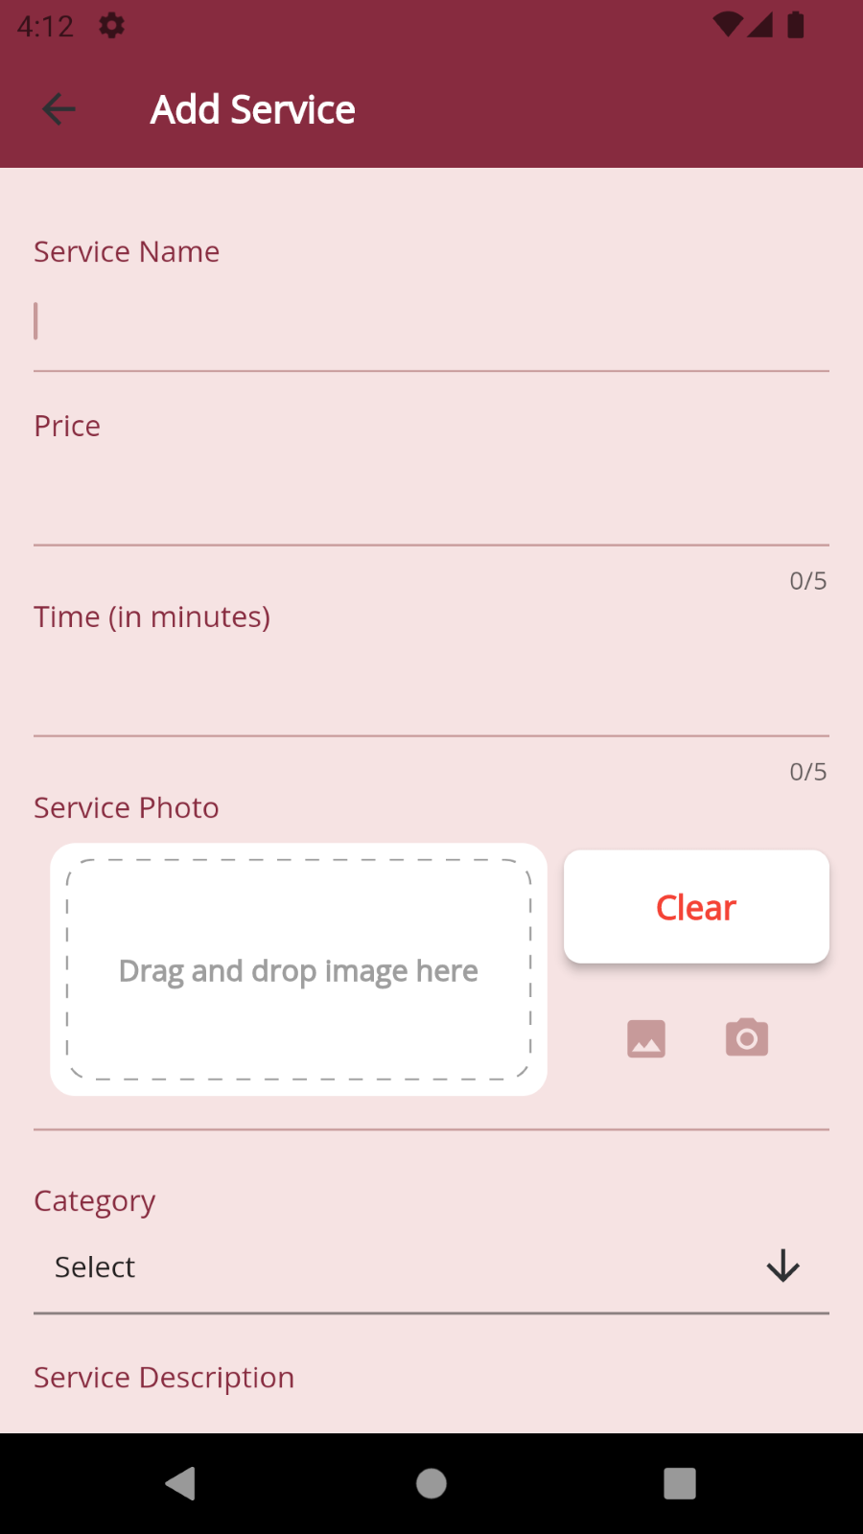

#### **7.4.2.2.1 Adding Services handling**

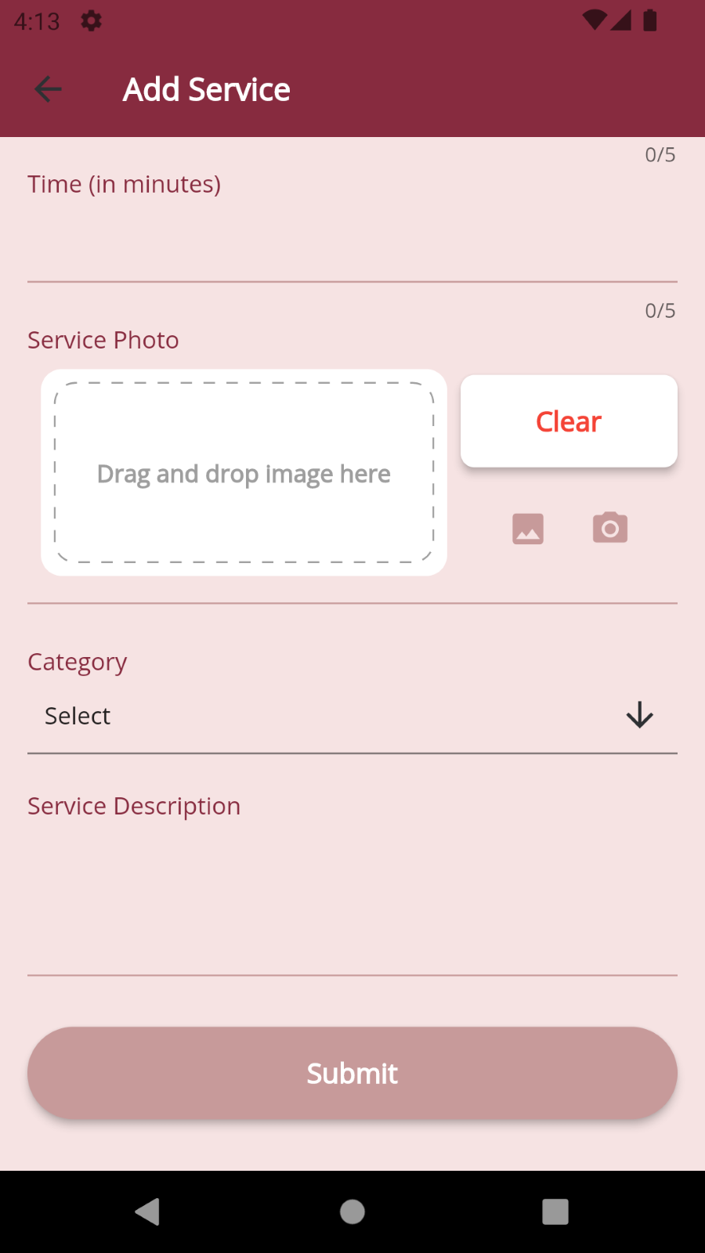 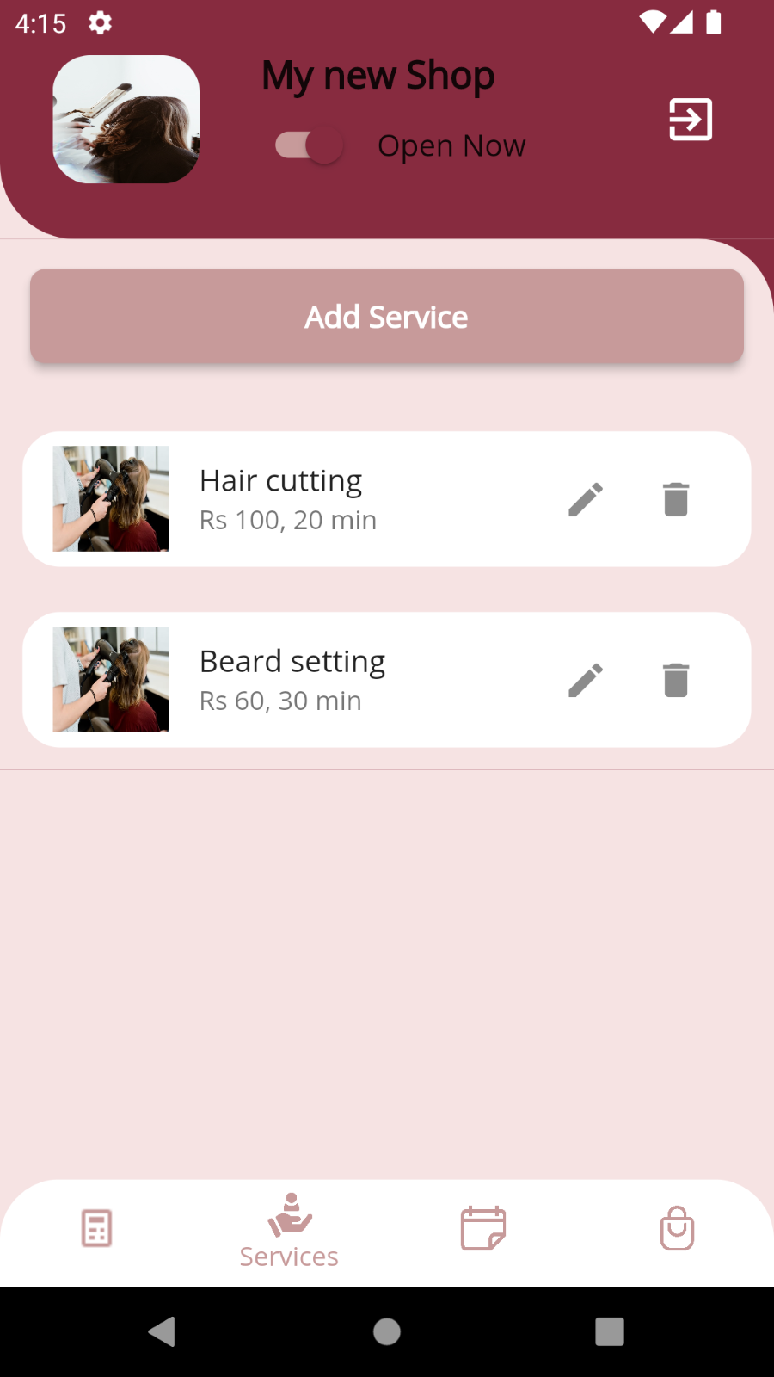

#### **7.4.2.2.2 Updating Services handling**

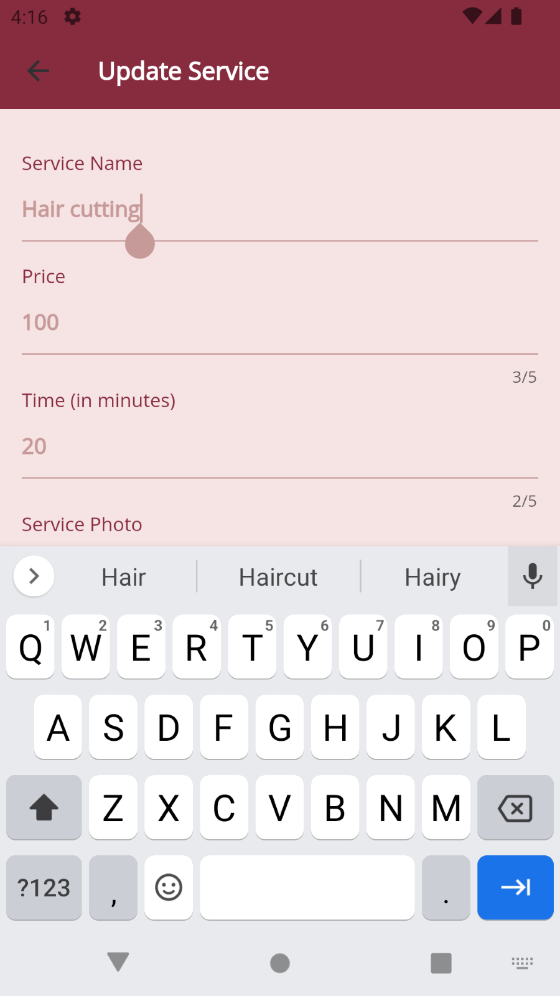 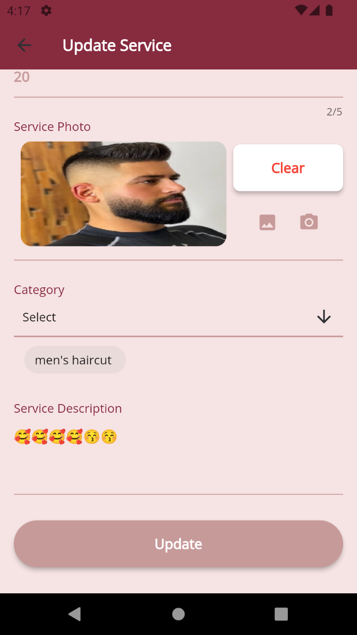

#### **7.4.2.3 Shop appointments**

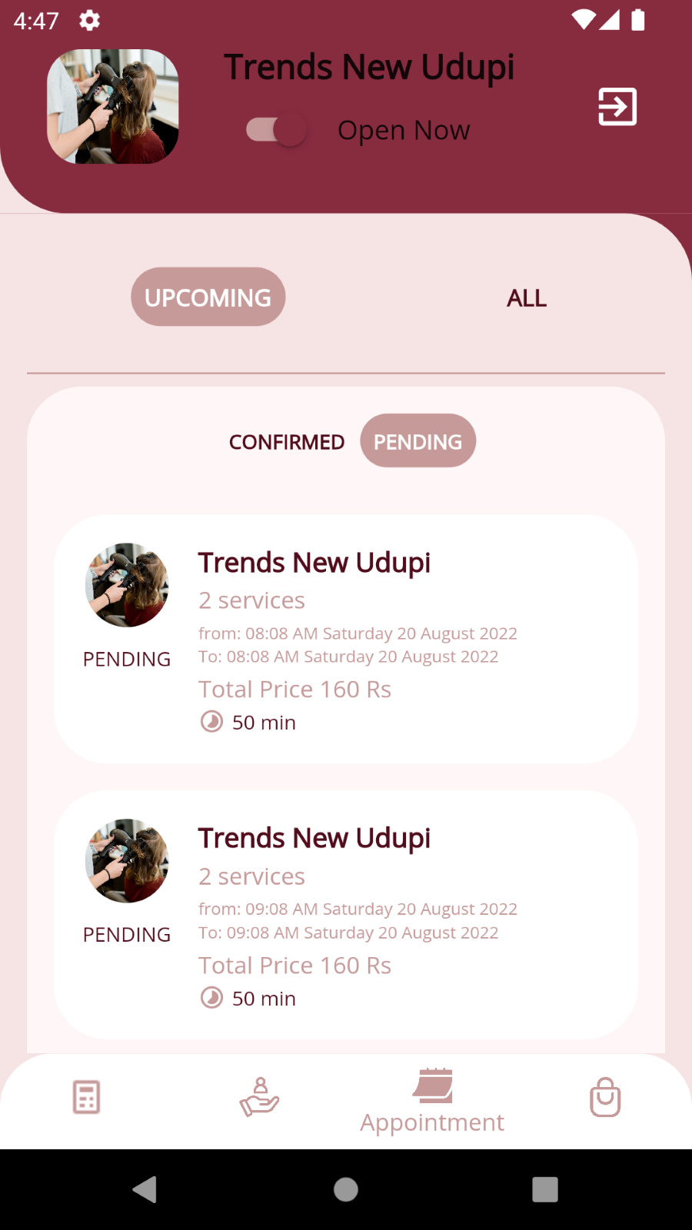

#### **7.4.2.3.1 Accept appointment**

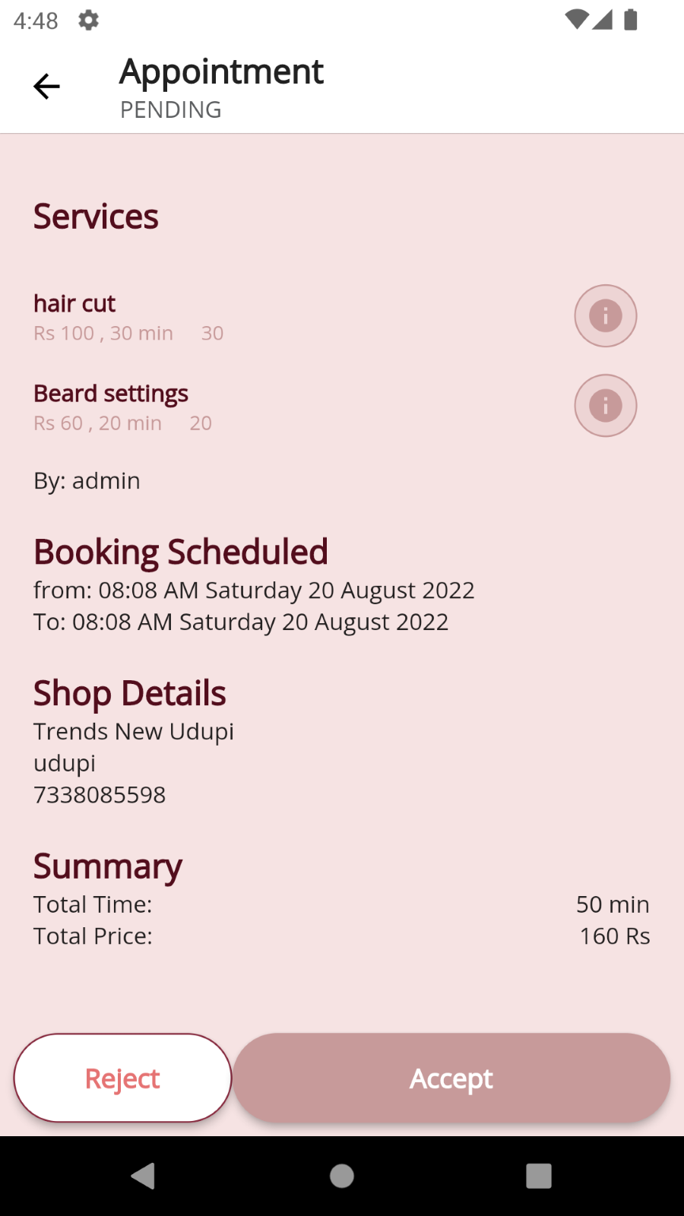 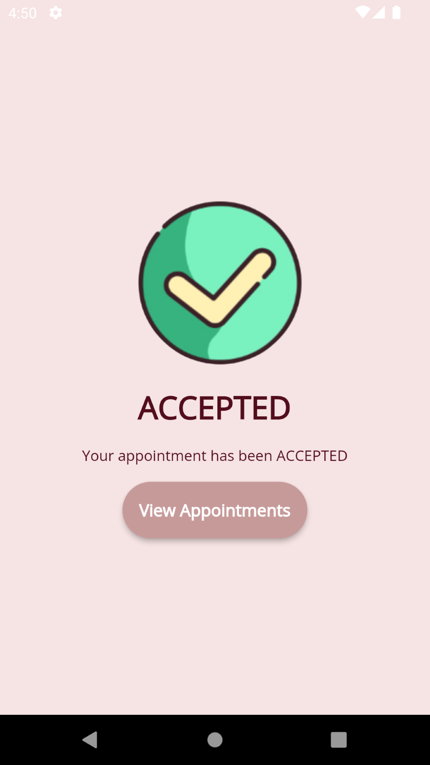

#### **7.4.2.3.2 Reject appointment**

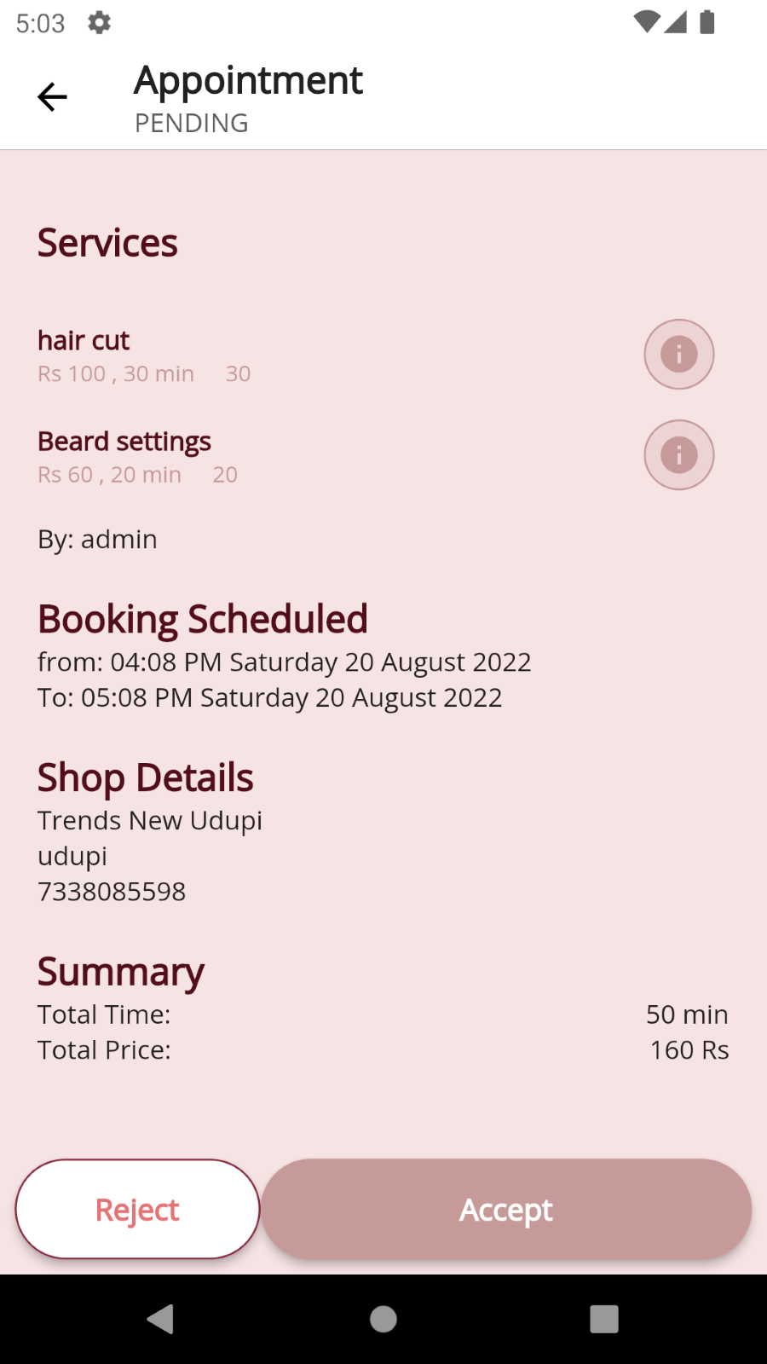 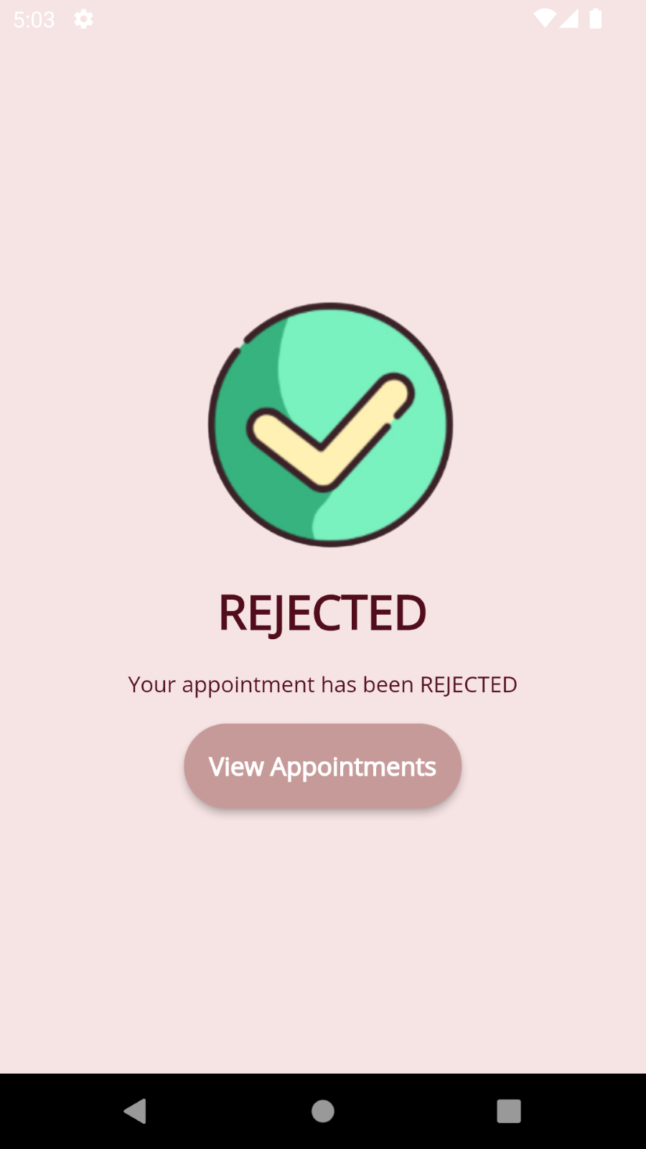

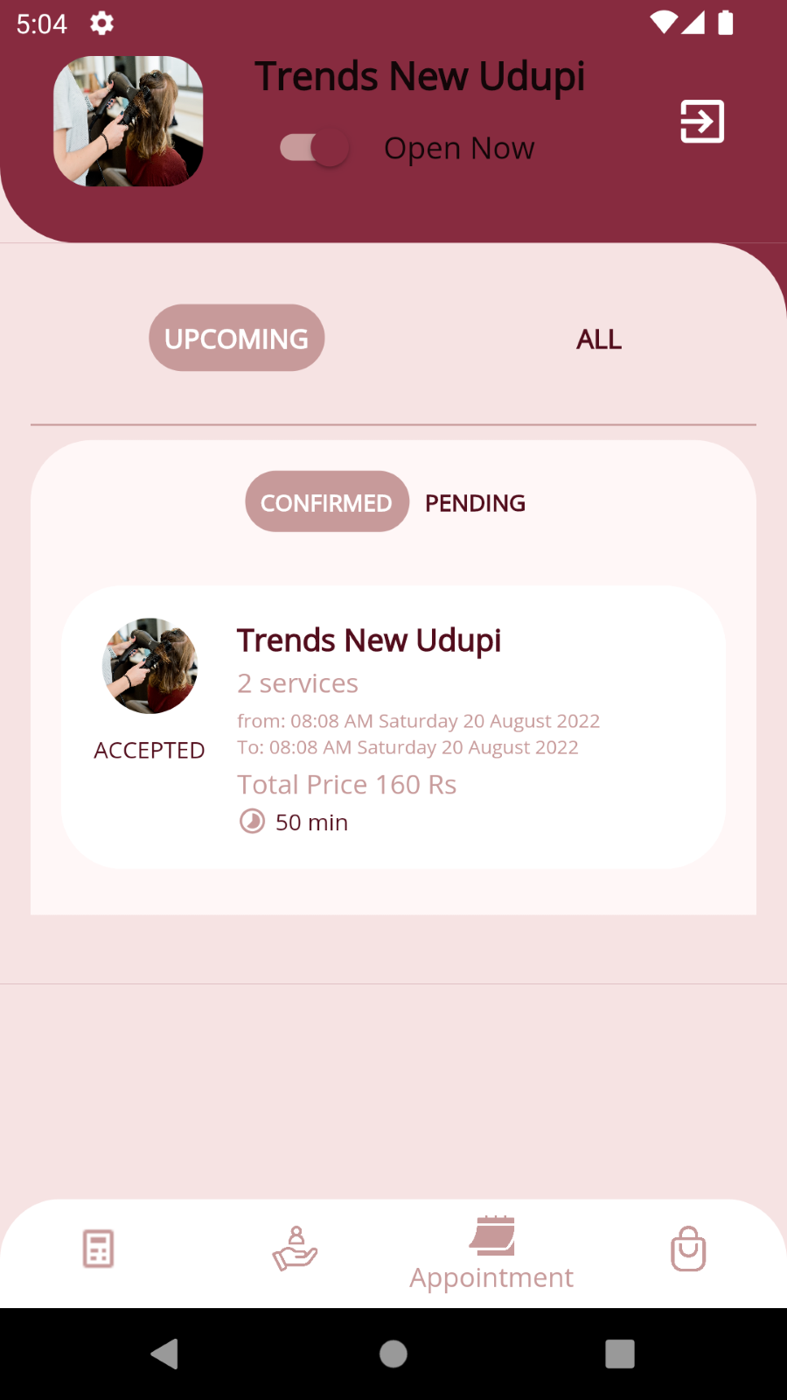 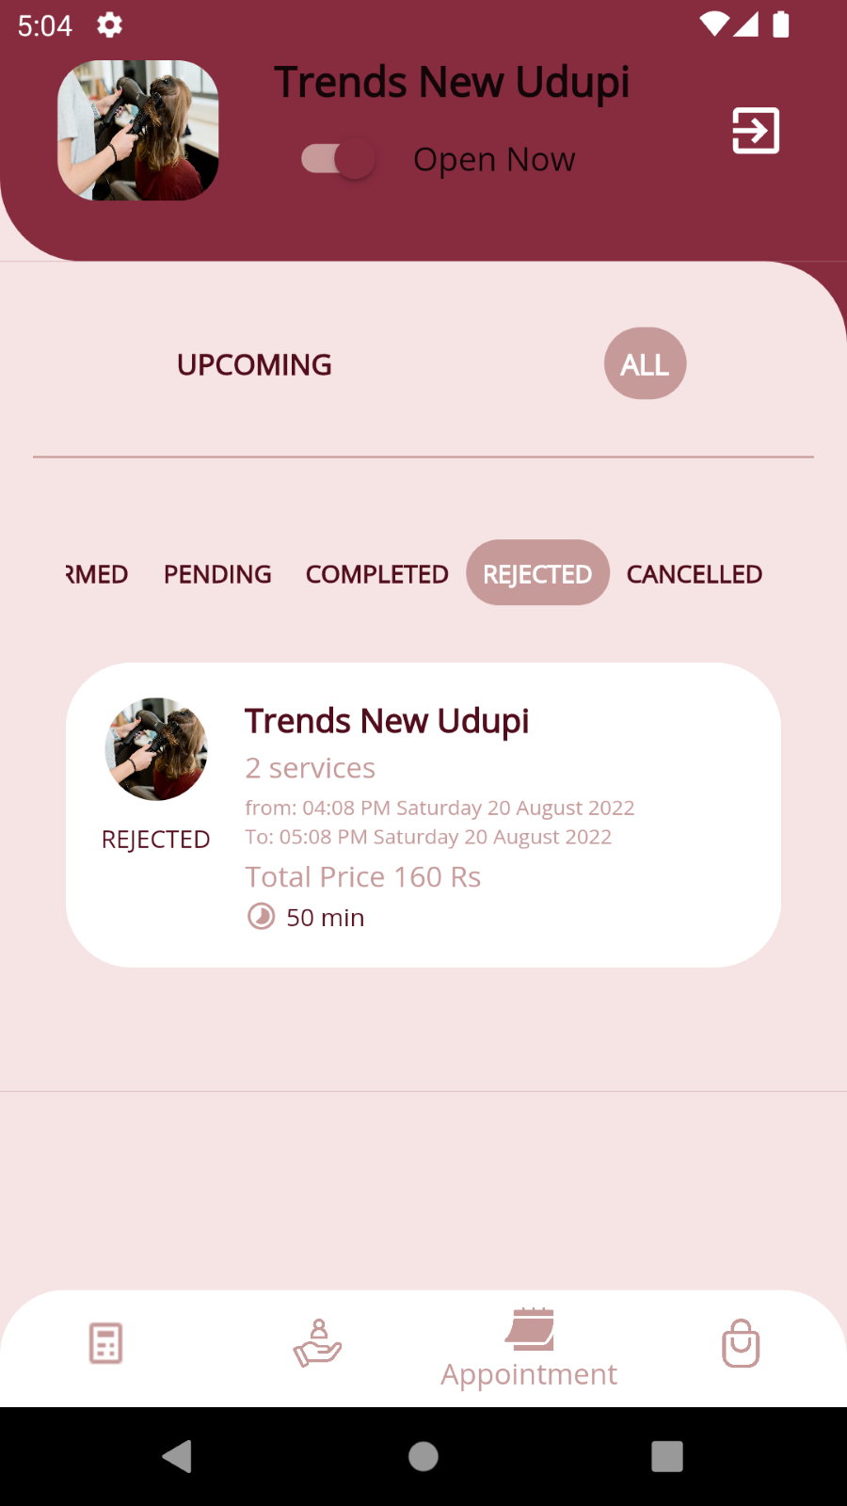

#### **7.4.2.4 Update Shop Information**

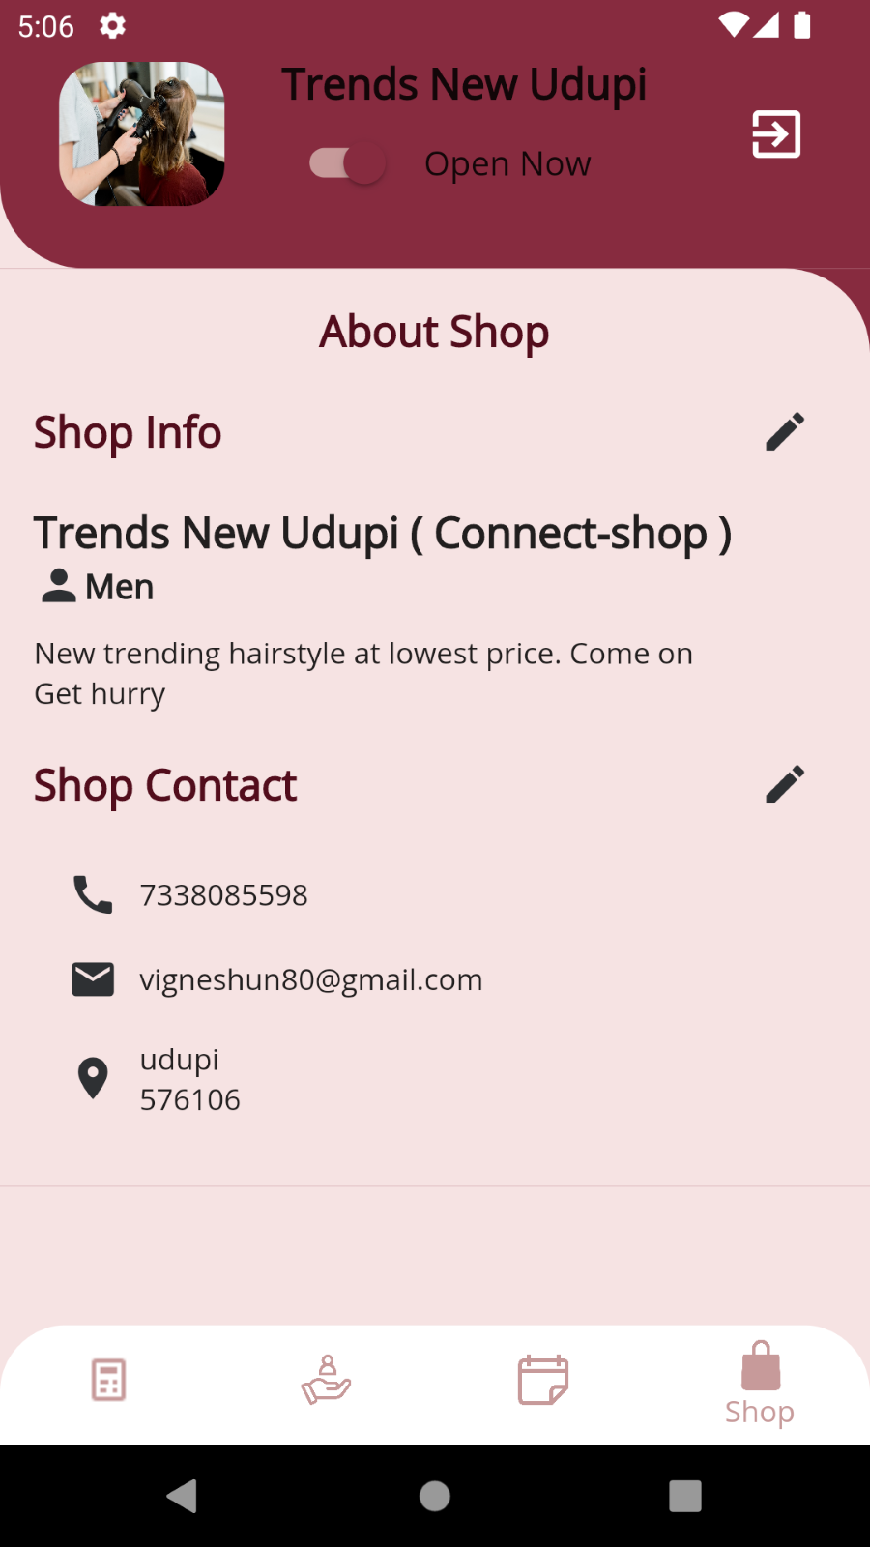 

### 7.4.3. Admin

#### **7.4.3.1 Manage category**

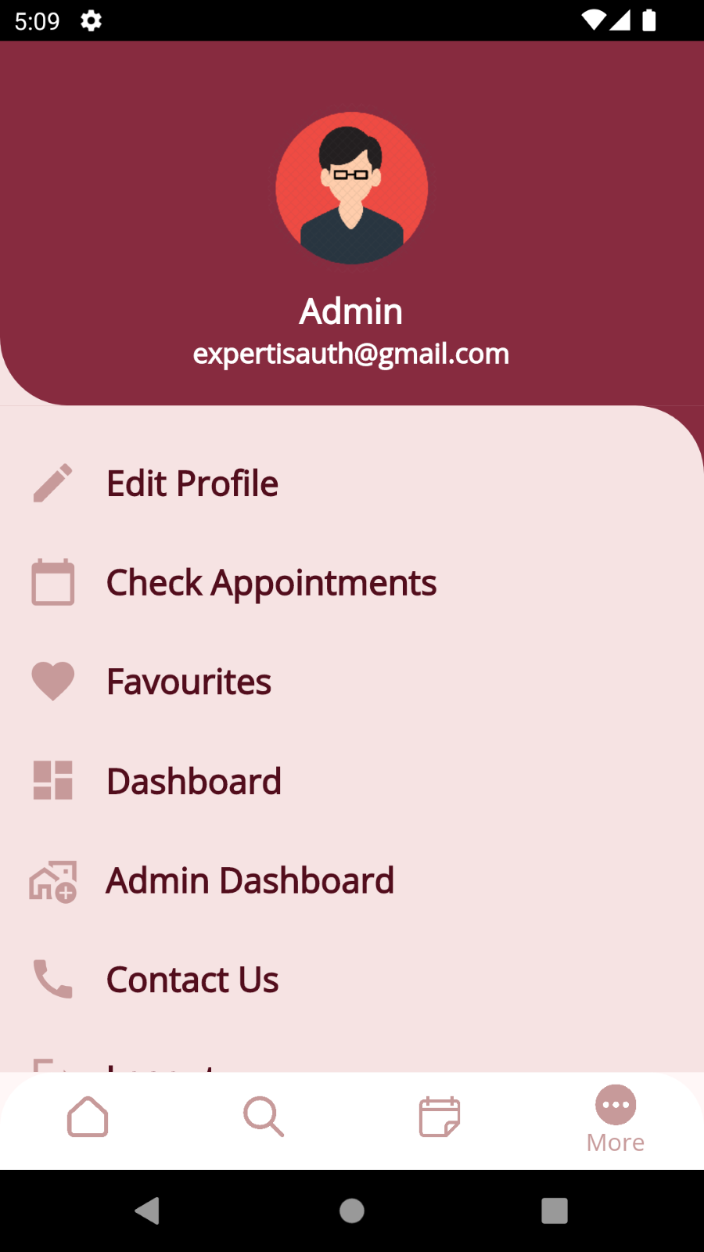 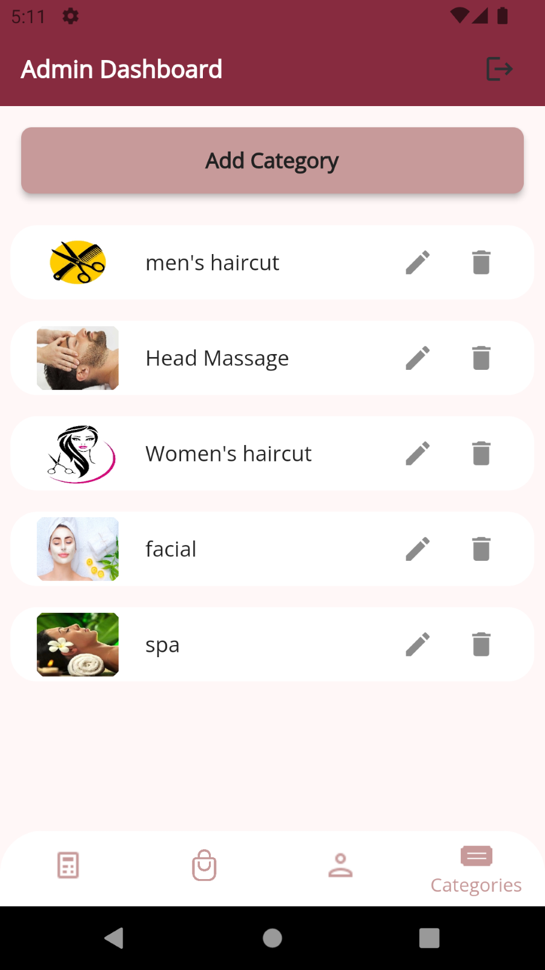

#### **7.4.3.1 Add & update category**

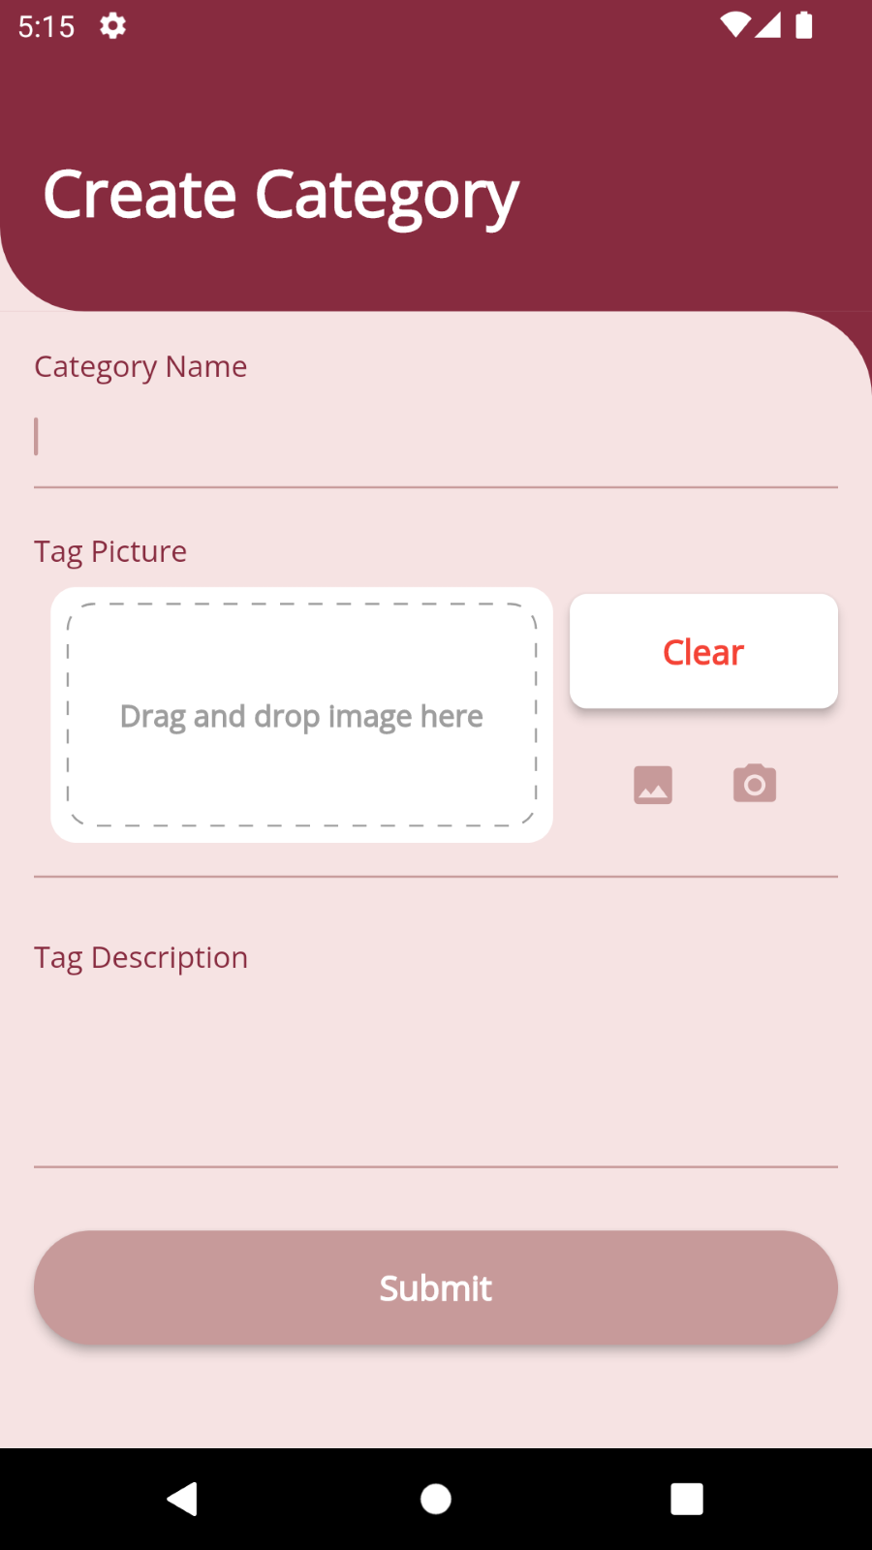 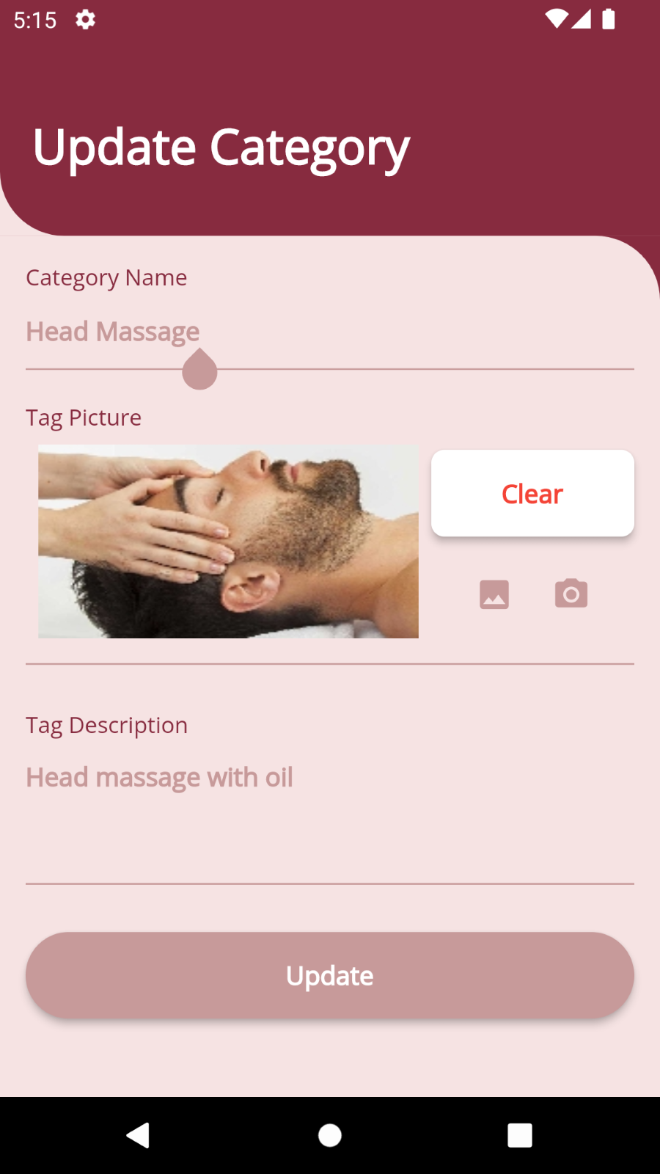

#### **7.4.3.2 Manage user**

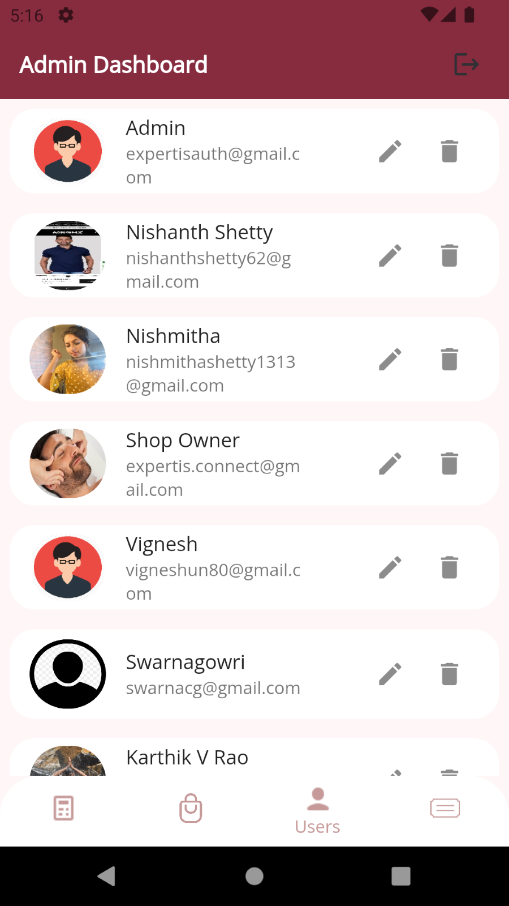 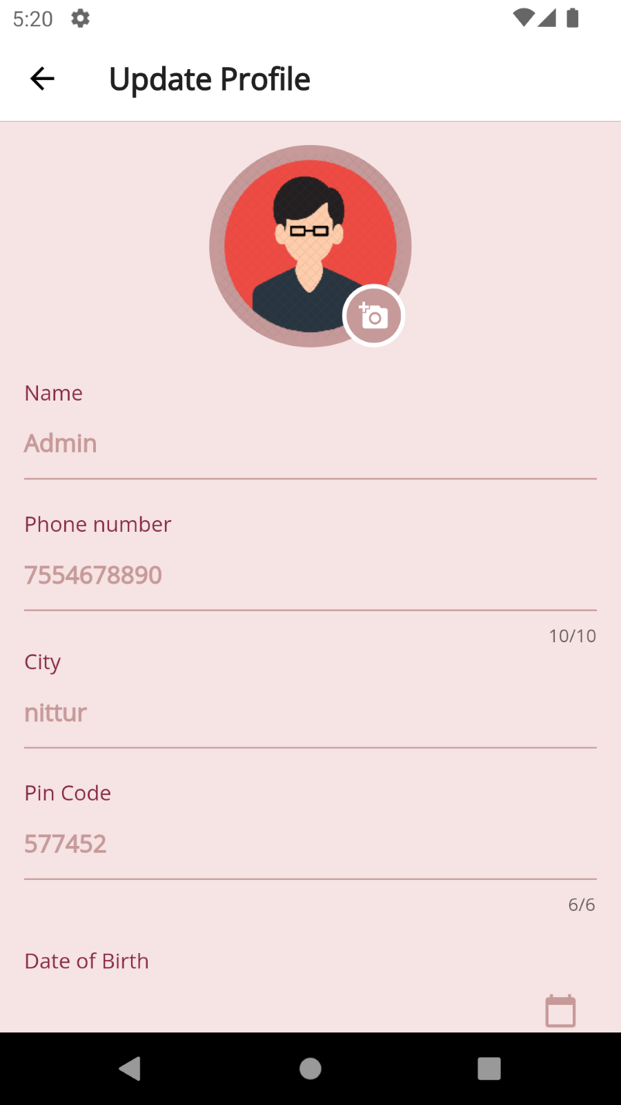

#### **7.4.3.3 Manage shop**

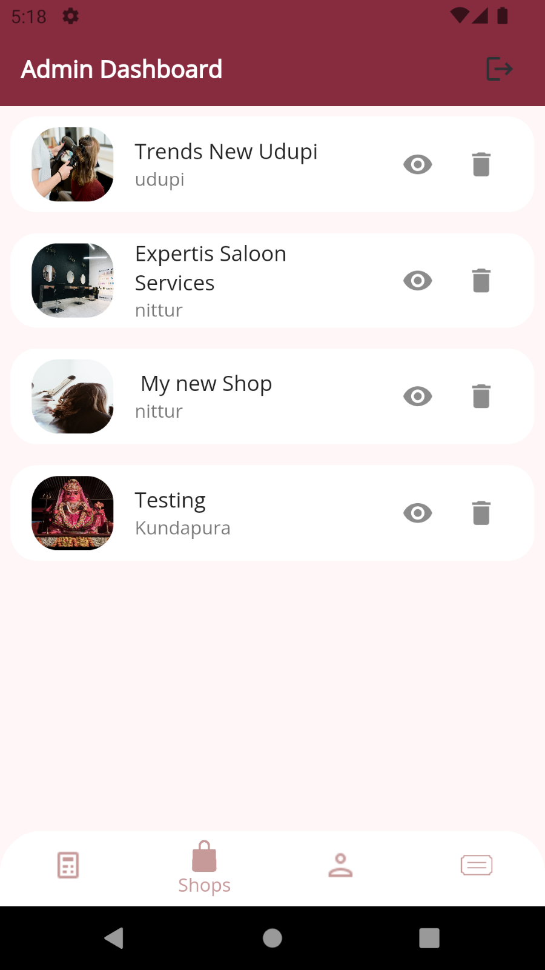 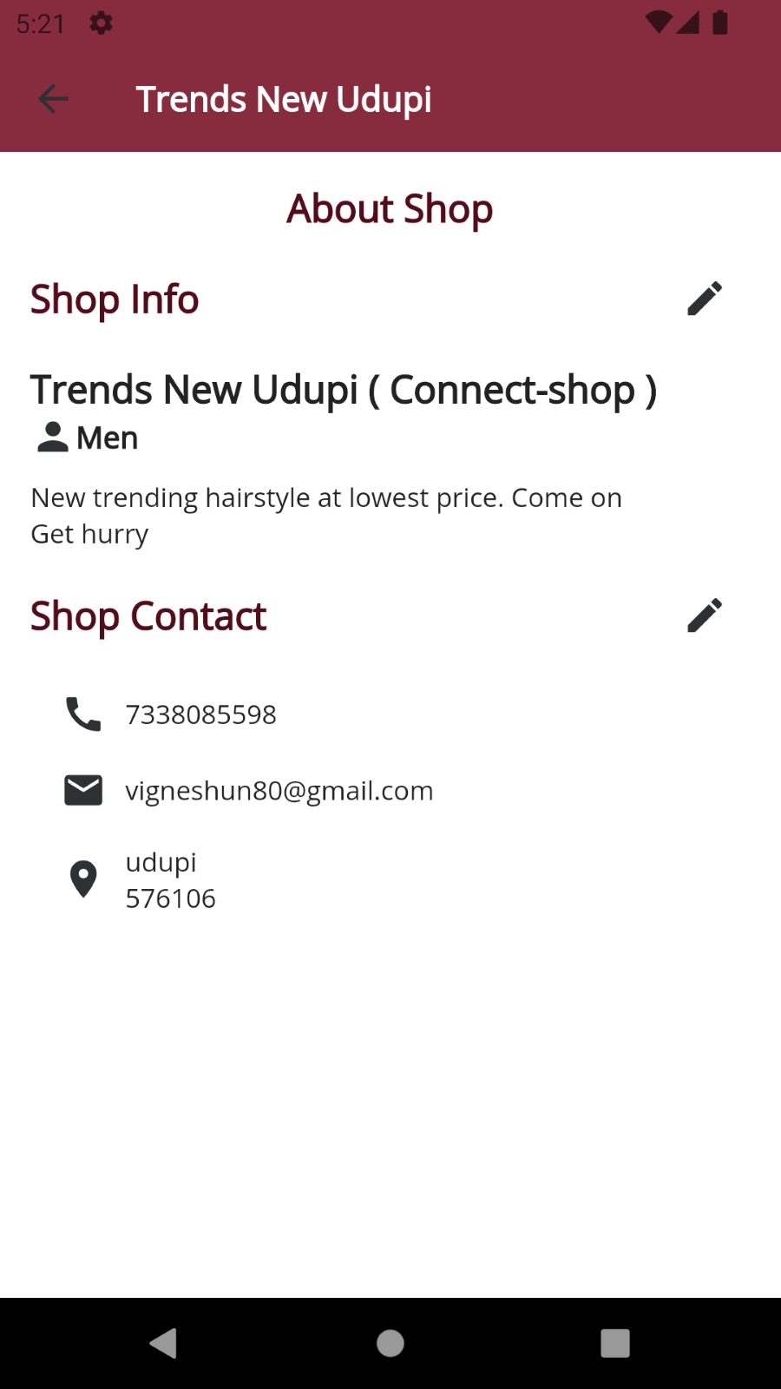

## 7.5 Validation

### 7.5.1 User Register required fields

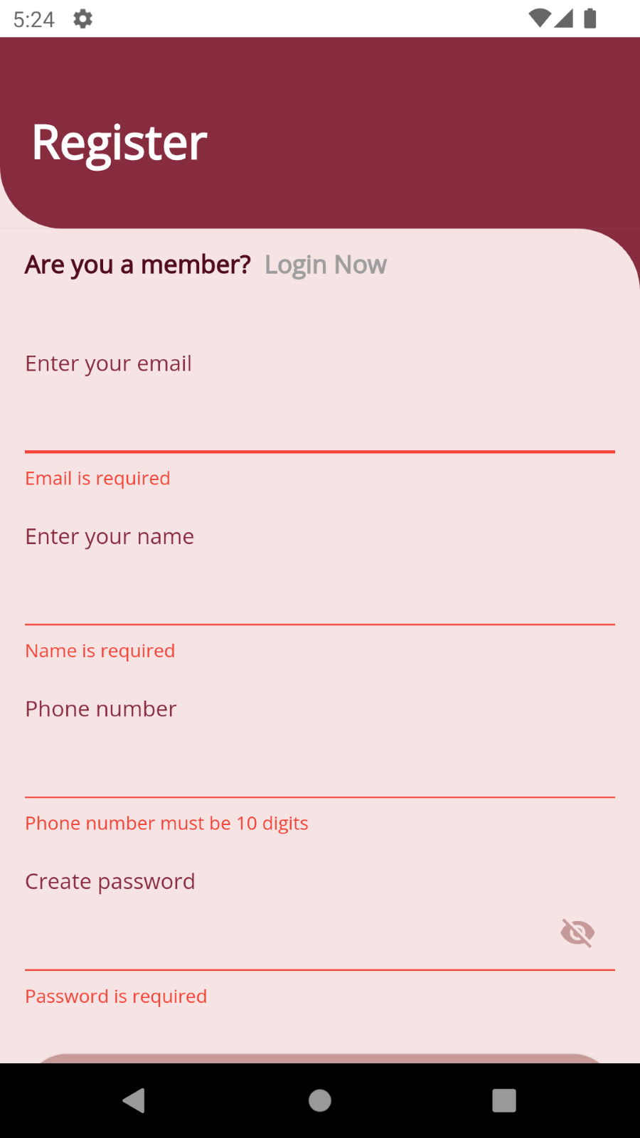

### 7.5.2 Invalid mail and phone



### 7.5.3 Password validation

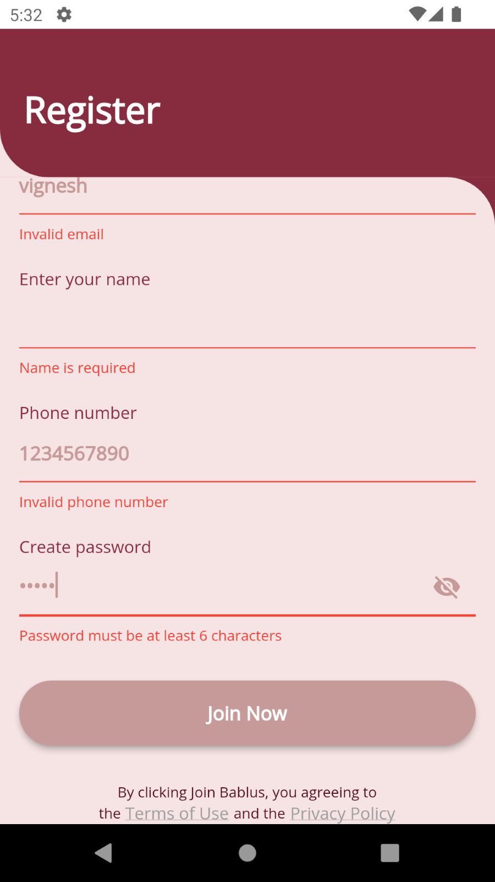

## 7.6 On-screen reports

### 7.6.1 Shop reports

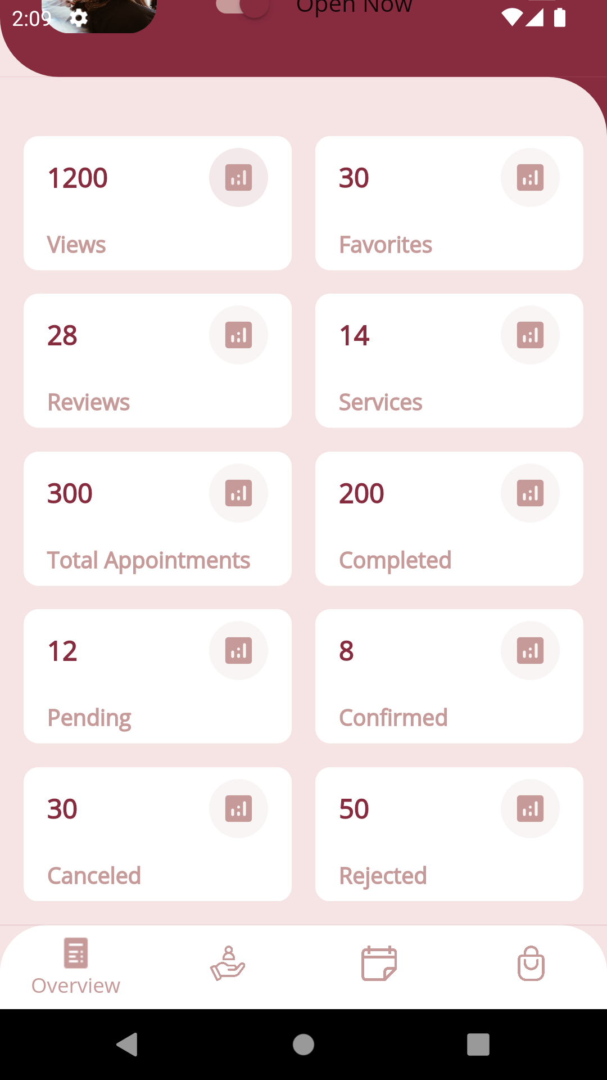

### 7.6.2 Admin reports

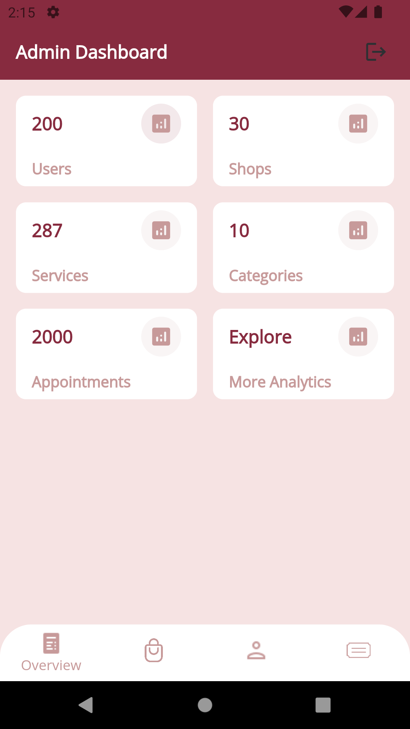

## 7.7 Error messages

### 7.7.1 User already exist

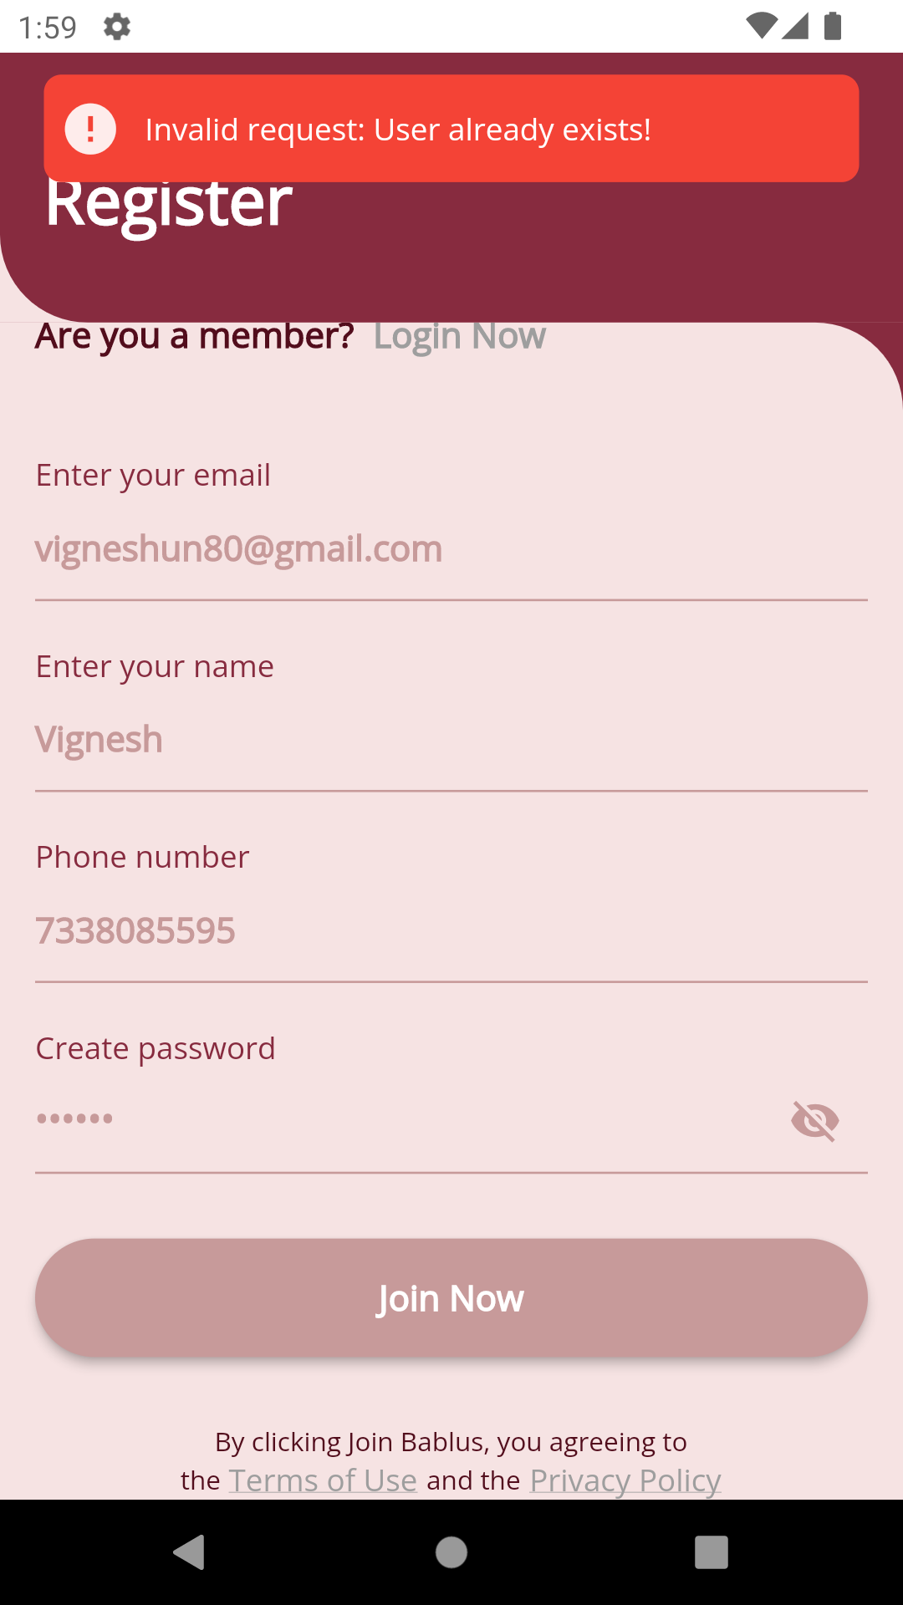

### 7.7.2 User not exist or invalid password while login

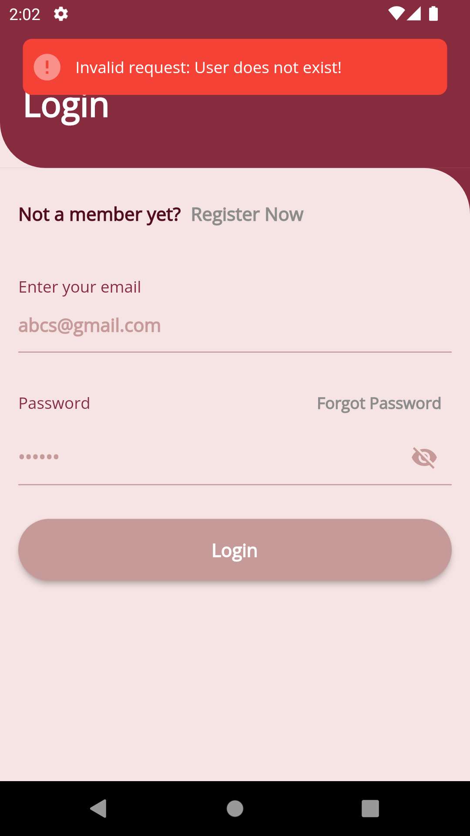 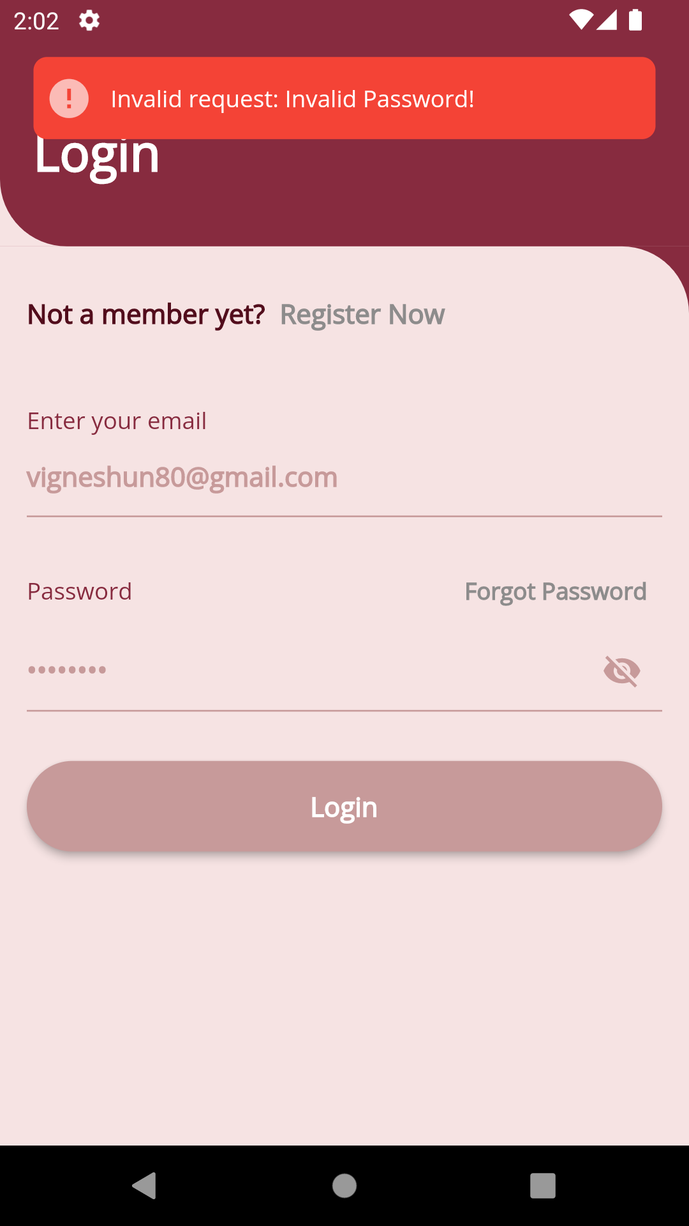

### 7.7.3 Shop already exist

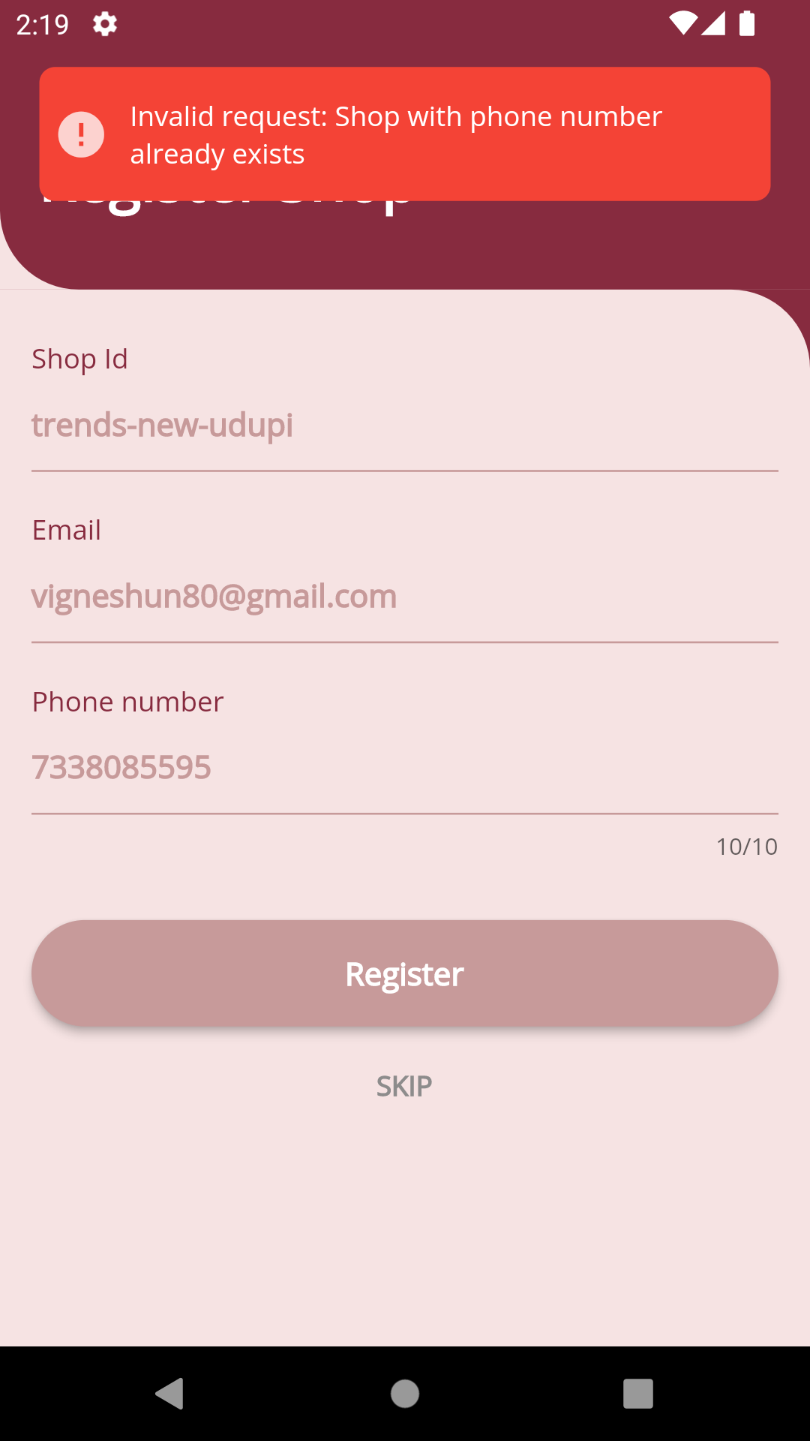t

# **8. Testing**

## 8.1 Introduction (brief write-up about Software Testing)

Testing is a process of detecting errors. Testing is a very important role in quality assurance and for ensuring the reliability of the software. The result of testing is mainly used during maintenance.

## 8.2 Test Reports

### 8.2.1 Unit Testing

Unit testing is the smallest unit of testing that focuses on verification. Using concept of detailed design, the process of specification testing is carried out to uncover the errors within the boundary of the modules. All modules must be successful in the testing before the integration test begins.

|  |  |
| --- | --- |
| **Test case ID** | **01** |
| Title | User Login |
| Purpose | Testing Login |
| Test data | E -mail address(Valid email address ,invalid email address ,empty field)   Password (Valid password ,invalid password ,empty field) |
| Expected output | 1.sucessfull login  2.login unsuccessful |
| Validation | 1 Invalid email address.  2. Password must have atleast 8 character. |
| Sample Test data | |  |  | | --- | --- | | E-mail address | Result | | [msupreetha2@gmail.com](mailto:msupreetha2@gmail.com) | Taken as valid email | | Sh | Invalid email address. | | Empty field | Invalid email address |  |  |  | | --- | --- | | Password | Result | | 9164141168 | Taken has valid password | | 918478 | Password must have at least 8 characters. | | Empty field | Password must have at least 8 characters. | |

|  |  |
| --- | --- |
| **Test case ID** | **02** |
| Title | User Registration |
| Purpose | Testing Registration |
| Test data | E -mail address(Valid email address ,invalid email address ,empty field)  Name (valid name, invalid name, empty field)  Phone (valid phone, invalid phone, empty field)   Password (Valid password ,invalid password ,empty field) |
| Expected output | 1.Registration successful  2. Registration unsuccessful |
| Validation | 1 Invalid email address.  2.Invalid phone number.  3.Email already exits.  4.Phone number already exits.  5. Password must have at least 6 characters.  6.Name should have at lest 3  characters. |
| Sample Test data | |  |  | | --- | --- | | E-mail address | Result | | [msupreetha2@gmail.com](mailto:msupreetha2@gmail.com) | Taken as valid email | | Sh | Invalid email address. | | Empty field | Invalid email address |  |  |  | | --- | --- | | Password | Result | | 9164141168 | Taken has valid password | | 91847 | Password must have at least 6 characters. | | Empty field | Password must have at least 6 characters. |  |  |  | | --- | --- | | Phone | Result | | 9342607939 | Taken has valid phone number | | 91847 | Phone number should be 10 characters. | | Empty field | Phone number should be 10 characters. |  |  |  | | --- | --- | | Name | Result | | Karthik | Taken has valid name | | na | Name must have at least 3 characters. | | Empty field | Name must have at least 3 characters. | |

|  |  |
| --- | --- |
| **Test case ID** | **03** |
| Title | Send forget Password OTP |
| Purpose | Testing Send forget Password OTP |
| Test data | E -mail address(Valid email address ,invalid email address ,empty field) |
| Expected output | 1.OTP sent Successfully  2.Email is not registered. |
| Validation | 1. Enter valid email. |
| Sample Test data | |  |  | | --- | --- | | E-mail address | Result | | [msupreetha2@gmail.com](mailto:msupreetha2@gmail.com) | Taken as valid email | | Sh | Invalid email address. | | Empty field | Invalid email address | |

|  |  |
| --- | --- |
| **Test case ID** | **04** |
| Title | Verify OTP and Change The Password |
| Purpose | Testing Forget Password |
| Test data | Rest Code (OTP) (valid Code, invalid Code, empty field).  New Password (valid Password, invalid Password, empty field).  Confirm Password (Valid password ,invalid password ,empty field). |
| Expected output | 1.Password Changed successful  2. Invalid OTP.  3.OTP expired. |
| Validation | 1 Password must have at least 6 characters.  2Reset Code must 6 characters.  3. Password is not Matching . |
| Sample Test data | |  |  | | --- | --- | | Reset Code (OTP) | Result | | 284567 | Taken as valid OTP | | 23 | Invalid email OTP | | Empty field | Invalid email OTP |  |  |  | | --- | --- | | Password | Result | | 9164141168 | Taken has valid password | | 91847 | Password must have at least 6 characters. | | Empty field | Password must have at least 6 characters. |  |  |  | | --- | --- | | Confirm Password | Result | | 9164141168 | Taken has valid password | | 91847 | Password must have at least 6 characters. | | Empty field | Password must match. | |

|  |  |
| --- | --- |
| **Test case ID** | **05** |
| Title | Shop Registration |
| Purpose | Testing Shop Registration |
| Test data | E -mail address(Valid email address ,invalid email address ,empty field)  ShopId (valid shopId, invalid shopId, empty field)  Password (Valid password ,invalid password ,empty field) |
| Expected output | 1.Redirect to shop contact detail screen.  2. Stay in that page only |
| Validation | 1Invalid ShopId.  2.Invalid phone number.  3.Email already exits.  4.Phone number already exits.  5. Password must have at least 6 characters.  6.Shop name is required.  7.ShopId required. |
| Sample Test data | |  |  | | --- | --- | | E-mail address | Result | | [msupreetha2@gmail.com](mailto:msupreetha2@gmail.com) | Taken as valid email | | Sh | Invalid email address. | | Empty field | Invalid email address |  |  |  | | --- | --- | | Password | Result | | 9164141168 | Taken has valid password | | 91847 | Password must have at least 6 characters. | | Empty field | Password must have at least 6 characters. |  |  |  | | --- | --- | | Phone | Result | | 9342607939 | Taken has valid phone number | | 91847 | Phone number should be 10 characters. | | Empty field | Phone number should be 10 characters. |  |  |  | | --- | --- | | Shop Name | Result | | New look | Taken has valid name | | na | Name must have at least 3 characters. | | Empty field | Name must have at least 3 characters. |  |  |  | | --- | --- | | Shop Id | Result | | Newlook | Taken has valid name | | New Look | Shop Id should not contain space | | Empty field | Shop Id must have at least 3 characters. | |

|  |  |
| --- | --- |
| **Test case ID** | **06** |
| Title | Shop contact details |
| Purpose | Testing Shop contact details |
| Test data | Address(Valid address ,invalid address ,empty field)  Pin Code (valid Pin Code, invalid Pin Code, empty field) |
| Expected output | 1.Shop Registered successful  2. Error Messages |
| Validation | 1. Pin Code must have 6 characters.  2.Address should have at lest 3  characters. |
| Sample Test data | |  |  | | --- | --- | | Pin Code | Result | | 576211 | Taken as valid Pin Code | | 23 | Pin Code must have 6 digits | | Empty field | Pin Code must have 6 digits |      |  |  | | --- | --- | | Address | Result | | Udupi main bus stand | Taken has valid name | | na | Address must have at least 3 characters. | | Empty field | Address Required. | |

|  |  |
| --- | --- |
| **Test case ID** | **07** |
| Title | Edit User Profile |
| Purpose | Testing User Profile Edit |
| Test data | Name (Valid name ,invalid name ,empty field)  Phone (valid phone number, invalid phone number, empty field)  City (Valid City ,invalid City ,empty field)  Pin Code (Valid Pin Code, invalid Pin Code, empty field).  Gender( Male, Female, Other ) |
| Expected output | 1.Redirect to user profile screen  2. Error Messages |
| Validation | 1. Pin Code must have 6 characters.  2.Invalid phone number.  3.Phone number already exits. ` |
| Sample Test data | |  |  | | --- | --- | | Pin Code | Result | | 576211 | Taken as valid Pin Code | | 23 | Pin Code must have 6 digits | | Empty field | Pin Code must have 6 digits |      |  |  | | --- | --- | | City | Result | | Udupi | Taken has valid name | | Empty field | Address Required. |  |  |  | | --- | --- | | Phone | Result | | 9342607939 | Taken has valid phone number | | 91847 | Phone number should be 10 characters. | | Empty field | Phone number should be 10 characters. |  |  |  | | --- | --- | | Name | Result | | Karthik | Taken has valid name | | na | Name must have at least 3 characters. | | Empty field | Name must have at least 3 characters. | |

|  |  |
| --- | --- |
| **Test case ID** | **08** |
| Title | Add or Update Category |
| Purpose | Testing Add or Update Category |
| Test data | Category Name(Valid Category Name, invalid Category Name, empty field) |
| Expected output | 1.Redirect to Back  2. Error Messages |
| Validation | 1. Category Name is required |
| Sample Test data | |  |  | | --- | --- | | City | Result | | Beauty | Taken has valid name | | Empty field | Category Name Required. | |

### 8.2.2 Integrate Testing

In this application developer test the programs as system. Software unit in a system are the modules and routines that are assembled and integrated to form a specific union.

**Booking Appointment**

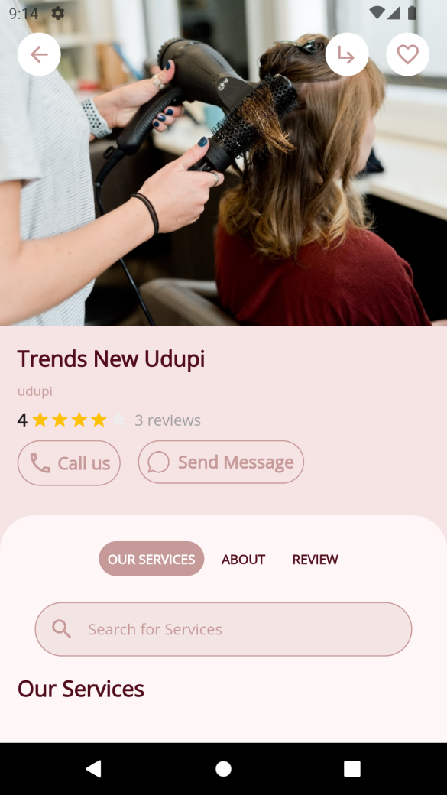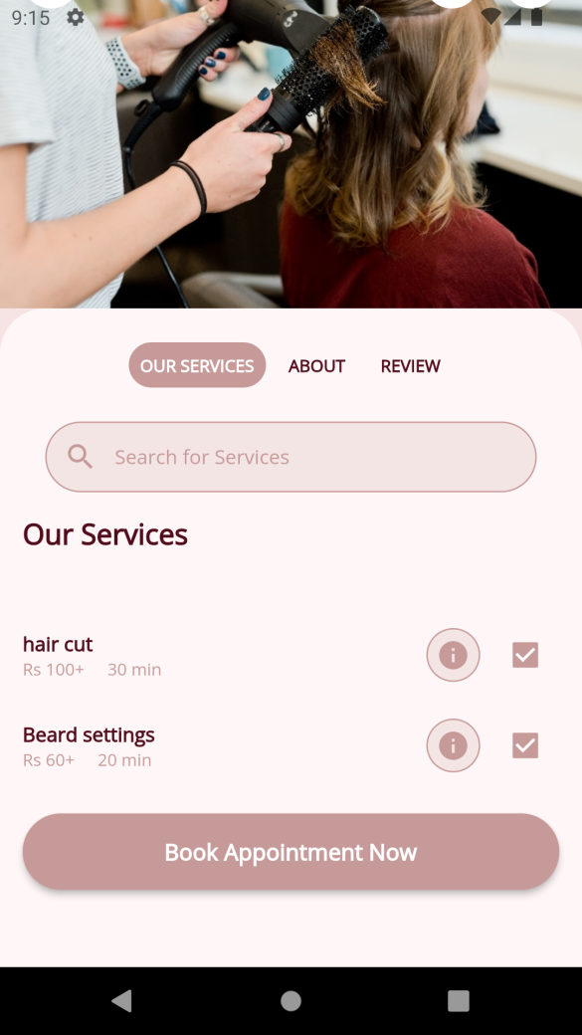

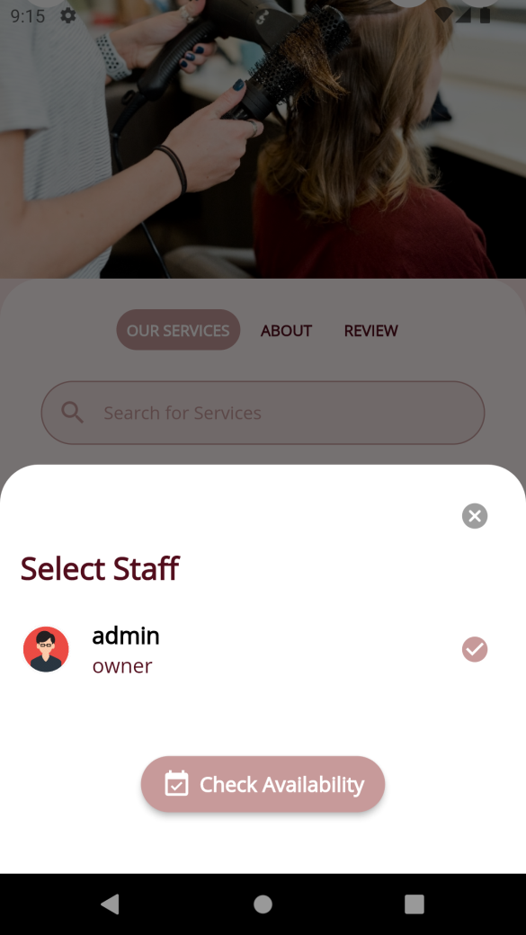 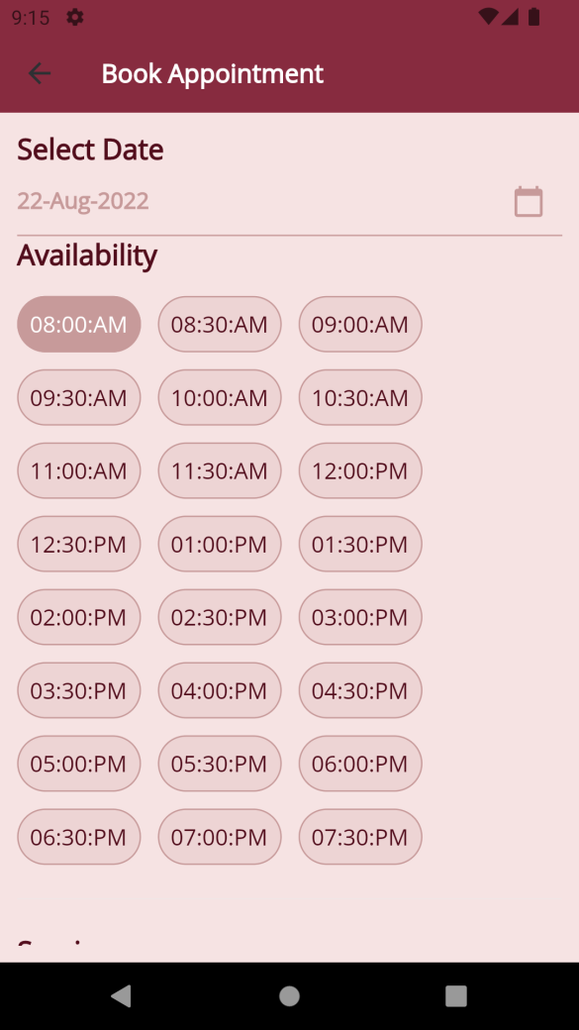

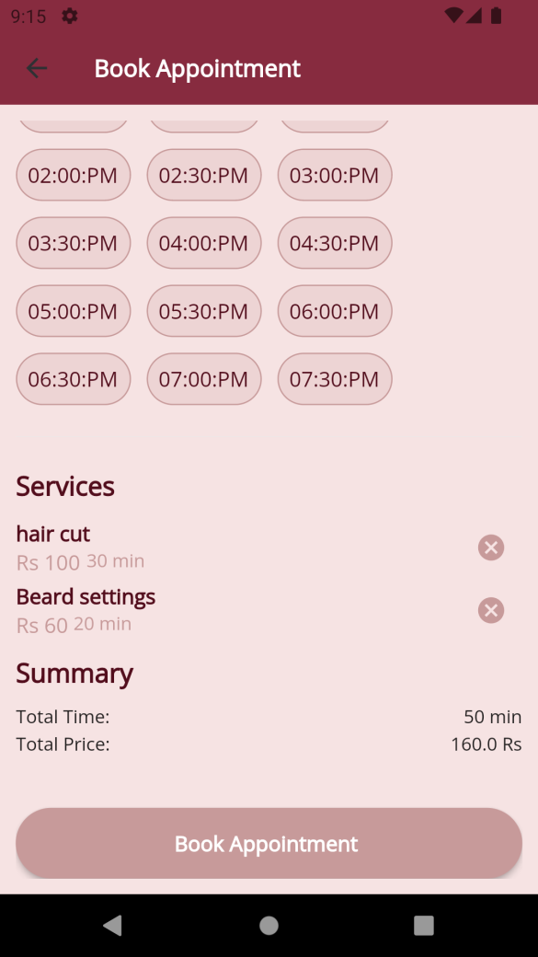 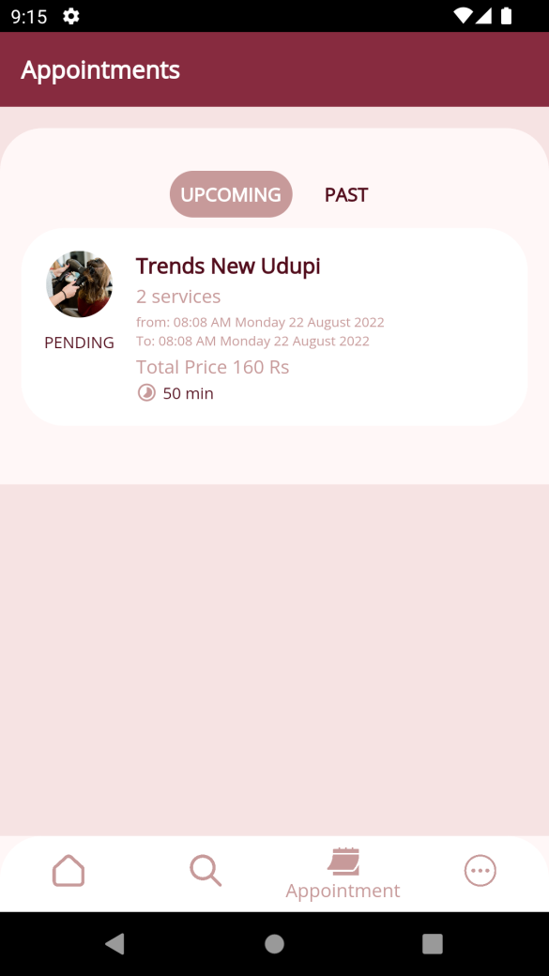

### 8.2.3 System Testing

In system testing entire system is tested as a whole with all forms, code, modules and class modules. After the integration testing the whole of the system is tested in different environments and it is found that the system has performed well without giving any runtime error. Hence after the testing it is concluded that the system will work fine in all environment.

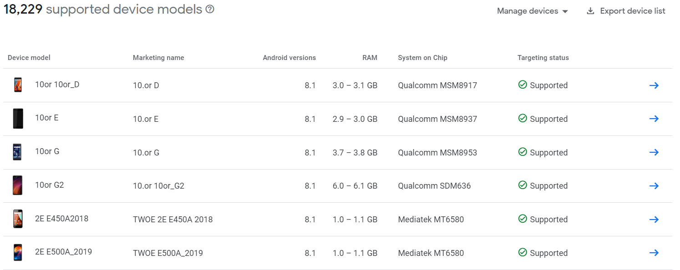

# **Conclusion**

The project work title “Bablus – A online saloon booking App” has been successfully designed and developed and tested. User friendly interface are added to make it very easy user interactive application. The project is tested successfully and report is generated.

The modules have fulfilled by the entire objectives identified. The project have been developed in attractive user interactive fashion. So, the user with common development knowledge about the computer can handle it very easily. The book can be easily upload and enrolled to the app. So it is a user friendly app. The Project has produced all the reports required by the user. The module has fulfilled all the objectives identified and supports interactive user-friendly interface.

# **Limitations:**

* Requires internet connectivity to use the application
* Shop owner should be active in the application

# **Scope for enhancement (future scope)**

* Google map integration for calculating distance and direction
* Payment Gateway Integration using RazorPay
* Quick chat option between the user and shop

# **Abbreviations and Acronyms (list)**

* SRS - Software Requirement Specification
* CFD - Context Flow Diagram
* DFD - Data Flow Diagram
* CFD - Control Flow Diagram
* ER diagram - Entity Relationship Diagram

# **Bibliography / References (list in specified format)**

* An integrated approach to software engineering book- Pankaj Jalote
* https://docs.flutter.dev

* <https://stackoverflow.com>
* Youtube.com